Systems Design Interview Concepts (for software engineers / full-stack web)

<https://www.youtube.com/watch?v=REB_eGHK_P4>

Load balancers: help distribute traffic to multiple web servers to help throughput, latency and scalability

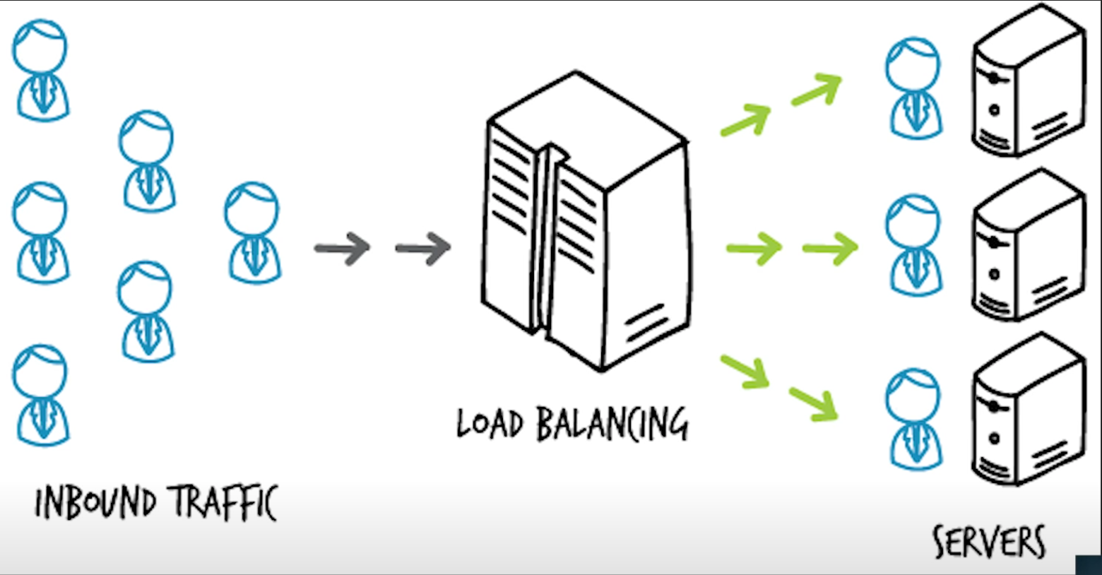

Nginx to route traffic / dns load balancing: given a url have the website route to multiple ip addresses, very simple we don’t need any machine, not much customibility

Web service may not go down but it’s the database – caching

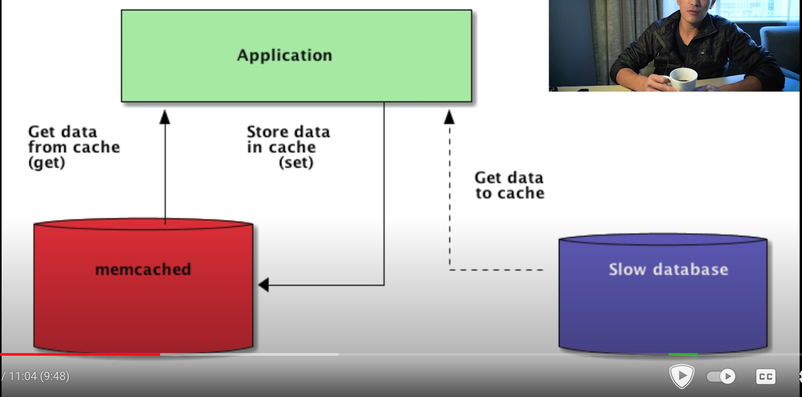

Some caching service are memcached (facebook uses it a lot ) , redis … they are all used in large tech company. In memory cache, it does not have to hit disk so it is efficient we can have the cache last for 24hrs or so

We can also use CDN (content delivery network): save files/css/html.. decrease load on the actual server, also make it faster

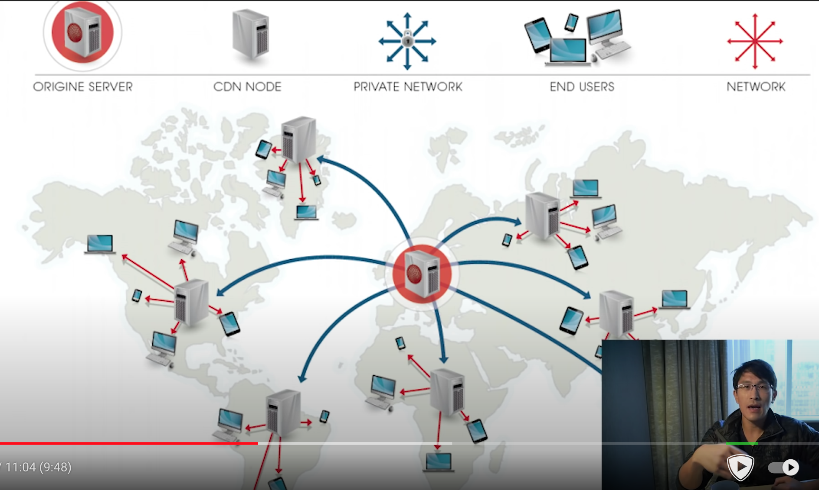

CDN: pull technique, first time user pull the content to CDN and next user can use the content from CDN

Push technique: server push the files to the CDN so it is fast even for the first access but higher cost.

If you allow user to upload image – we need a distributed file system like amazon s3

Database schema: what are the primary keys , what are the indices – make query fast

To avoid database going down:Replication: slave master replication , master to write into, cloned into multiple slave databases where we read from . add 1-2 seconds delay to read, may affect consistency: if write to the database, immediately able to read the same value. In that case, for something like profile that we don’t want delay, we can always read from master database or from a cache.

How to scale:

Web server using load balancer

Image server: use CDN

Database reads:: caching , replication and index, we can have handreds of caching servers and slave servers in order to scale out reads

Database writes: database sharding : split the database into multiple master databases:

vertical sharding: take each table and put in a new machine: you may have a user table, a tweets table, a comments table, a user supports table, a chat table, each is in different machine, that can work well.

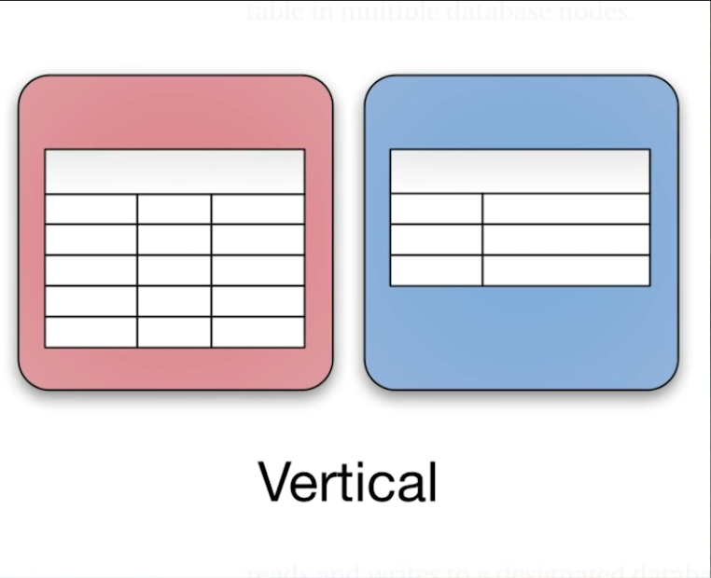

But what if you have a single tweets table and it is going very large how do we handle that? That’s horizontal sharding: you take a single table and you split that across multiple machine

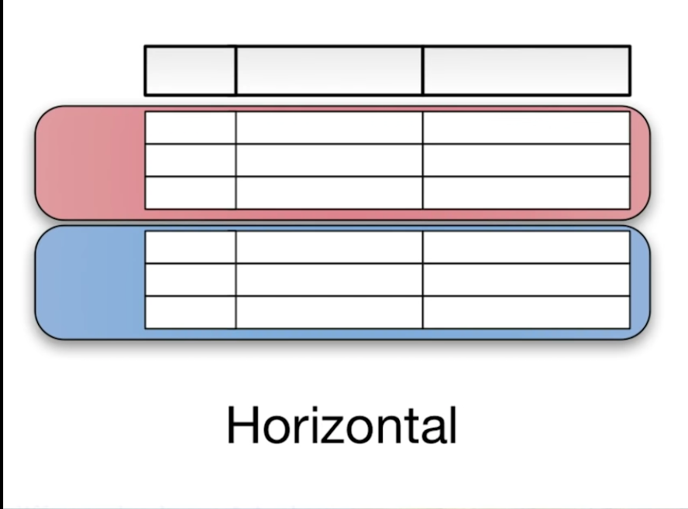

there are multiple ways to do this, one common way you take the user id just multiply by the total number of the machines you want to allocate the user id to. say if you five master machines for a table, you just take the user id , multiply by 5, routes each user to a different machine

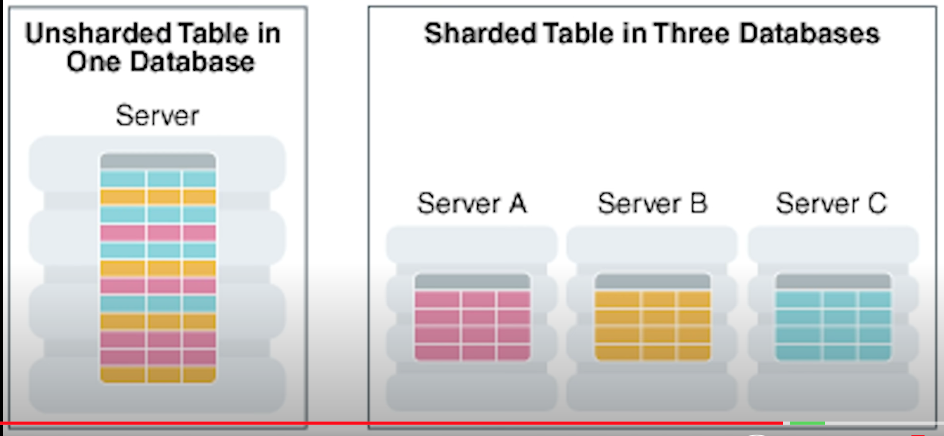

Another way: master table which indicated for each user which machine it will be located on. This master table is responsible for the sharding algorithm

Nosql: not relational. Key value pairs, naturally able to scale automatically by themselves across multiple machines. Easily. Mongodb, amazon’s dynamodb or fire base fire store.

You can use hybrid of these to scale up. If you have active chat server, you could be using nosql engine or simply in memory table. And for your more persistent needs like user table you can use standard relational database like mysql

API design: you may have a client and server. How do they communicate with each other what are the functions and methods they use. What is the data transport mechanism are you using json or protocol bufferes what does the data look like how do you handle security, do you support offline usage. How do you make it fast. Its open ended. Depending on the application and user senarios and where your load is going to be. No two applications are going to scale exactly the same way. Which is why it is important to ask a lot of clarifying questions and figure out what type of load and scenario the system will be put under. You never want to scale too early or put in premature optimizations. Because it just complicate the system. The things people value the most is simplicity.

<https://blog.bytebytego.com/p/ep14-algorithms-you-should-known> ：

What are some of the algorithms you should know before taking system design interviews?

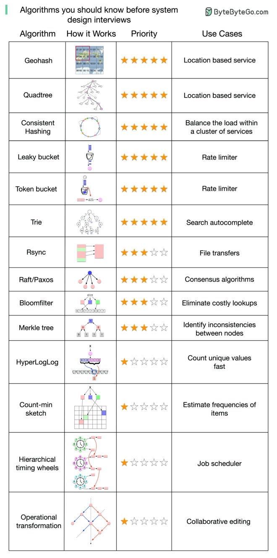

One thing to keep in mind is that understanding “how those algorithms are used in real-world systems” is generally more important than the implementation details in a system design interview.

How to store passwords safely in the database? (YouTube video) <https://www.youtube.com/watch?v=zt8Cocdy15c&feature=emb_title> ：

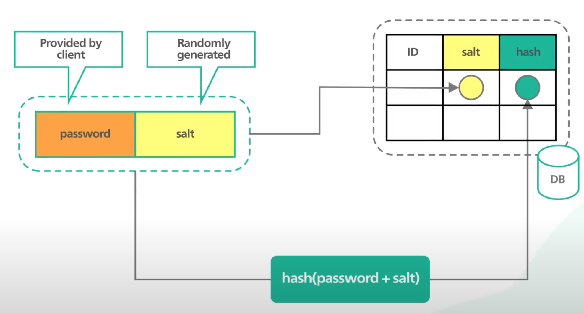

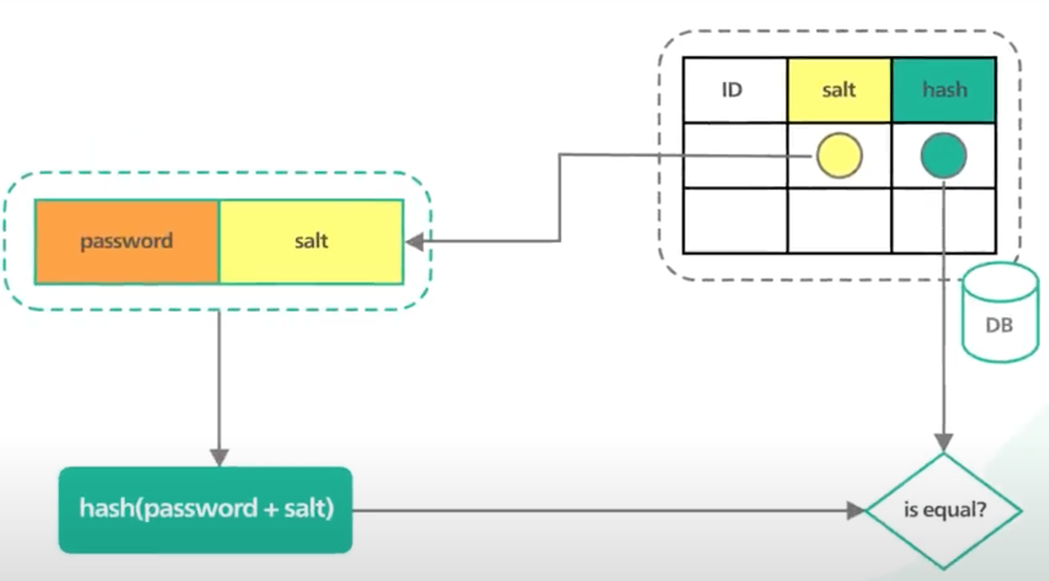

Zheng li is reading system design interview – an insider's guide: volume 2

system design interview – an insider's guide edition 2:

**CHAPTER 1: SCALE FROM ZERO TO MILLIONS OF USERS**

Single server:

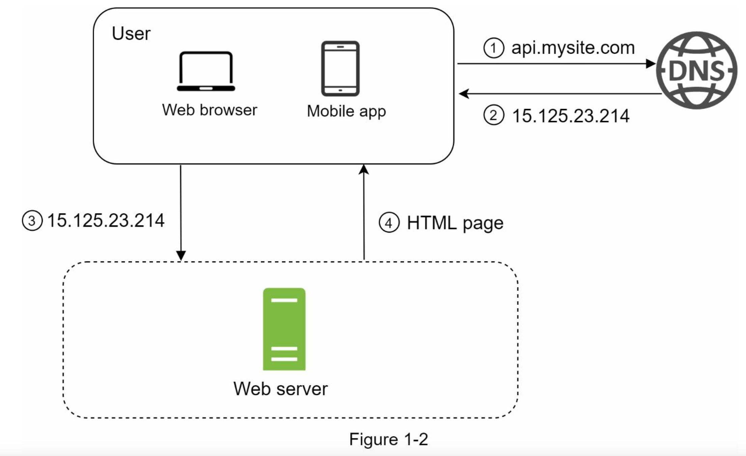

+ database server

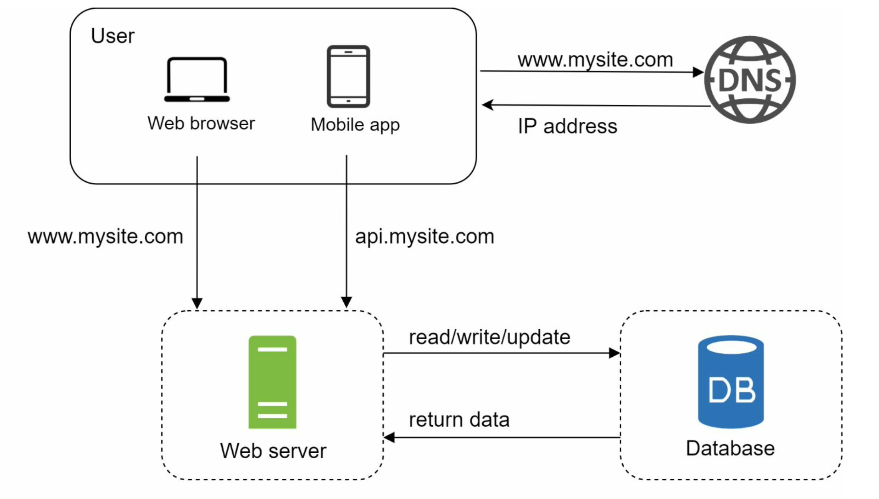

Relational databases are also called a relational database management system (RDBMS) or SQL database. The most popular ones are MySQL, Oracle database, PostgreSQL, etc. Relational databases represent and store data in tables and rows. You can perform join operations using SQL across different database tables.

Non-Relational databases are also called NoSQL databases. Popular ones are CouchDB, Neo4j, Cassandra, HBase, Amazon DynamoDB, etc. [2]. These databases are grouped into four categories: key-value stores, graph stores, column stores, and document stores. Join operations are generally not supported in non-relational databases.

For most developers, relational databases are the best option because they have been around for over 40 years and historically, they have worked well. However, if relational databases are not suitable for your specific use cases, it is critical to explore beyond relational databases. Non-relational databases might be the right choice if:

• Your application requires super-low latency.

• Your data are unstructured, or you do not have any relational data.

 • You only need to serialize and deserialize data (JSON, XML, YAML, etc.).

• You need to store a massive amount of data.

Vertical scaling, referred to as “scale up”, means the process of adding more power (CPU, RAM, etc.) to your servers. Horizontal scaling, referred to as “scale-out”, allows you to scale by adding more servers into your pool of resources.

When traffic is low, vertical scaling is a great option, and the simplicity of vertical scaling is its main advantage. Unfortunately, it comes with serious limitations.

• Vertical scaling has a hard limit. It is impossible to add unlimited CPU and memory to a single server.

• Vertical scaling does not have failover and redundancy. If one server goes down, the website/app goes down with it completely.

Horizontal scaling is more desirable for large scale applications due to the limitations of vertical scaling.

A load balancer is the best technique to address these problems.

A load balancer evenly distributes incoming traffic among web servers that are defined in a load-balanced set.

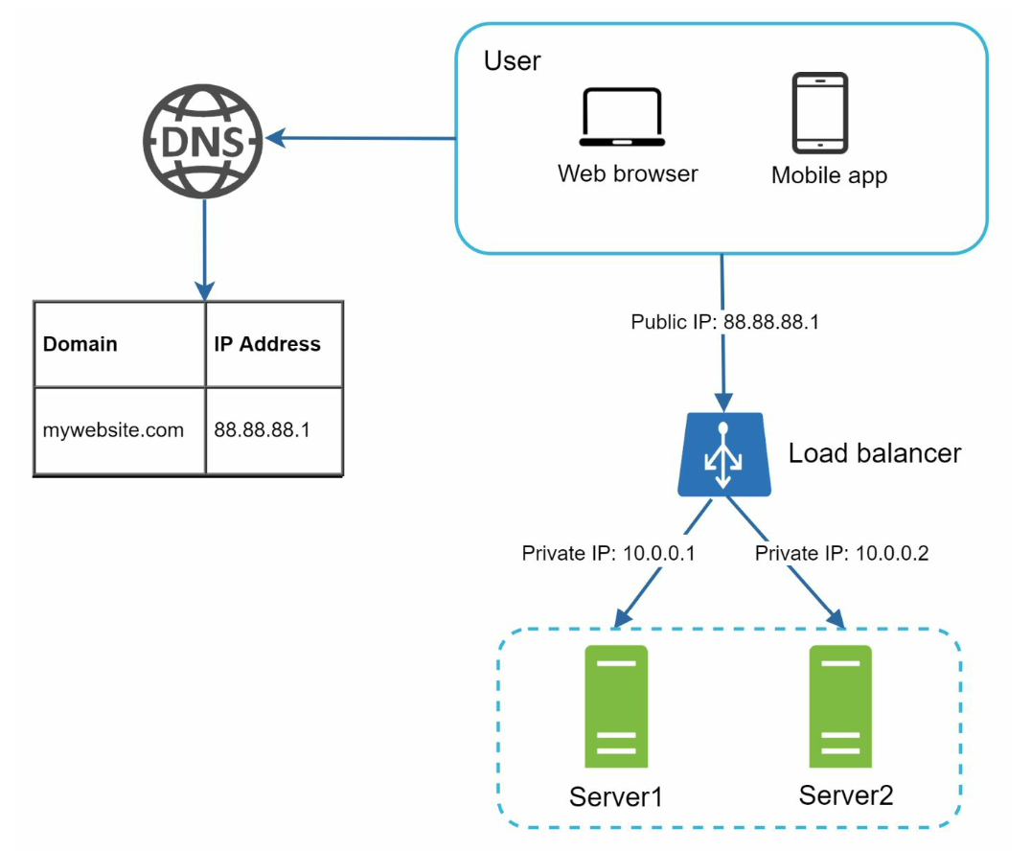

For better security, private IPs are used for communication between servers. A private IP is an IP address reachable only between servers in the same network; however, it is unreachable over the internet. The load balancer communicates with web servers through private IPs.

after a load balancer and a second web server are added, we successfully solved no failover issue and improved the availability of the web tier. Details are explained below:

• If server 1 goes offline, all the traffic will be routed to server 2. This prevents the website from going offline. We will also add a new healthy web server to the server pool to balance the load.

• If the website traffic grows rapidly, and two servers are not enough to handle the traffic, the load balancer can handle this problem gracefully. You only need to add more servers to the web server pool, and the load balancer automatically starts to send requests to them.

The current design has one database , so it does not support failover and redundancy. Database replication is a common technique to address those problems.

Database replication can be used in many database management systems, usually with a master/slave relationship between the original (master) and the copies (slaves)

A master database generally only supports write operations. A slave database gets copies of the data from the master database and only supports read operations.

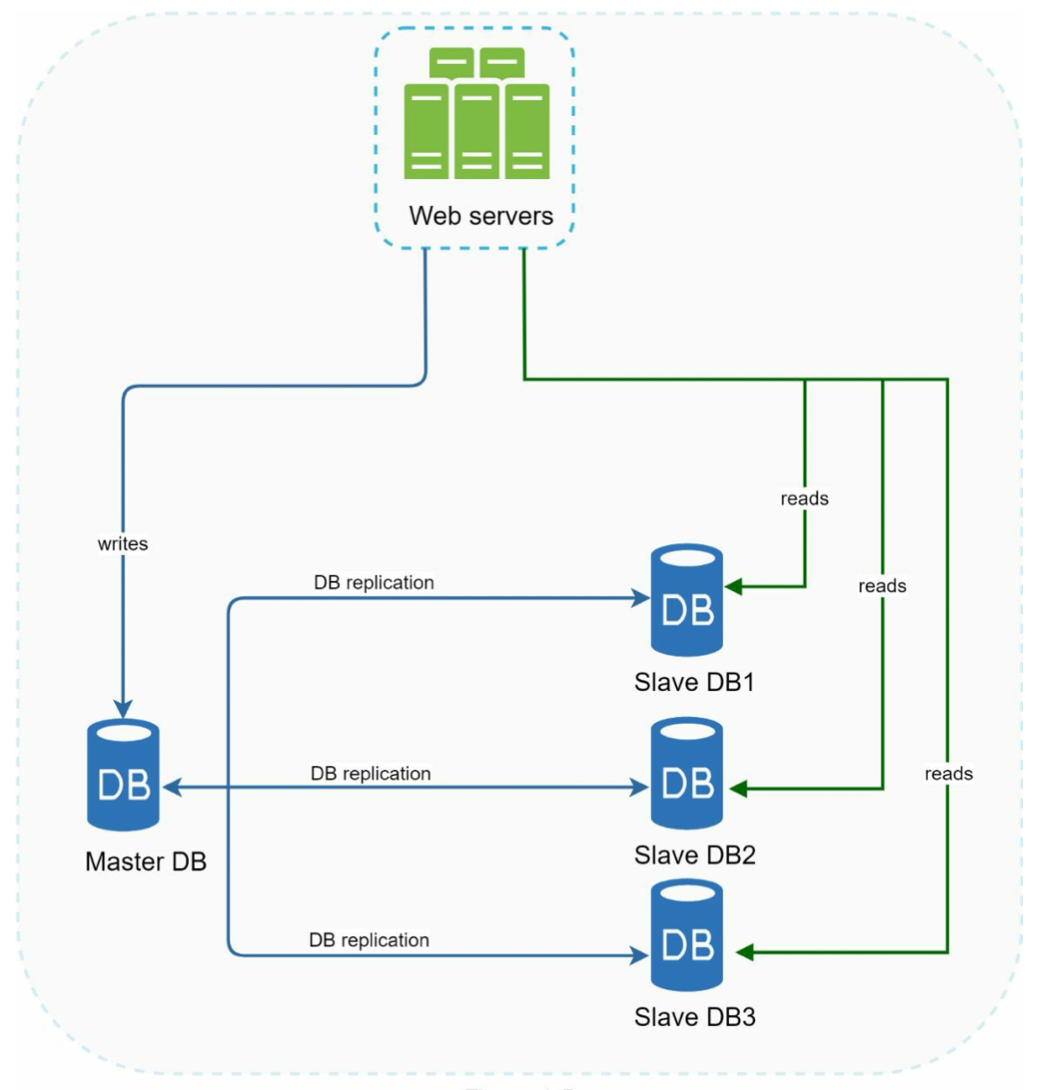

Advantages of database replication:

• Better performance: In the master-slave model, all writes and updates happen in master nodes; whereas, read operations are distributed across slave nodes. This model improves performance because it allows more queries to be processed in parallel.

• Reliability: If one of your database servers is destroyed by a natural disaster, such as a typhoon or an earthquake, data is still preserved. You do not need to worry about data loss because data is replicated across multiple locations.

• High availability: By replicating data across different locations, your website remains in operation even if a database is offline as you can access data stored in another database server.

what if one of the databases goes offline?

• If only one slave database is available and it goes offline, read operations will be directed to the master database temporarily. As soon as the issue is found, a new slave database will replace the old one. In case multiple slave databases are available, read operations are redirected to other healthy slave databases. A new database server will replace the old one.

• If the master database goes offline, a slave database will be promoted to be the new master. All the database operations will be temporarily executed on the new master database. A new slave database will replace the old one for data replication immediately. In production systems, promoting a new master is more complicated as the data in a slave database might not be up to date. The missing data needs to be updated by running data recovery scripts. Although some other replication methods like multi-masters and circular replication could help, those setups are more complicated

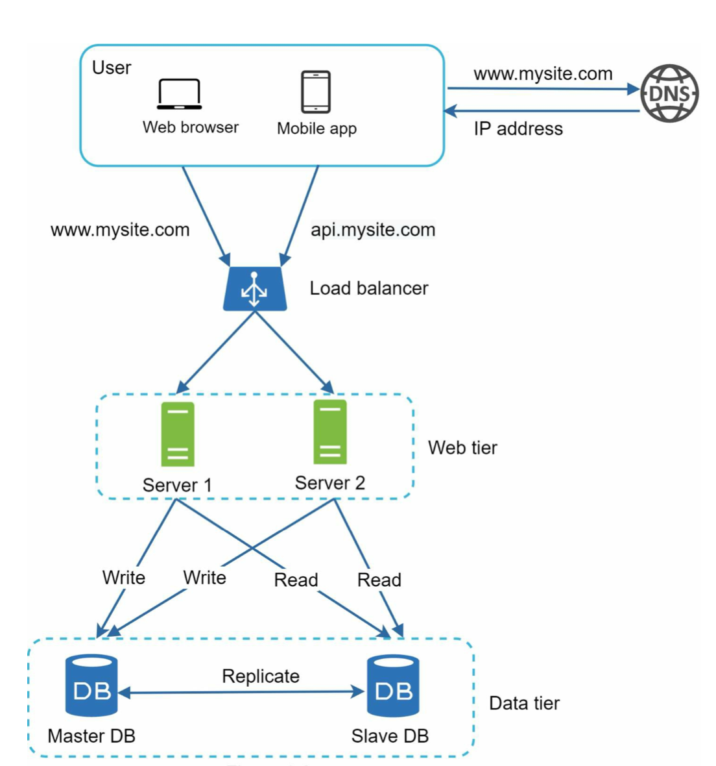

Now, you have a solid understanding of the web and data tiers, it is time to improve the load/response time. This can be done by adding a cache layer and shifting static content (JavaScript/CSS/image/video files) to the content delivery network (CDN).

A cache is a temporary storage area that stores the result of expensive responses or frequently accessed data in memory so that subsequent requests are served more quickly.

The cache tier is a temporary data store layer, much faster than the database. The benefits of having a separate cache tier include better system performance, ability to reduce database workloads, and the ability to scale the cache tier independently.

Figure 1-7 shows a possible setup of a cache server:

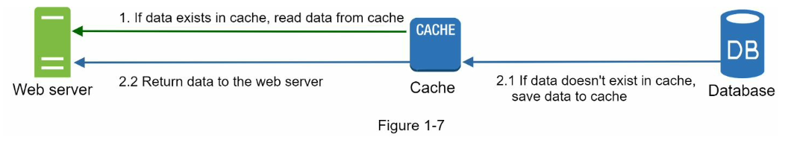

Interacting with cache servers is simple because most cache servers provide APIs for common programming languages. The following code snippet shows typical Memcached APIs:

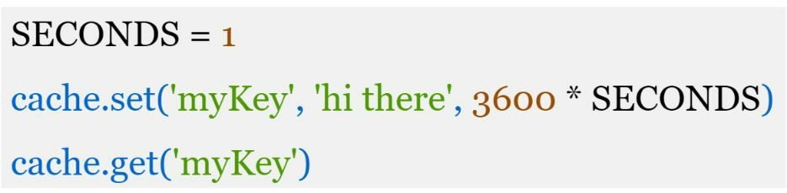

Here are a few considerations for using a cache system:

• Decide when to use cache. Consider using cache when data is read frequently but modified infrequently. Since cached data is stored in volatile memory, a cache server is not ideal for persisting data.

• Expiration policy. It is a good practice to implement an expiration policy. Once cached data is expired, it is removed from the cache. When there is no expiration policy, cached data will be stored in the memory permanently. It is advisable not to make the expiration date too short as this will cause the system to reload data from the database too frequently. Meanwhile, it is advisable not to make the expiration date too long as the data can become stale.

• Consistency: This involves keeping the data store and the cache in sync. Inconsistency can happen because data-modifying operations on the data store and cache are not in a single transaction. When scaling across multiple regions, maintaining consistency between the data store and cache is challenging**.** For further details, refer to the paper titled “Scaling Memcache at Facebook” published by Facebook [7].

• Mitigating failures: A single cache server represents a potential single point of failure (SPOF), defined in Wikipedia as follows: “A single point of failure (SPOF) is a part of a system that, if it fails, will stop the entire system from working” [8]. As a result, multiple cache servers across different data centers are recommended to avoid SPOF. Another recommended approach is to overprovision the required memory by certain percentages. This provides a buffer as the memory usage increases.

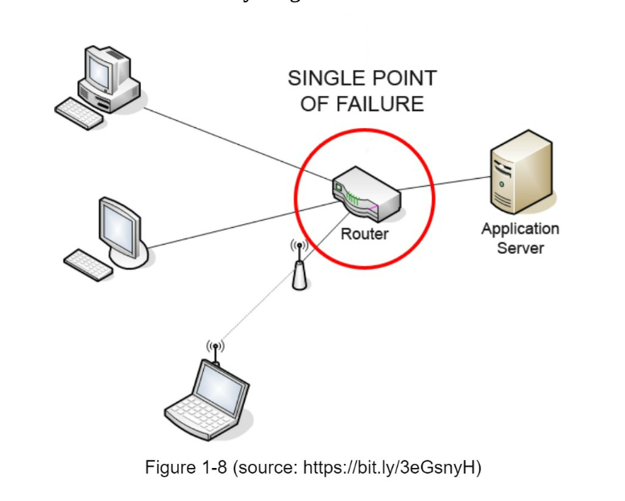

• Eviction Policy: Once the cache is full, any requests to add items to the cache might cause existing items to be removed. This is called cache eviction. Least-recently-used (LRU) is the most popular cache eviction policy. Other eviction policies, such as the Least Frequently Used (LFU) or First in First Out (FIFO), can be adopted to satisfy different use cases.

A CDN is a network of geographically dispersed servers used to deliver static content. CDN servers cache static content like images, videos, CSS, JavaScript files, etc.

CDN improves load time.

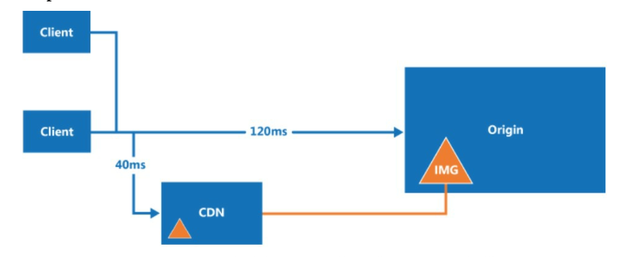

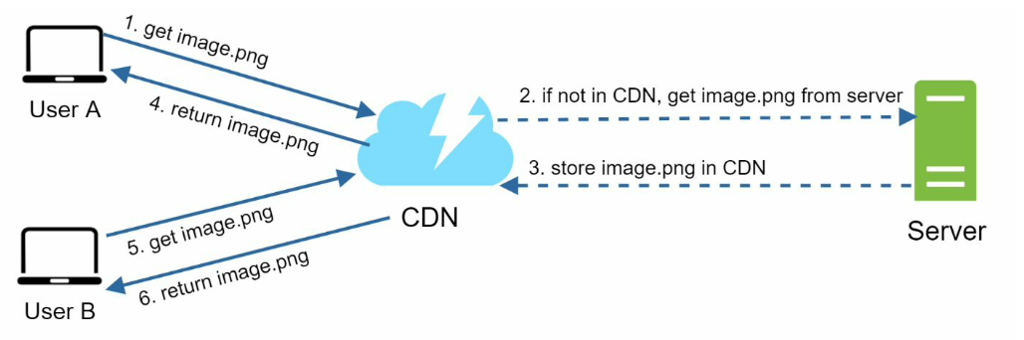

The image remains cached in the CDN until the TTL expires.

**Considerations of using a CDN**

• Cost: CDNs are run by third-party providers, and you are charged for data transfers in and out of the CDN. Caching infrequently used assets provides no significant benefits so you should consider moving them out of the CDN.

• Setting an appropriate cache expiry: For time-sensitive content, setting a cache expiry time is important. The cache expiry time should neither be too long nor too short. If it is too long, the content might no longer be fresh. If it is too short, it can cause repeat reloading of content from origin servers to the CDN.

• CDN fallback: You should consider how your website/application copes with CDN failure. If there is a temporary CDN outage, clients should be able to detect the problem and request resources from the origin.

• Invalidating files: You can remove a file from the CDN before it expires by performing one of the following operations:

• Invalidate the CDN object using APIs provided by CDN vendors.

• Use object versioning to serve a different version of the object. To version an object, you can add a parameter to the URL, such as a version number. For example, version number 2 is added to the query string: image.png?v=2.

the design after the CDN and cache are added：

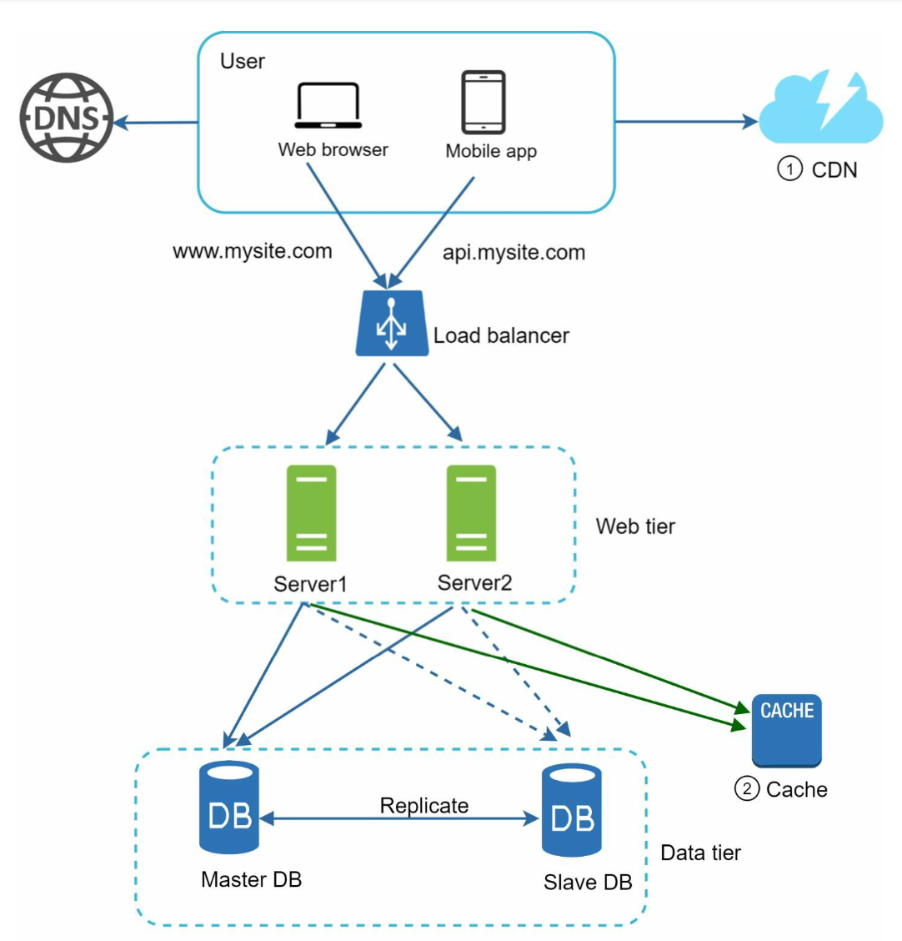

1. Static assets (JS, CSS, images, etc.,) are no longer served by web servers. They are fetched from the CDN for better performance.

2. The database load is lightened by caching data.

stateful architecture

A stateful server remembers client data (state) from one request to the next

The issue is that every request from the same client must be routed to the same server. This can be done with sticky sessions in most load balancers [10]; however, this adds the overhead. Adding or removing servers is much more difficult with this approach. It is also challenging to handle server failures.

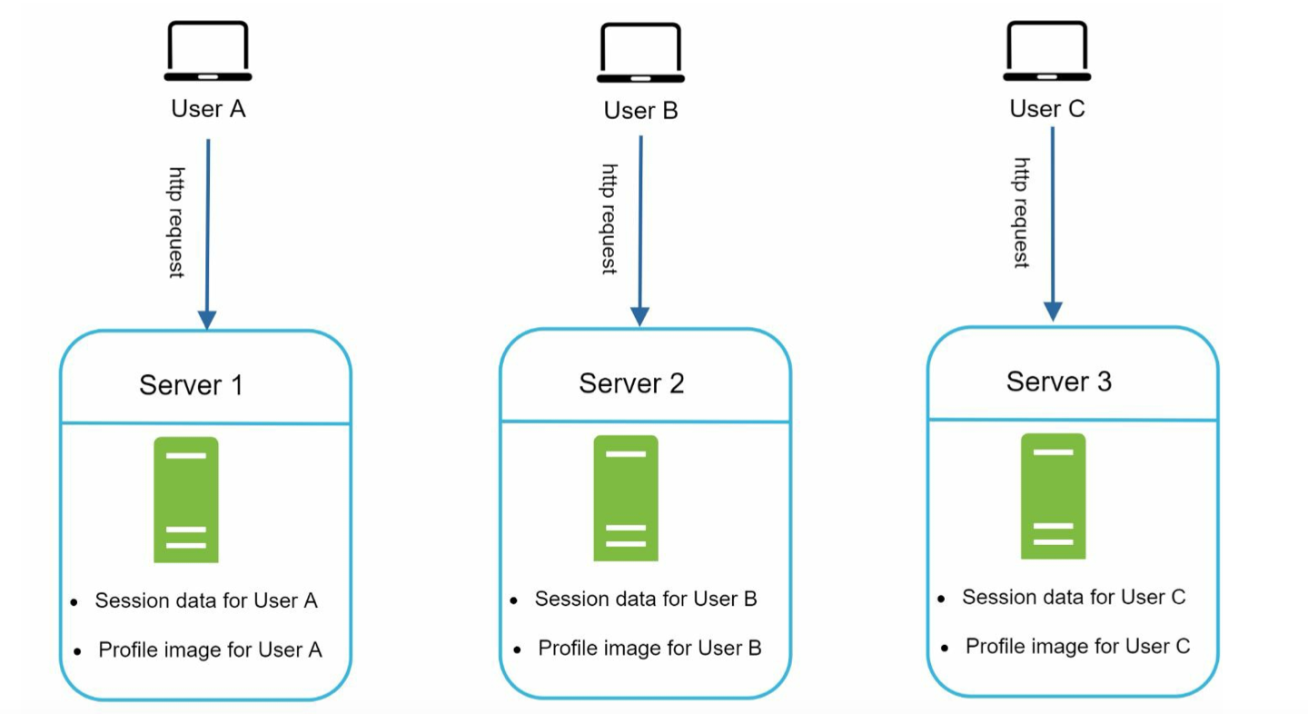

Stateless architecture ：

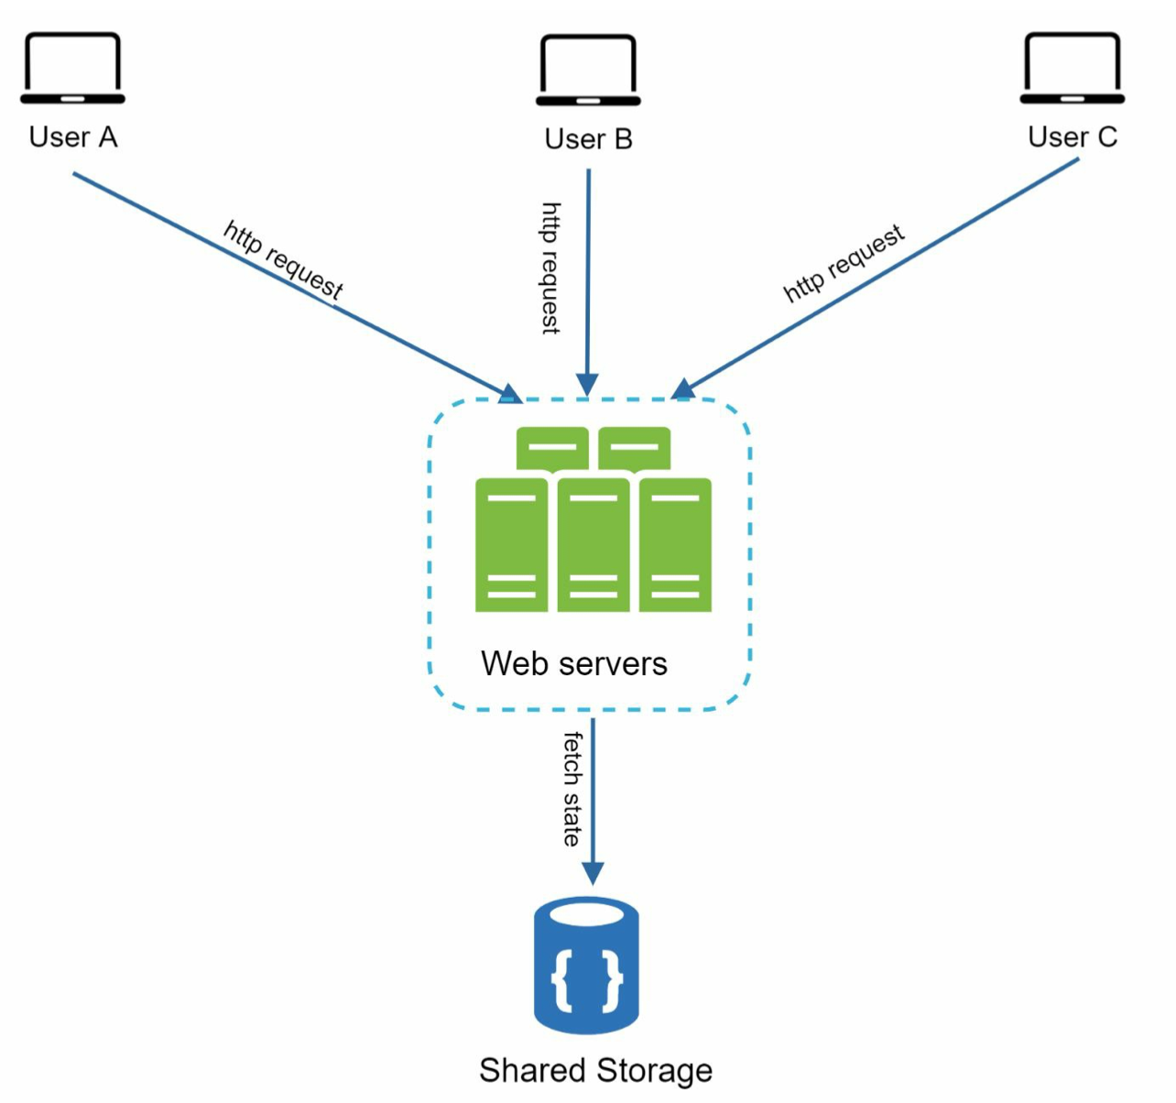

updated design with a stateless web tier

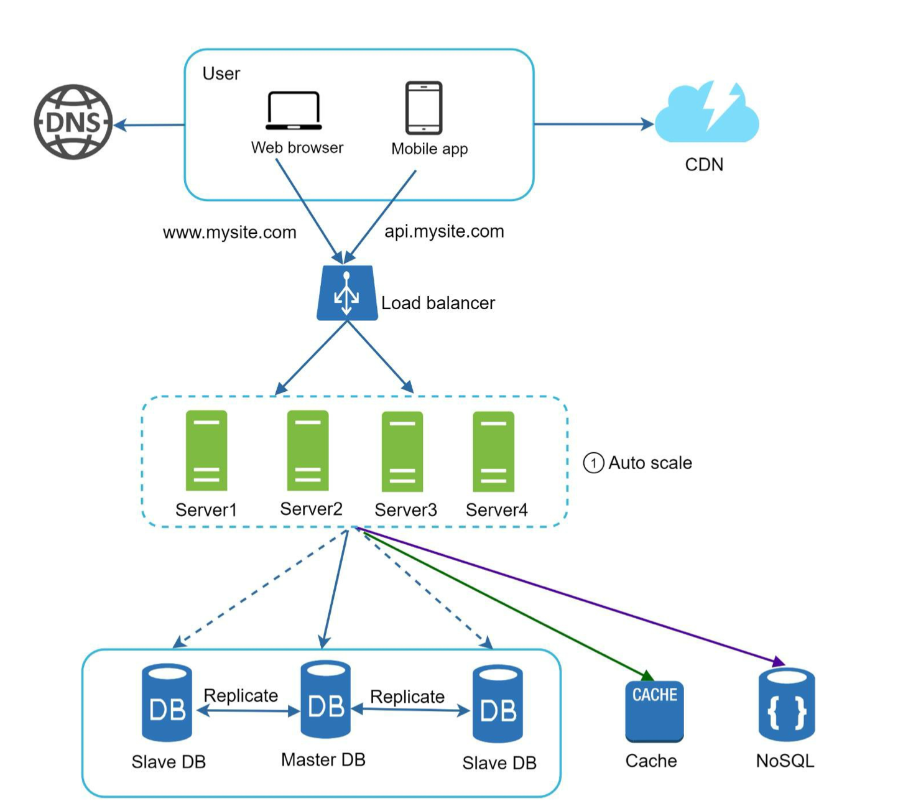

we move the session data out of the web tier and store them in the persistent data store. The shared data store could be a relational database, Memcached/Redis, NoSQL, etc. The NoSQL data store is chosen as it is easy to scale. Autoscaling means adding or removing web servers automatically based on the traffic load.

<https://medium.com/@t0ri/being-stateful-in-a-stateless-web-8185ed777048>

[The stateless web exists purposefully by design](https://restfulapi.net/statelessness/), but it can also be a restriction. If the server doesn’t store any information about what the client is up to, how did Medium remember you were logged in when you navigated to this page? Moreso, how did the server know *which*account you were logged into?

HTTP as “a stateless application-level protocol”.

because HTTP is stateless, the *server* doesn’t automatically know your information when you click a link and ask to be served a new response

The preferred solution is to use cookies to store a Session Id 🏷️ locally, but save the session data on server-side. An HTTP request can pass the Id from your cookies in your GET request, be looked up in a database of thousands of states from all clients 🗃️, and have the state sent back.

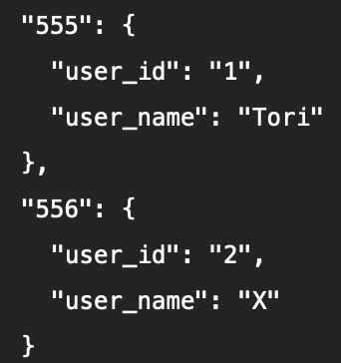

With Session Ids, the server is constantly creating and destroying states. Each state for each client at many different moments is being saved, and the Session Id stored in your cookies will be rewritten to reflect where your state is currently saved. Session data stored on a server is kept in key-value pairs, where 555 is my Session Id and 556 is yours.

Now when we send out that HTTP request asking for my Medium article, the conversation from before may look a little more like this:

**Client**: Hey, can you GET this article for session 555?  
**Server**: Of course, {555.user_name}! Coming right up!

Session Ids are preferred because the actual values and data is hidden from the client, not to mention that the developers are in control of the data and its expiration.

To improve availability and provide a better user experience across wider geographical areas, supporting multiple data centers is crucial.

an example setup with two data centers:

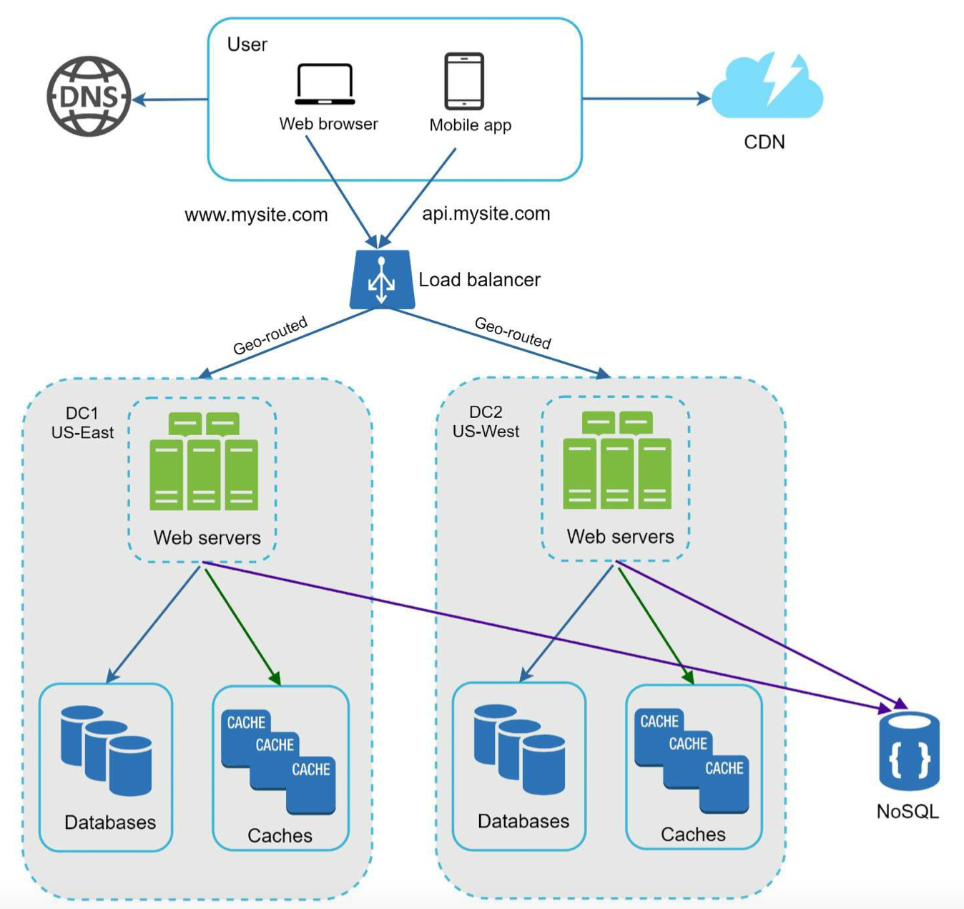

In normal operation, users are geoDNS-routed, also known as geo-routed, to the closest data center, with a split traffic of *x%* in US-East and *(100 – x)%* in US-West. geoDNS is a DNS service that allows domain names to be resolved to IP addresses based on the location of a user.

In the event of any significant data center outage, we direct all traffic to a healthy data center:

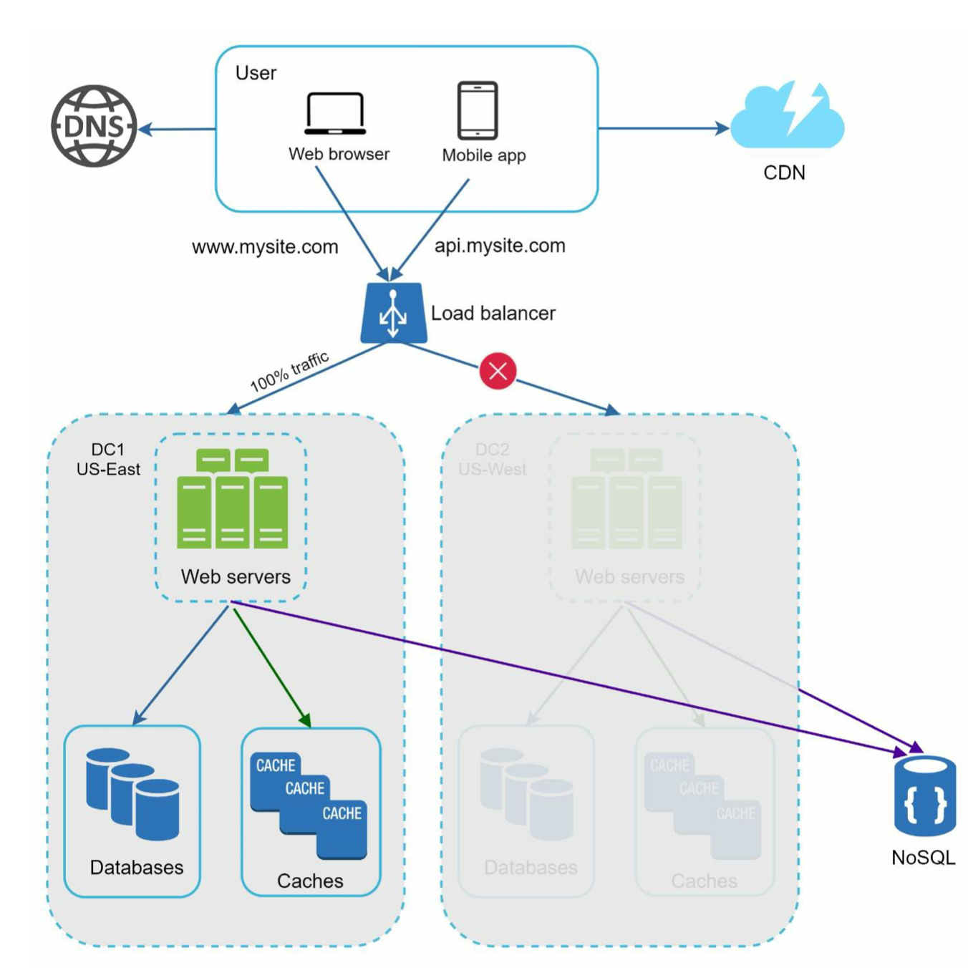

Several technical challenges must be resolved to achieve multi-data center setup:

• Traffic redirection: Effective tools are needed to direct traffic to the correct data center. GeoDNS can be used to direct traffic to the nearest data center depending on where a user is located.

• Data synchronization: Users from different regions could use different local databases or caches. In failover cases, traffic might be routed to a data center where data is unavailable. A common strategy is to replicate data across multiple data centers. A previous study shows how Netflix implements asynchronous multi-data center replication [11].

• Test and deployment: With multi-data center setup, it is important to test your website/application at different locations. Automated deployment tools are vital to keep services consistent through all the data centers [11].

**Message queue**

To further scale our system, we need to decouple different components of the system so they can be scaled independently. Messaging queue is a key strategy employed by many real- world distributed systems to solve this problem.

A message queue is a durable component, stored in memory, that supports asynchronous communication.

Input services, called producers/publishers, create messages, and publish them to a message queue. Other services or servers, called consumers/subscribers, connect to the queue, and perform actions defined by the messages.

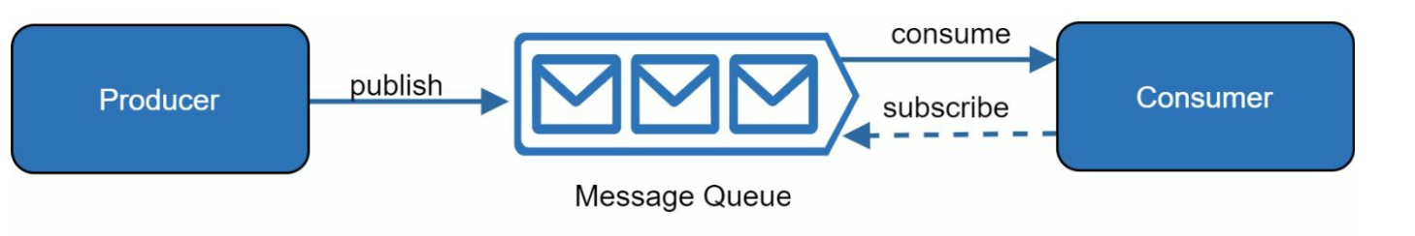

e.g. The producer and the consumer can be scaled independently. When the size of the queue becomes large, more workers are added to reduce the processing time. However, if the queue is empty most of the time, the number of workers can be reduced.

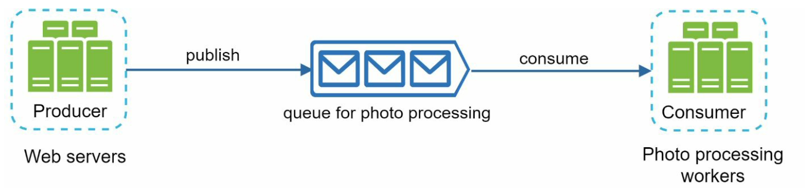

Logging: Monitoring error logs is important because it helps to identify errors and problems in the system. You can monitor error logs at per server level or use tools to aggregate them to a centralized service for easy search and viewing.

Metrics: Collecting different types of metrics help us to gain business insights and understand the health status of the system. Some of the following metrics are useful:

• Host level metrics: CPU, Memory, disk I/O, etc.

• Aggregated level metrics: for example, the performance of the entire database tier, cache tier, etc.

• Key business metrics: daily active users, retention, revenue, etc.

Automation: When a system gets big and complex, we need to build or leverage automation tools to improve productivity. Continuous integration is a good practice, in which each code check-in is verified through automation, allowing teams to detect problems early. Besides, automating your build, test, deploy process, etc. could improve developer productivity significantly.

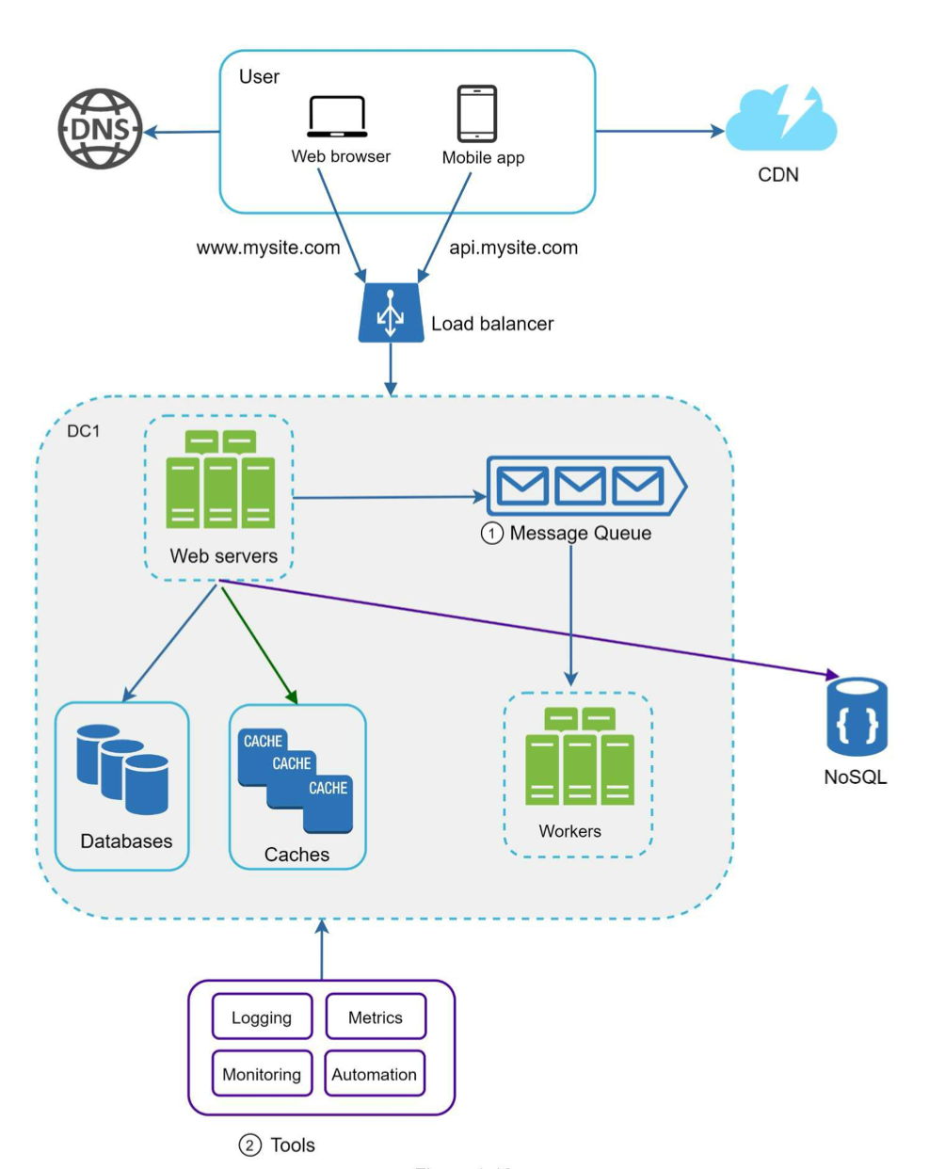

As the data grows every day, your database gets more overloaded. It is time to scale the data tier.

**Database scaling**

Vertical scaling, also known as scaling up, is the scaling by adding more power (CPU, RAM, DISK, etc.) to an existing machine.

However, vertical scaling comes with some serious drawbacks:

• You can add more CPU, RAM, etc. to your database server, but there are hardware limits. If you have a large user base, a single server is not enough.

• Greater risk of single point of failures. • The overall cost of vertical scaling is high. Powerful servers are much more expensive.

Horizontal scaling, also known as sharding, is the practice of adding more servers.

Sharding separates large databases into smaller, more easily managed parts called shards. Each shard shares the same schema, though the actual data on each shard is unique to the shard.

an example of sharded databases. User data is allocated to a database server based on user IDs. Anytime you access data, a hash function is used to find the corresponding shard. In our example, *user_id % 4* is used as the hash function.

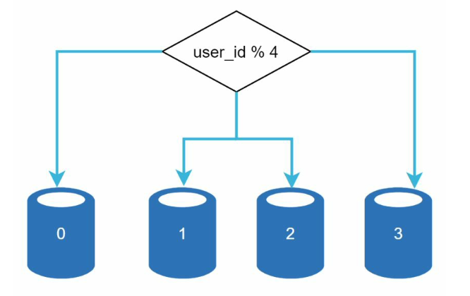

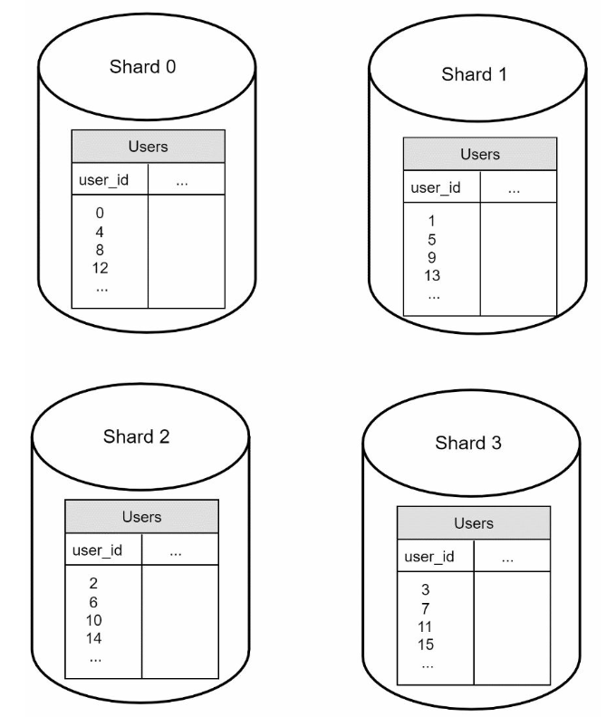

The most important factor to consider when implementing a sharding strategy is the choice of the sharding key. Sharding key (known as a partition key) consists of one or more columns that determine how data is distributed. In the example above user_id is sharding key

Sharding is a great technique to scale the database but it is far from a perfect solution. It introduces complexities and new challenges to the system:

**Resharding data**: Resharding data is needed when 1) a single shard could no longer hold more data due to rapid growth. 2) Certain shards might experience shard exhaustion faster than others due to uneven data distribution. When shard exhaustion happens, it requires updating the sharding function and moving data around. Consistent hashing, which will be discussed in Chapter 5, is a commonly used technique to solve this problem.

**Celebrity problem**: This is also called a hotspot key problem. Excessive access to a specific shard could cause server overload. Imagine data for Katy Perry, Justin Bieber, and Lady Gaga all end up on the same shard. For social applications, that shard will be overwhelmed with read operations. To solve this problem, we may need to allocate a shard for each celebrity. Each shard might even require further partition.

**Join and de-normalization**: Once a database has been sharded across multiple servers, it is hard to perform join operations across database shards. A common workaround is to de- normalize the database so that queries can be performed in a single table.

<https://www.guru99.com/database-normalization.html>

**Normalization** is a database design technique that reduces data redundancy and eliminates undesirable characteristics like Insertion, Update and Deletion Anomalies. Normalization rules divides larger tables into smaller tables and links them using relationships. The purpose of Normalisation in SQL is to eliminate redundant (repetitive) data and ensure data is stored logically.

In Figure 1-23, we shard databases to support rapidly increasing data traffic. At the same time, some of the non-relational functionalities are moved to a NoSQL data store to reduce the database load.

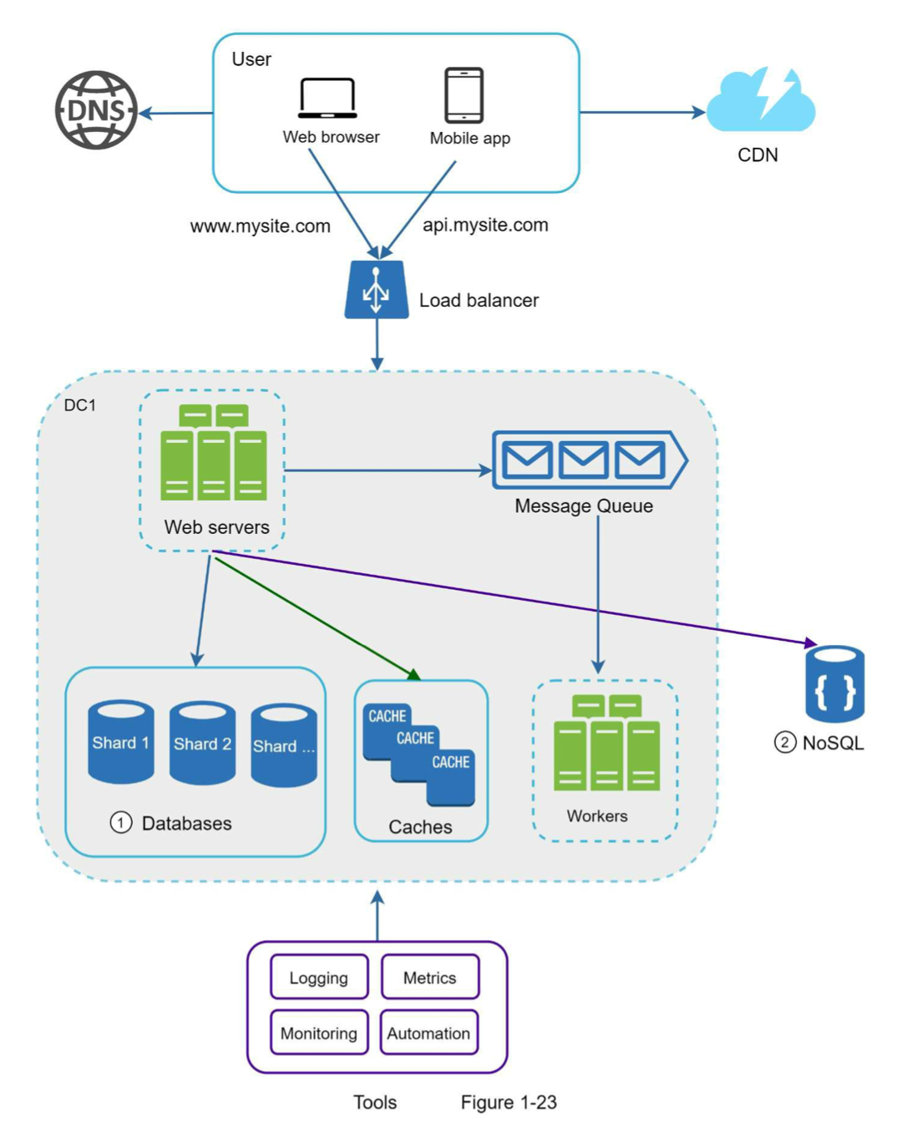

Scaling a system is an iterative process. Iterating on what we have learned in this chapter could get us far. More fine-tuning and new strategies are needed to scale beyond millions of users. For example, you might need to optimize your system and decouple the system to even smaller services.

we provide a summary of how we scale our system to support millions of users:

• Keep web tier stateless

• Build redundancy at every tier

• Cache data as much as you can

• Support multiple data centers

• Host static assets in CDN

• Scale your data tier by sharding

• Split tiers into individual services

• Monitor your system and use automation tools

power of 2: A byte is a sequence of 8 bits. An ASCII character uses one byte of memory (8 bits).

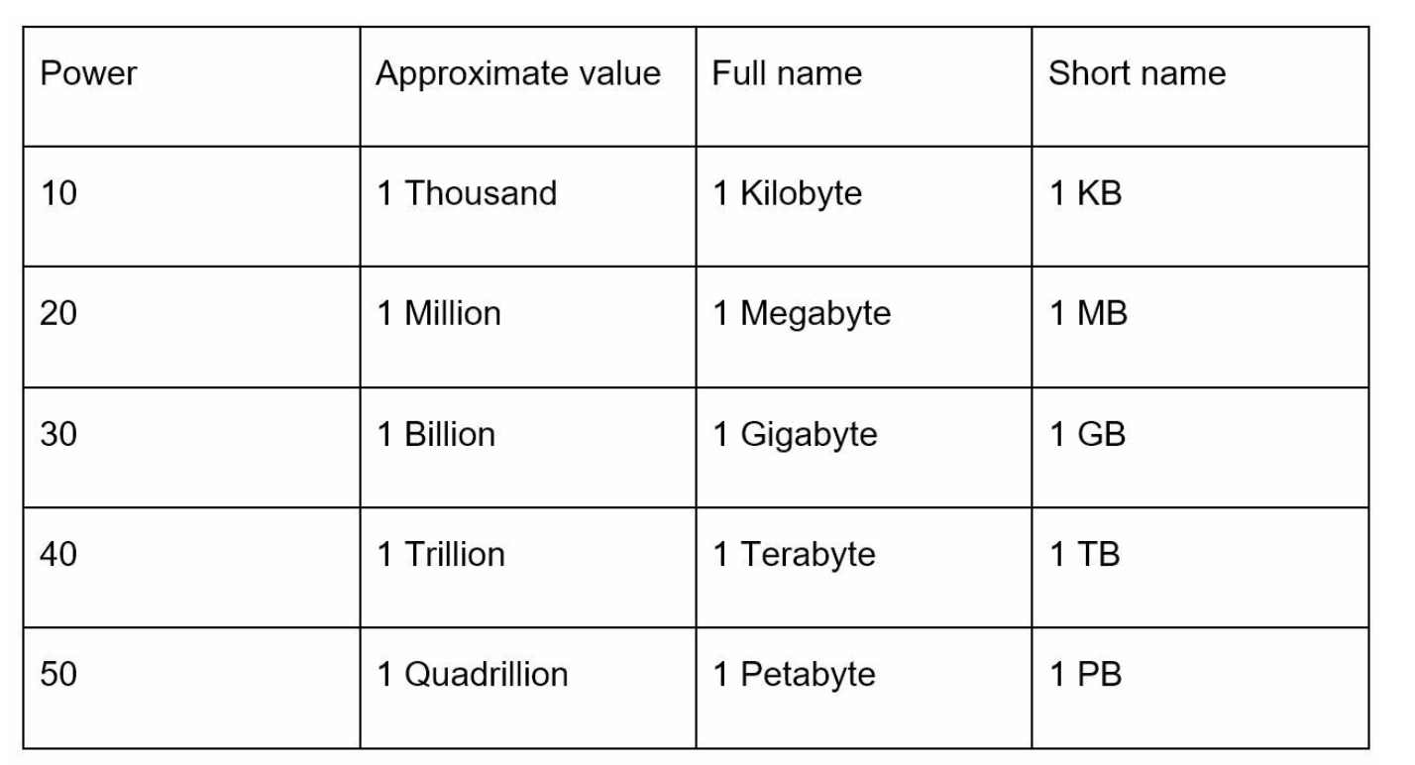

**Latency numbers every programmer should know**

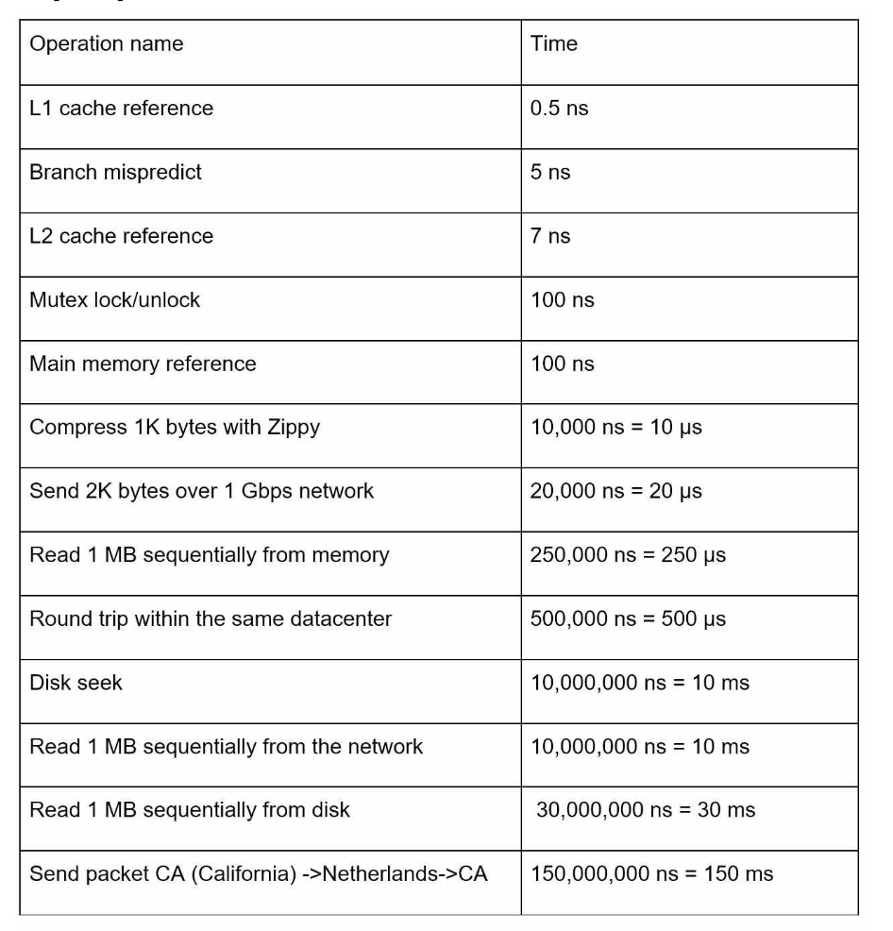

ns = nanosecond, μs = microsecond, ms = millisecond 1 ns = 10^-9 seconds 1 μs= 10^-6 seconds = 1,000 ns 1 ms = 10^-3 seconds = 1,000 μs = 1,000,000 ns

• Memory is fast but the disk is slow.

• Avoid disk seeks if possible.

• Simple compression algorithms are fast.

• Compress data before sending it over the internet if possible.

• Data centers are usually in different regions, and it takes time to send data between them.

**Availability numbers**

High availability is the ability of a system to be continuously operational for a desirably long period of time. High availability is measured as a percentage, with 100% means a service that has 0 downtime. Most services fall between 99% and 100%.

A service level agreement (SLA) is a commonly used term for service providers. This is an agreement between you (the service provider) and your customer, and this agreement formally defines the level of uptime your service will deliver. Cloud providers Amazon [4], Google [5] and Microsoft [6] set their SLAs at 99.9% or above. Uptime is traditionally measured in nines. The more the nines, the better.

Query per second (QPS) estimate:

Assumptions:

• 300 million monthly active users.

• 50% of users use Twitter daily.

• Users post 2 tweets per day on average.

• 10% of tweets contain media.

• Data is stored for 5 years.

• Daily active users (DAU) = 300 million * 50% = 150 million

• Tweets QPS = 150 million * 2 tweets / 24 hour / 3600 seconds = ~3500 • PeekQPS=2*QPS=~7000

We will only estimate media storage here.

• Average tweet size:

• tweet_id 64 bytes

• text 140 bytes

• media 1MB

• Mediastorage:150million*2*10%*1MB=30TBperday

• 5-yearmediastorage:30TB*365*5=~55PB

Back-of-the-envelope estimation is all about the process. Solving the problem is more important than obtaining results. Interviewers may test your problem-solving skills. Here are a few tips to follow:

• Rounding and Approximation. “100,000 / 10” instead of “99987 / 9.1”

• Write down your assumptions.

• Label your units. When you write down “5”, does it mean 5 KB or 5 MB?

• Commonly asked back-of-the-envelope estimations: QPS, peak QPS, storage, cache, number of servers, etc.

The system design interview simulates real-life problem solving where two co-workers collaborate on an ambiguous problem and come up with a solution that meets their goals. The problem is open-ended, and there is no perfect answer. The final design is less important compared to the work you put in the design process. This allows you to demonstrate your design skill, defend your design choices, and respond to feedback in a constructive manner.

An effective system design interview gives strong signals about a person's ability to collaborate, to work under pressure, and to resolve ambiguity constructively. The ability to ask good questions is also an essential skill, and many interviewers specifically look for this skill.

A good interviewer also looks for red flags. **Over-engineering** is a real disease of many engineers as they delight in design purity and ignore tradeoffs. Other red flags include **narrow mindedness, stubbornness**, etc.

Answering without a thorough understanding of the requirements is **a huge red flag** as the interview is not a trivia contest. There is no right answer. So, do not jump right in to give a solution. **Slow down.** Think deeply and ask questions to clarify requirements and assumptions. This is **extremely** important.

**Step 1 - Understand the problem and establish design scope**

One of the most important skills as an engineer is to ask the right questions, make the proper assumptions, and gather all the information needed to build a system. So, do not be afraid to ask questions.

write down your assumptions on the whiteboard or paper. You might need them later.

Here is a list of questions to help you get started:

• What specific features are we going to build?

• How many users does the product have?

• How fast does the company anticipate to scale up? What are the anticipated scales in 3 months, 6 months, and a year?

• What is the company’s technology stack? What existing services you might leverage to simplify the design?

If you are asked to design a news feed system, you want to ask questions that help you clarify the requirements.

**Candidate**: Is this a mobile app? Or a web app? Or both?

**Candidate**: What are the most important features for the product?

**Candidate**: Is the news feed sorted in reverse chronological order or a particular order? The particular order means each post is given a different weight. For instance, posts from your close friends are more important than posts from a group.

**Candidate**: How many friends can a user have?

**Candidate**: What is the traffic volume?

**Candidate**: Can feed contain images, videos, or just text?

**Step 2 - Propose high-level design and get buy-in**

• Come up with an initial blueprint for the design. Ask for feedback. Treat your interviewer as a teammate and work together.

• Draw box diagrams with key components on the whiteboard or paper. This might include clients (mobile/web), APIs, web servers, data stores, cache, CDN, message queue, etc.

• Do back-of-the-envelope calculations to evaluate if your blueprint fits the scale constraints. Think out loud. Communicate with your interviewer if back-of-the-envelope is necessary before diving into it.

If possible, go through a few concrete use cases.

Should we include API endpoints and database schema here? This depends on the problem. For large design problems like “Design Google search engine”, this is a bit of too low level. For a problem like designing the backend for a multi-player poker game, this is a fair game. Communicate with your interviewer.

Let us use “Design a news feed system” to demonstrate how to approach the high-level design. Here you are not required to understand how the system actually works.

• Feed publishing: when a user publishes a post, corresponding data is written into cache/database, and the post will be populated into friends’ news feed.

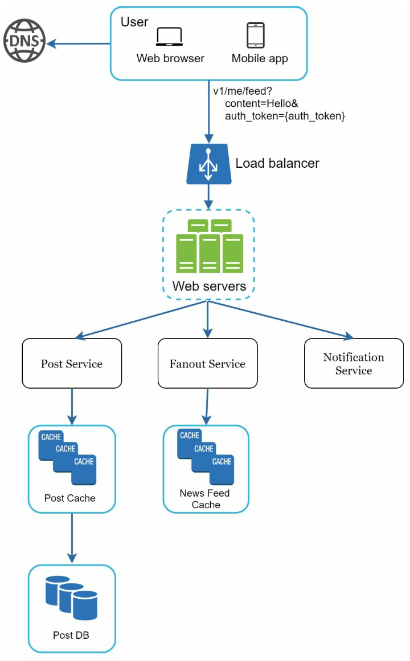

Fan-out is a messaging pattern where messages are broadcast in a one-to-many arrangement. A basic example of this pattern can be seen in the functionality of a [Publish/Subscribe messaging system](https://www.pubnub.com/learn/glossary/what-is-publish-subscribe/), as Pub/Sub implies the ability to route messages from a single sender to multiple receivers. : <https://www.pubnub.com/learn/glossary/what-is-fan-out-software/>

Publish/Subscribe: <https://www.pubnub.com/learn/glossary/what-is-publish-subscribe/>

• Newsfeed building: the news feed is built by aggregating friends’ posts in a reverse chronological order.

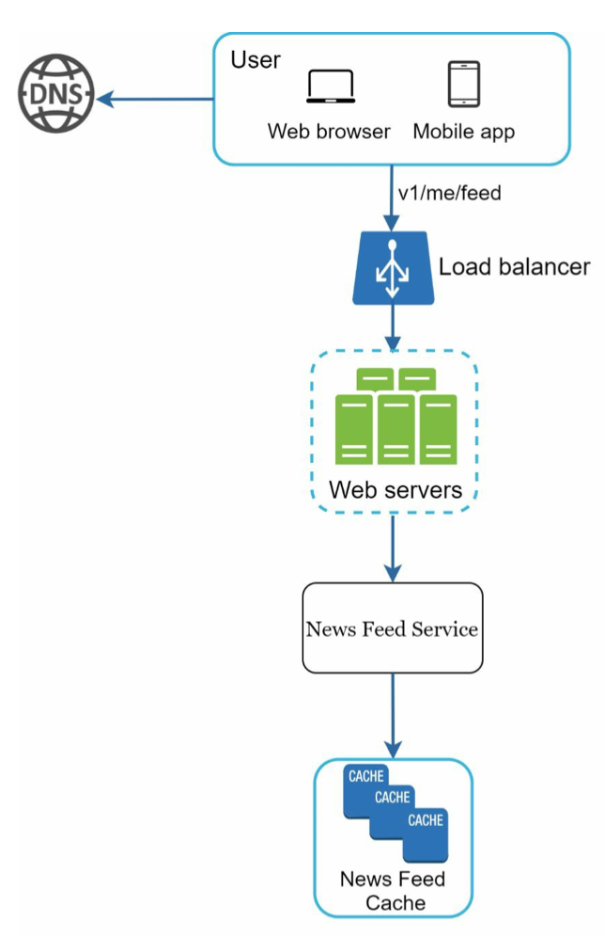

**Step 3 - Design deep dive**

Try not to get into unnecessary details. For example, talking about the EdgeRank algorithm of Facebook feed ranking in detail is not ideal during a system design interview as this takes much precious time and does not prove your ability in designing a scalable system.

**Example**

two of the most important use cases:

1. Feed publishing 2. News feed retrieval

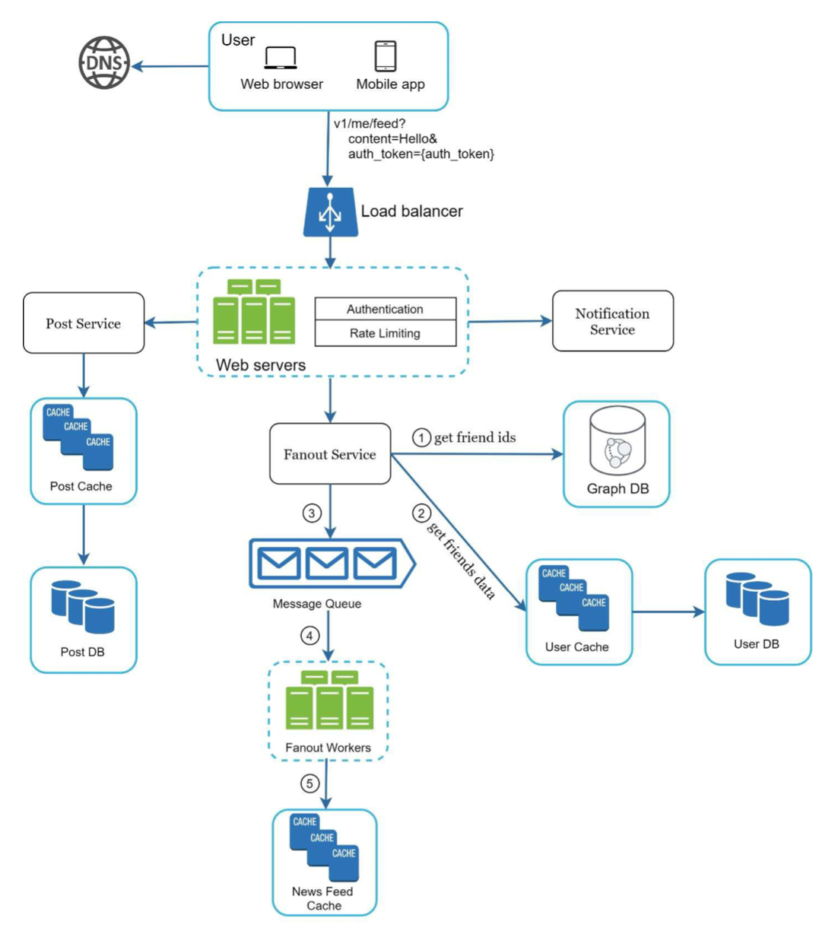

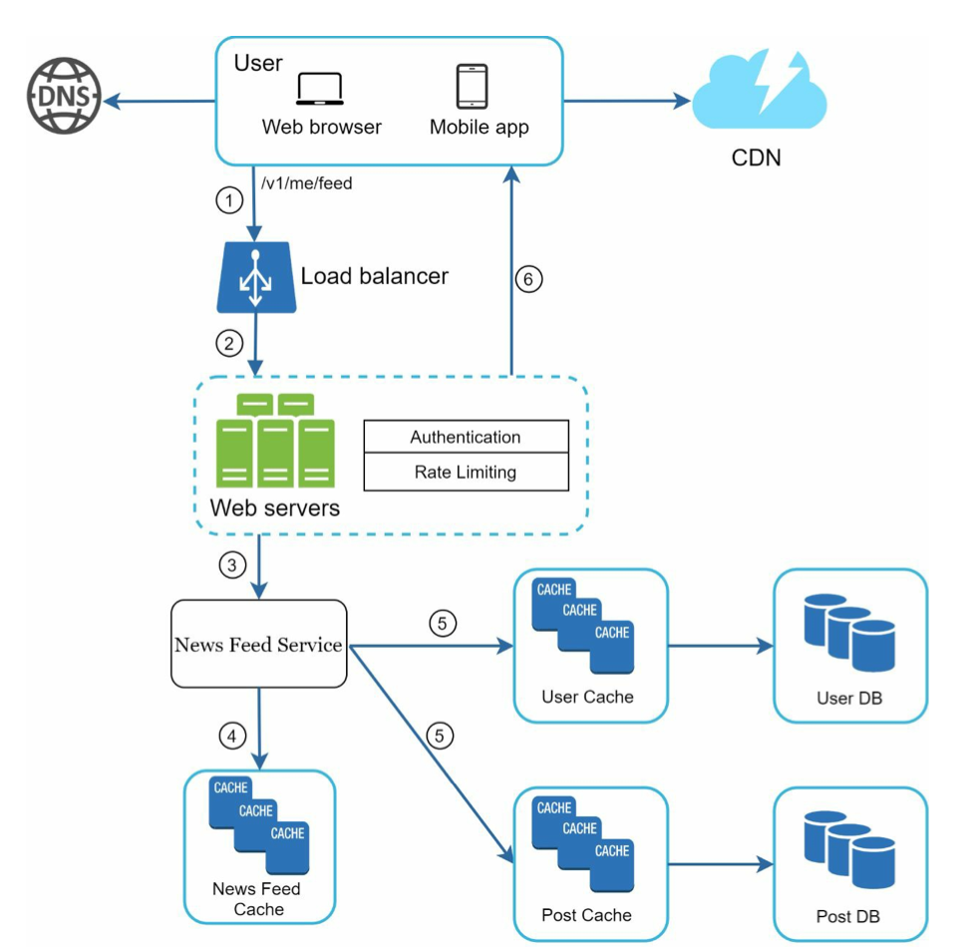

A rate limiting algorithm is **used to check if the user session (or IP address) has to be limited based on the information in the session cache**. In case a client made too many requests within a given time frame, HTTP servers can respond with status code 429: Too Many Requests.

**Step 4 - Wrap up**

In this final step, the interviewer might ask you a few follow-up questions or give you the freedom to discuss other additional points.

• The interviewer might want you to identify the system bottlenecks and discuss potential improvements.

• It could be useful to give the interviewer a recap of your design. This is particularly important if you suggested a few solutions.

• Error cases (server failure, network loss, etc.) are interesting to talk about.

• Operation issues are worth mentioning. How do you monitor metrics and error logs? How to roll out the system?

• How to handle the next scale curve is also an interesting topic. For example, if your current design supports 1 million users, what changes do you need to make to support 10 million users?

Summary:

• There is neither the right answer nor the best answer. A solution designed to solve the problems of a young startup is different from that of an established company with millions of users. Make sure you understand the requirements.

• Communicate

• high level first, then go into details

Step 1 Understand the problem and establish design scope: 3 - 10 minutes

Step 2 Propose high-level design and get buy-in: 10 - 15 minutes

Step 3 Design deep dive: 10 - 25 minutes

Step 4 Wrap: 3 - 5 minutes

In the HTTP world, a **rate limiter** limits the number of client requests allowed to be sent over a specified period. If the API request count exceeds the threshold defined by the rate limiter, all the excess calls are blocked. Here are a few examples:

• A user can write no more than 2 posts per second.

• You can create a maximum of 10 accounts per day from the same IP address.

• You can claim rewards no more than 5 times per week from the same device.

­

the benefits of using an API rate limiter:

• Prevent resource starvation caused by Denial of Service (DoS) attack [1]. Almost all APIs published by large tech companies enforce some form of rate limiting. For example, Twitter limits the number of tweets to 300 per 3 hours [2]

• Reduce cost. Limiting excess requests means fewer servers and allocating more resources to high priority APIs. Rate limiting is extremely important for companies that use paid third party APIs.

• Prevent servers from being overloaded. To reduce server load, a rate limiter is used to filter out excess requests caused by bots or users’ misbehavior.

**Step 1 - Understand the problem and establish design scope**

**Candidate**: What kind of rate limiter are we going to design? Is it a client-side rate limiter or server-side API rate limiter?

Candidate: Does the rate limiter throttle API requests based on IP, the user ID, or other properties?

**Candidate**: What is the scale of the system? Is it built for a startup or a big company with a large user base?

Candidate: Will the system work in a distributed environment?

**Candidate**: Do we need to inform users who are throttled?

**Requirements**

Here is a summary of the requirements for the system:

• Accurately limit excessive requests.

• Low latency. The rate limiter should not slow down HTTP response time.

• Use as little memory as possible.

• Distributed rate limiting. The rate limiter can be shared across multiple servers or processes.

• Exception handling. Show clear exceptions to users when their requests are throttled.

• High fault tolerance. If there are any problems with the rate limiter (for example, a cache server goes offline), it does not affect the entire system.

Here is a summary of the requirements for the system:

• Accurately limit excessive requests.

• Low latency. The rate limiter should not slow down HTTP response time.

• Use as little memory as possible.

• Distributed rate limiting. The rate limiter can be shared across multiple servers or processes.

• Exception handling. Show clear exceptions to users when their requests are throttled.

• High fault tolerance. If there are any problems with the rate limiter (for example, a cache server goes offline), it does not affect the entire system.

**Step 2 - Propose high-level design and get buy-in**

**Where to put the rate limiter?**

• Client-side implementation. Generally speaking, client is an unreliable place to enforce rate limiting because client requests can easily be forged by malicious actors. Moreover, we might not have control over the client implementation.

• Server-side implementation.

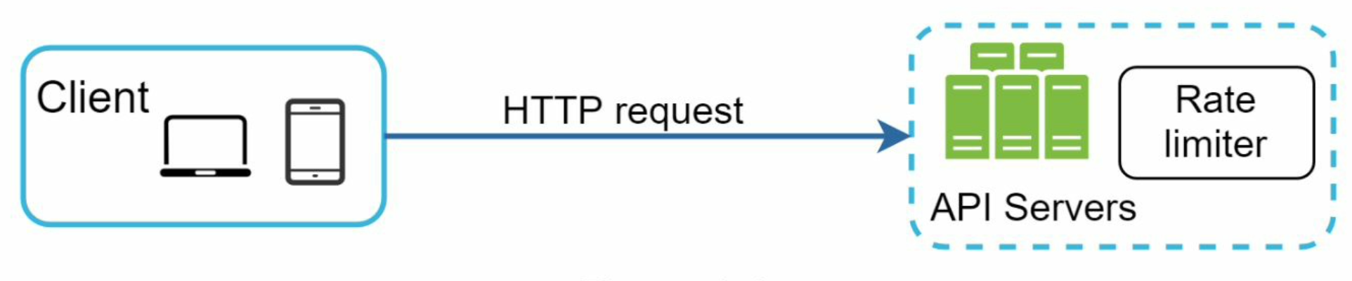

Besides the client and server-side implementations, there is an alternative way. Instead of putting a rate limiter at the API servers, we create a rate limiter middleware, which throttles requests to your APIs as shown in Figure 4-2.

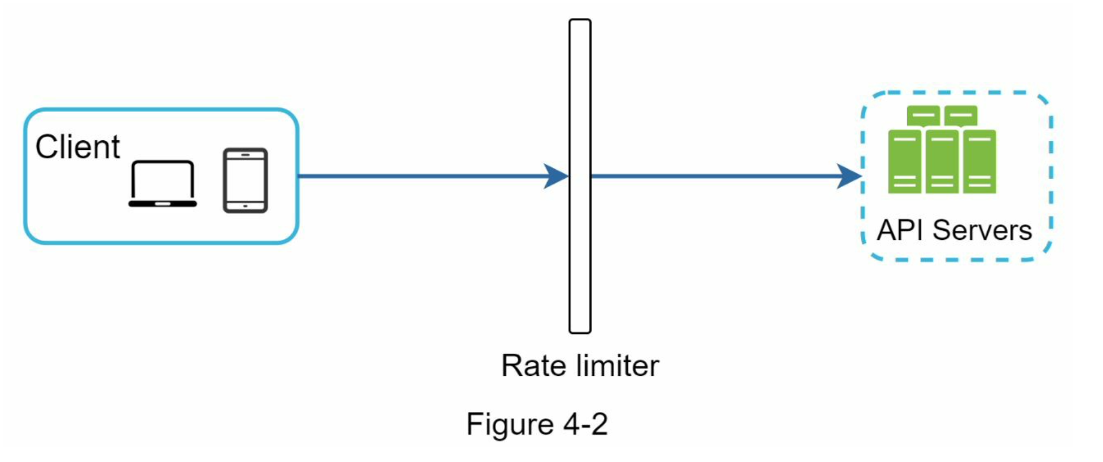

Assume our API allows 2 requests per second, and a client sends 3 requests to the server within a second. The first two requests are routed to API servers. However, the rate limiter middleware throttles the third request and returns a HTTP status code 429. The HTTP 429 response status code indicates a user has sent too many requests.

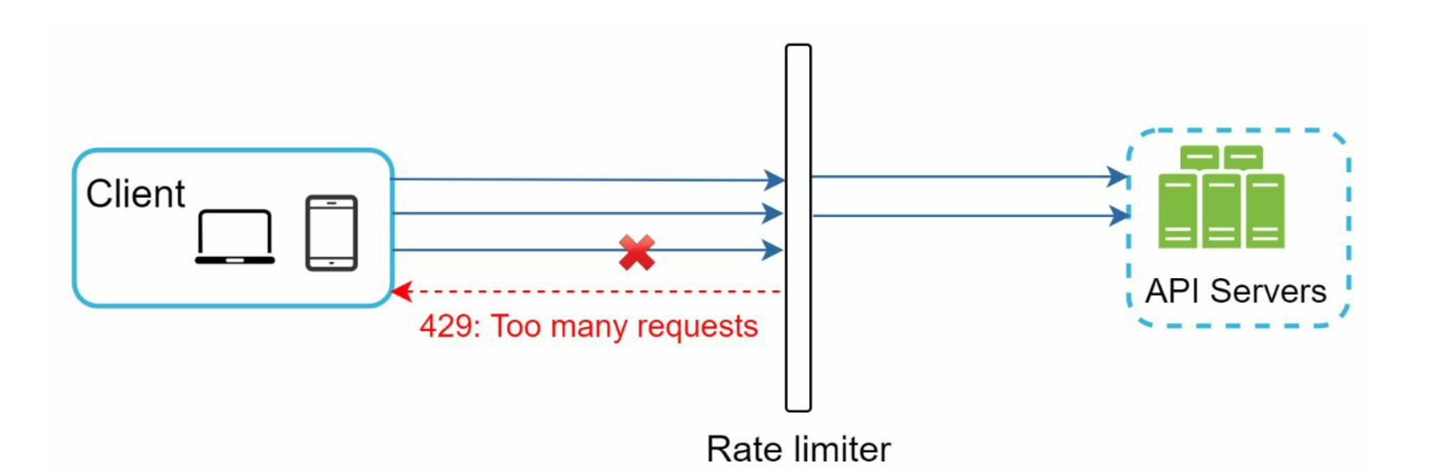

Cloud microservices [4] have become widely popular and rate limiting is usually implemented within a component called API gateway. API gateway is a fully managed service that supports rate limiting, SSL termination, authentication, IP whitelisting, servicing static content, etc. For now, we only need to know that the API gateway is a middleware that supports rate limiting.

While designing a rate limiter, an important question to ask ourselves is: where should the rater limiter be implemented, on the server-side or in a gateway? There is no absolute answer. It depends on your company’s current technology stack, engineering resources, priorities, goals, etc. Here are a few general guidelines:

• Evaluate your current technology stack, such as programming language, cache service, etc. Make sure your current programming language is efficient to implement rate limiting on the server-side.

• Identify the rate limiting algorithm that fits your business needs. When you implement everything on the server-side, you have full control of the algorithm. However, your choice might be limited if you use a third-party gateway.

• If you have already used microservice architecture and included an API gateway in the design to perform authentication, IP whitelisting, etc., you may add a rate limiter to the API gateway.

• Building your own rate limiting service takes time. If you do not have enough engineering resources to implement a rate limiter, a commercial API gateway is a better option.

**Algorithms for rate limiting**

**Token bucket algorithm**

It is simple, well understood and commonly used by internet companies. Both Amazon [5] and Stripe [6] use this algorithm to throttle their API requests.

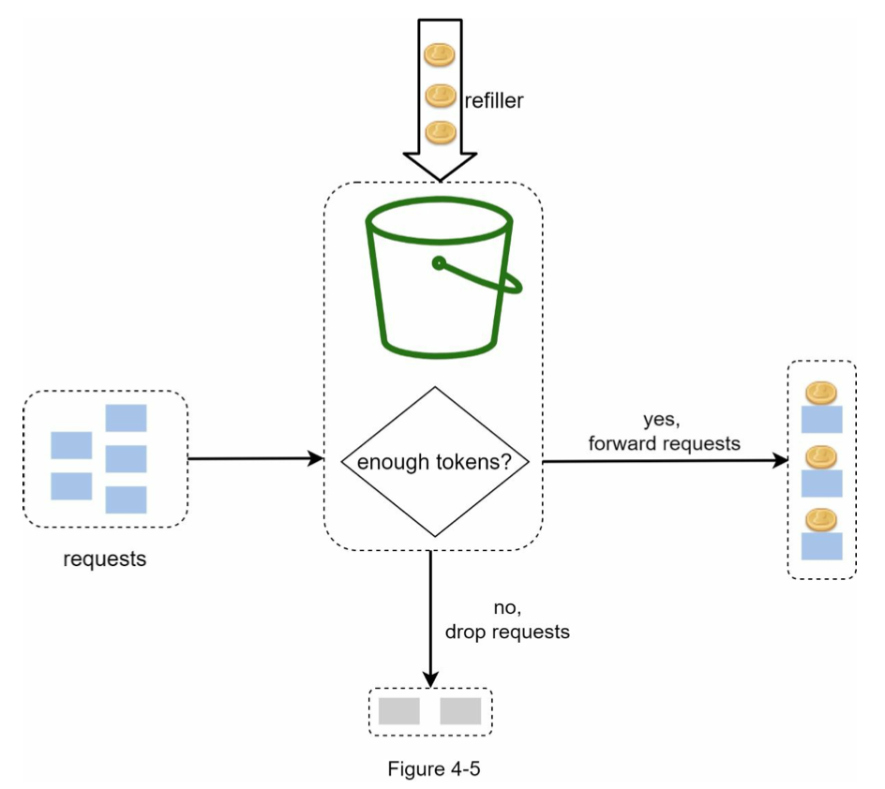

Figure 4-6 illustrates how token consumption, refill, and rate limiting logic work. In this example, the token bucket size is 4, and the refill rate is 4 per 1 minute.

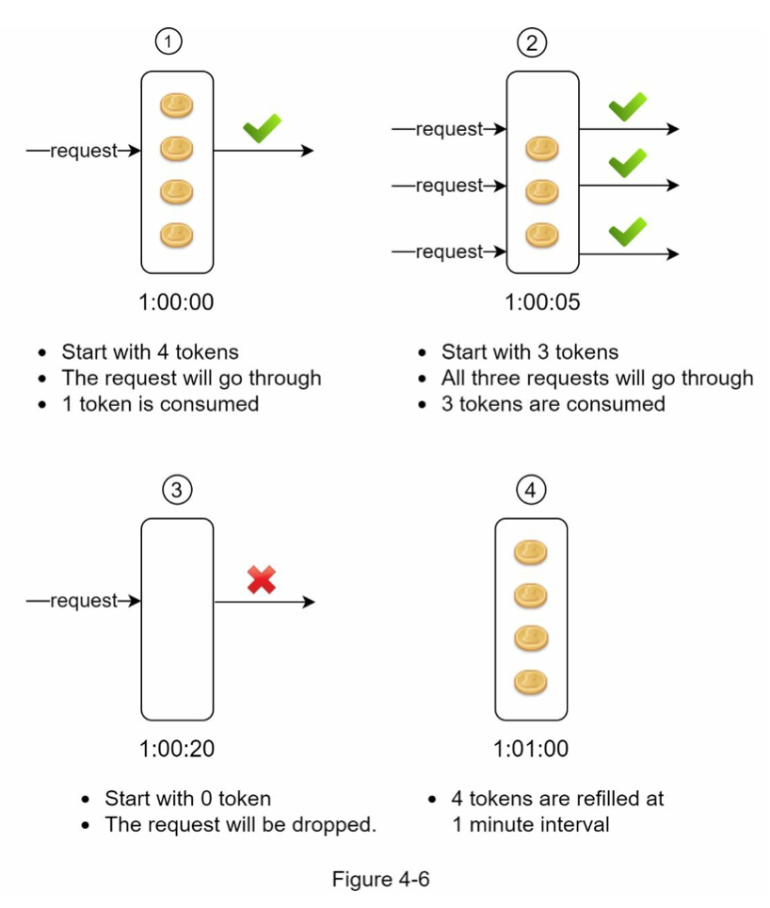

The token bucket algorithm takes two parameters:

• Bucket size: the maximum number of tokens allowed in the bucket

• Refill rate: number of tokens put into the bucket every second

How many buckets do we need? This varies, and it depends on the rate-limiting rules. Here are a few examples.

• It is usually necessary to have different buckets for different API endpoints. For instance, if a user is allowed to make 1 post per second, add 150 friends per day, and like 5 posts per second, 3 buckets are required for each user.

• If we need to throttle requests based on IP addresses, each IP address requires a bucket.

• If the system allows a maximum of 10,000 requests per second, it makes sense to have a global bucket shared by all requests.

Pros:

• The algorithm is easy to implement.

• Memory efficient.

• Token bucket allows a burst of traffic for short periods. A request can go through as long as there are tokens left.

Cons: • Two parameters in the algorithm are bucket size and token refill rate. However, it might

be challenging to tune them properly.

**Leaking bucket algorithm**

similar to the token bucket except that requests are processed at a fixed rate.

first-in-first-out (FIFO) queue. The algorithm works as follows:

• When a request arrives, the system checks if the queue is full. If it is not full, the request is added to the queue.

• Otherwise, the request is dropped. • Requests are pulled from the queue and processed at regular intervals.

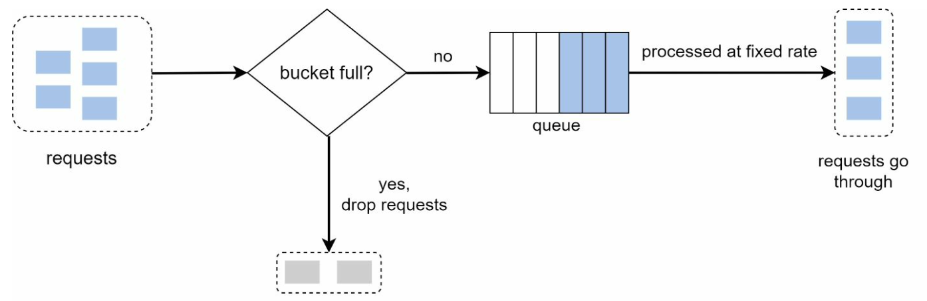

takes the following two parameters:

• Bucket size: it is equal to the queue size. The queue holds the requests to be processed at a fixed rate.

• Outflow rate: it defines how many requests can be processed at a fixed rate, usually in seconds.

Pros:

• Memory efficient given the limited queue size.

• Requests are processed at a fixed rate therefore it is suitable for use cases that a stable outflow rate is needed.

Cons:

• A burst of traffic fills up the queue with old requests, and if they are not processed in time, recent requests will be rate limited.

• There are two parameters in the algorithm. It might not be easy to tune them properly.

**Fixed window counter algorithm**

• The algorithm divides the timeline into fix-sized time windows and assign a counter for each window.

• Each request increments the counter by one.

• Once the counter reaches the pre-defined threshold, new requests are dropped until a new time window starts.

In Figure 4-8, the time unit is 1 second and the system allows a maximum of 3 requests per second. In each second window, if more than 3 requests are received, extra requests are dropped as shown in Figure 4-8.

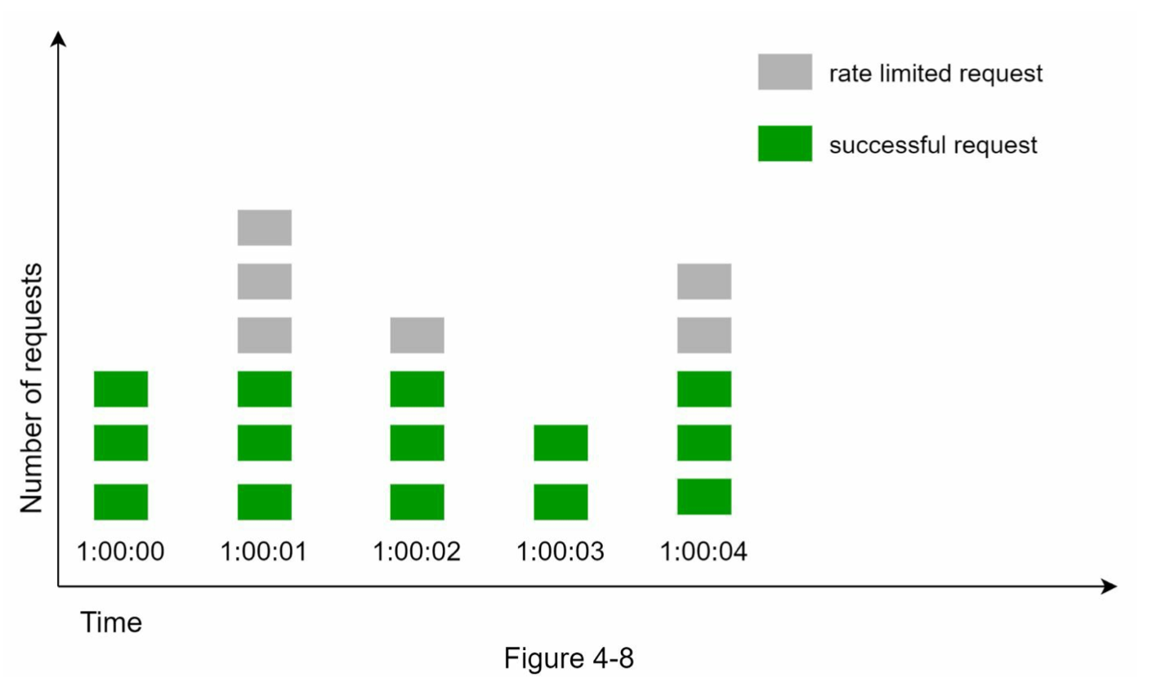

A major problem with this algorithm is that a burst of traffic at the edges of time windows could cause more requests than allowed quota to go through.

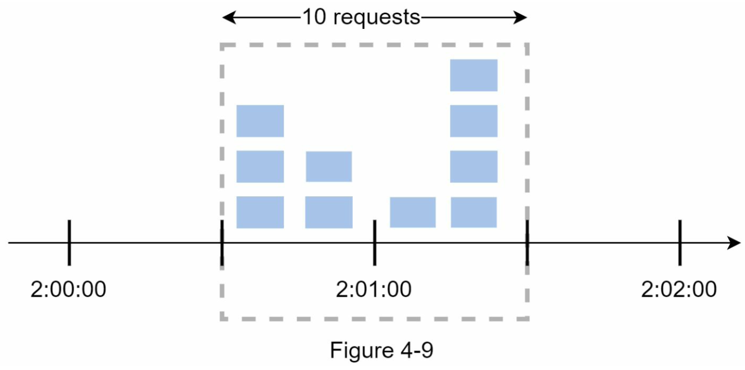

In Figure 4-9, the system allows a maximum of 5 requests per minute, and the available quota resets at the human-friendly round minute. As seen, there are five requests between 2:00:00 and 2:01:00 and five more requests between 2:01:00 and 2:02:00. For the one-minute window between 2:00:30 and 2:01:30, 10 requests go through. That is twice as many as allowed requests.

Pros: • Memory efficient.

• Easy to understand. • Resetting available quota at the end of a unit time window fits certain use cases.

Cons:

• Spike in traffic at the edges of a window could cause more requests than the allowed quota to go through.

**Sliding window log algorithm**

As discussed previously, the fixed window counter algorithm has a major issue: it allows more requests to go through at the edges of a window. The sliding window log algorithm fixes the issue. It works as follows:

• The algorithm keeps track of request timestamps. Timestamp data is usually kept in cache, such as sorted sets of Redis [8].

• When a new request comes in, remove all the outdated timestamps. Outdated timestamps are defined as those older than the start of the current time window.

• Add timestamp of the new request to the log.

• If the log size is the same or lower than the allowed count, a request is accepted. Otherwise, it is rejected.

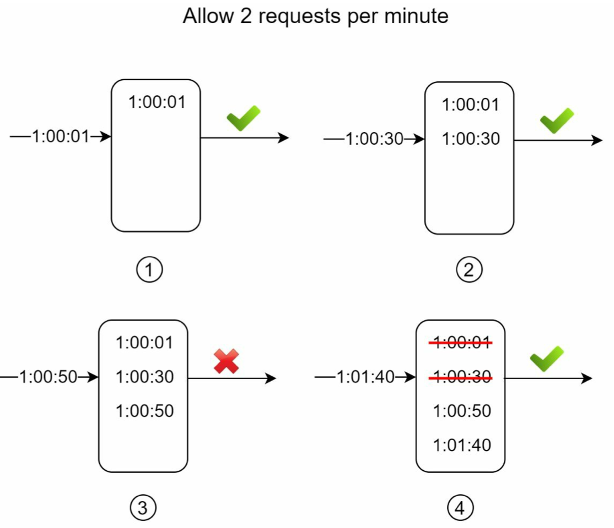

• The log is empty when a new request arrives at 1:00:01. Thus, the request is allowed.

• A new request arrives at 1:00:30, the timestamp 1:00:30 is inserted into the log. After the insertion, the log size is 2, not larger than the allowed count. Thus, the request is allowed.

• A new request arrives at 1:00:50, and the timestamp is inserted into the log. After the insertion, the log size is 3, larger than the allowed size 2. Therefore, this request is rejected even though the timestamp remains in the log.

• A new request arrives at 1:01:40. Requests in the range [1:00:40,1:01:40) are within the latest time frame, but requests sent before 1:00:40 are outdated. Two outdated timestamps, 1:00:01 and 1:00:30, are removed from the log. After the remove operation, the log size becomes 2; therefore, the request is accepted.

Pros:

• Rate limiting implemented by this algorithm is very accurate. In any rolling window, requests will not exceed the rate limit.

Cons:

• The algorithm consumes a lot of memory because even if a request is rejected, its timestamp might still be stored in memory.

**Sliding window counter algorithm**

The sliding window counter algorithm is a hybrid approach that combines the fixed window counter and sliding window log.

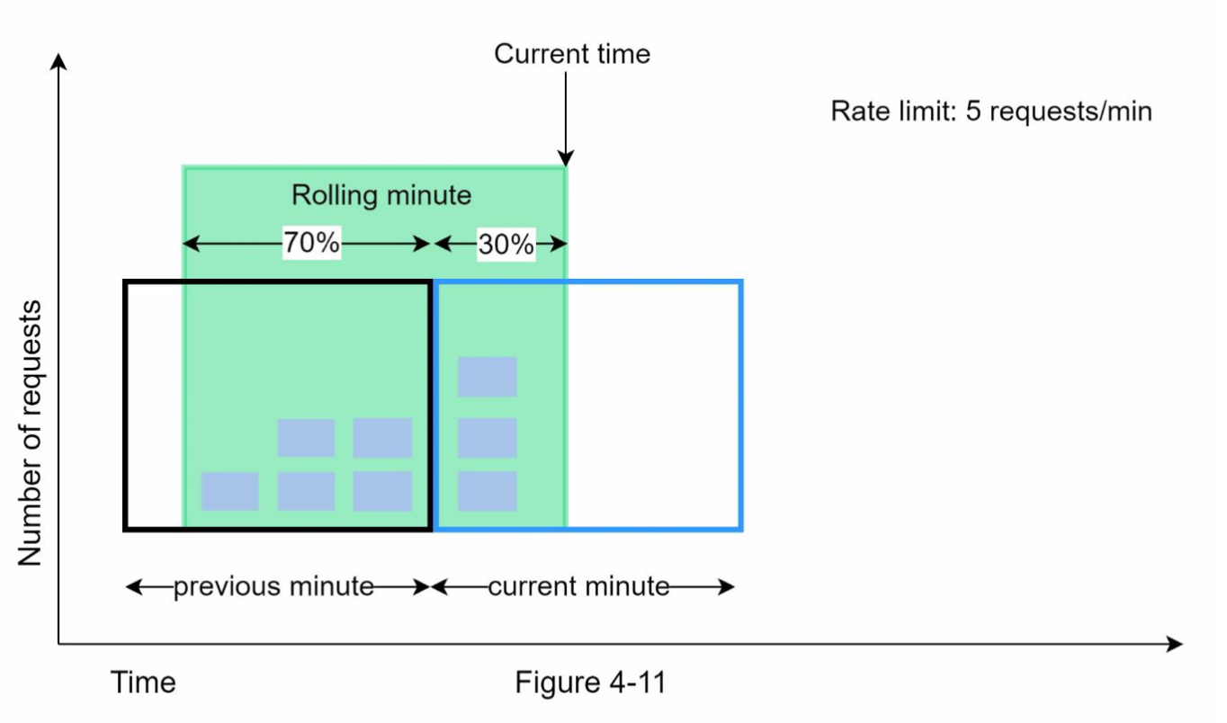

Assume the rate limiter allows a maximum of 7 requests per minute, and there are 5 requests in the previous minute and 3 in the current minute. For a new request that arrives at a 30% position in the current minute, the number of requests in the rolling window is calculated using the following formula:

• Requests in current window **+** requests in the previous window **\*** overlap percentage of the rolling window and previous window

• Using this formula, we get 3 + 5 * 0.7% = 6.5 request. Depending on the use case, the number can either be rounded up or down. In our example, it is rounded down to 6.

Since the rate limiter allows a maximum of 7 requests per minute, the current request can go through. However, the limit will be reached after receiving one more request.

Pros

• It smooths out spikes in traffic because the rate is based on the average rate of the previous window.

• Memory efficient.

Cons

• It only works for not-so-strict look back window. It is an approximation of the actual rate because it assumes requests in the previous window are evenly distributed. However, this problem may not be as bad as it seems. According to experiments done by Cloudflare [10], only 0.003% of requests are wrongly allowed or rate limited among 400 million requests.

**High-level architecture**

The basic idea of rate limiting algorithms is simple. At the high-level, we need a counter to keep track of how many requests are sent from the same user, IP address, etc. If the counter is larger than the limit, the request is disallowed.

Where shall we store counters? Using the database is not a good idea due to slowness of disk access. In-memory cache is chosen because it is fast and supports time-based expiration strategy. For instance, Redis [11] is a popular option to implement rate limiting. It is an in- memory store that offers two commands: INCR and EXPIRE.

• INCR: It increases the stored counter by 1.

• EXPIRE: It sets a timeout for the counter. If the timeout expires, the counter is automatically deleted.

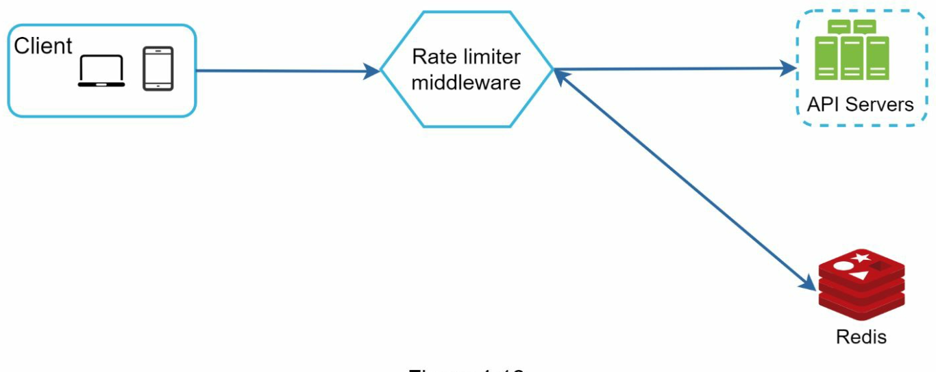

• The client sends a request to rate limiting middleware.

• Rate limiting middleware fetches the counter from the corresponding bucket in Redis and

checks if the limit is reached or not.

• If the limit is reached, the request is rejected.

• If the limit is not reached, the request is sent to API servers. Meanwhile, the system increments the counter and saves it back to Redis.

**Step 3 - Design deep dive**

**Rate limiting rules**

domain: auth

descriptors:

- key: auth_type

Value: login

rate_limit:

unit: minute

requests_per_unit: 5

This rule shows that clients are not allowed to login more than 5 times in 1 minute. Rules are generally written in configuration files and saved on disk.

**Exceeding the rate limit**

In case a request is rate limited, APIs return a HTTP response code 429 (too many requests) to the client. Depending on the use cases, we may enqueue the rate-limited requests to be processed later.

**Rate limiter headers**

How does a client know whether it is being throttled? …The answer lies in HTTP response headers.

*X-Ratelimit-Remaining*: The remaining number of allowed requests within the window. *X-Ratelimit-Limit:* It indicates how many calls the client can make per time window.

*X-Ratelimit-Retry-After:* The number of seconds to wait until you can make a request again without being throttled.

**Detailed design**

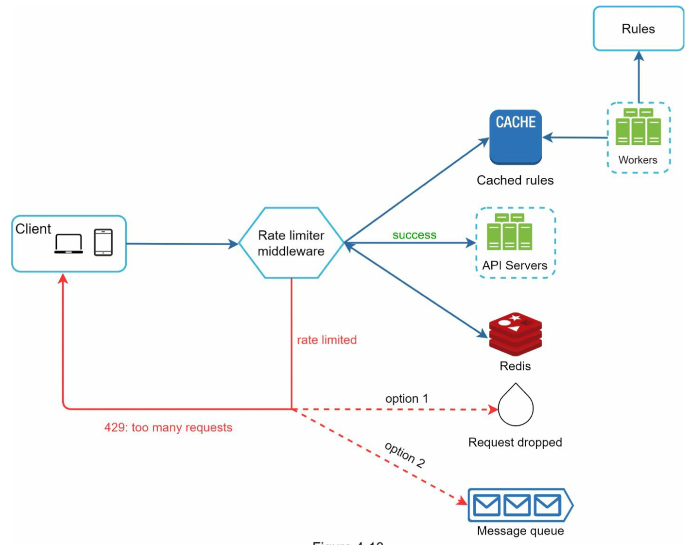

• Rules are stored on the disk. Workers frequently pull rules from the disk and store them in the cache.

• When a client sends a request to the server, the request is sent to the rate limiter middleware first.

• Rate limiter middleware loads rules from the cache. It fetches counters and last request timestamp from Redis cache. Based on the response, the rate limiter decides:

• if the request is not rate limited, it is forwarded to API servers.

• if the request is rate limited, the rate limiter returns 429 too many requests error to the client. In the meantime, the request is either dropped or forwarded to the queue.

**Rate limiter in a distributed environment**

There are two challenges:

• Race condition

• Synchronization issue

Assume the *counter* value in Redis is 3. If two requests concurrently read the *counter* value before either of them writes the value back, each will increment the *counter* by one and write it back without checking the other thread. Both requests (threads) believe they have the correct *counter* value 4. However, the correct *counter* value should be 5.

Locks are the most obvious solution for solving race condition. However, locks will significantly slow down the system. Two strategies are commonly used to solve the problem: Lua script [13] and sorted sets data structure in Redis [8]. For readers interested in these strategies, refer to the corresponding reference materials [8] [13].

sorted sets data structure in Redis: <https://engineering.classdojo.com/blog/2015/02/06/rolling-rate-limiter/>

**Synchronization issue**

To support millions of users, one rate limiter server might not be enough to handle the traffic.

When multiple rate limiter servers are used, synchronization is required. For example, on the left side of Figure 4-15, client 1 sends requests to rate limiter 1, and client 2 sends requests to rate limiter 2. As the web tier is stateless, clients can send requests to a different rate limiter as shown on the right side of Figure 4-15. If no synchronization happens, rate limiter 1 does not contain any data about client 2. Thus, the rate limiter cannot work properly.

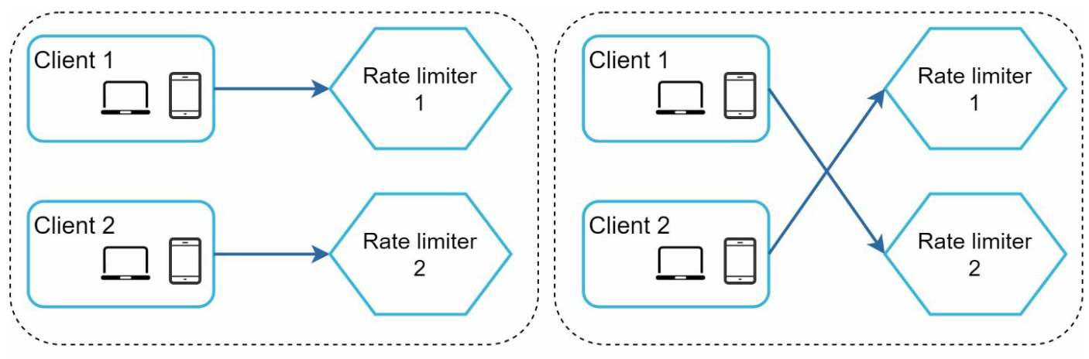

One possible solution is to use sticky sessions that allow a client to send traffic to the same rate limiter. This solution is not advisable because it is neither scalable nor flexible. A better approach is to use centralized data stores like Redis.

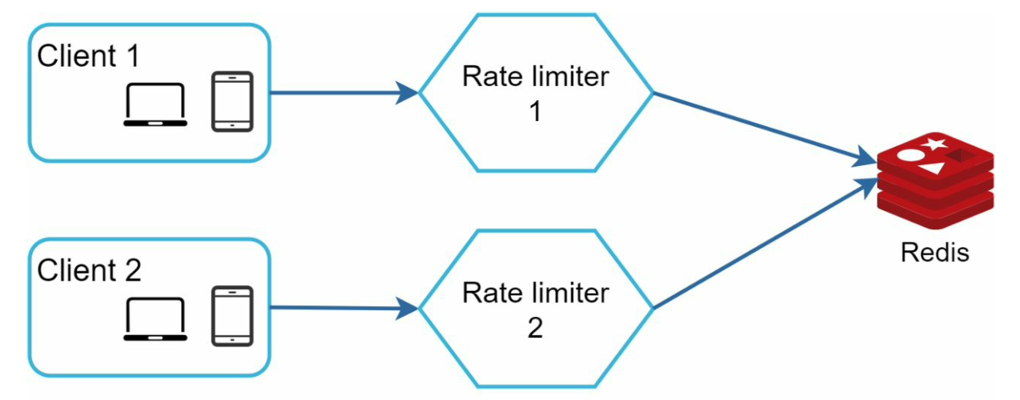

**Performance optimization**

First, multi-data center setup is crucial for a rate limiter because latency is high for users located far away from the data center. Most cloud service providers build many edge server locations around the world.

Second, synchronize data with an eventual consistency model.

**Monitoring**

gather analytics data to check whether the rate limiter is effective. Primarily, we want to make sure:

• The rate limiting algorithm is effective.

• The rate limiting rules are effective.

For example, if rate limiting rules are too strict, many valid requests are dropped. In this case, we want to relax the rules a little bit. In another example, we notice our rate limiter becomes ineffective when there is a sudden increase in traffic like flash sales. In this scenario, we may replace the algorithm to support burst traffic. Token bucket is a good fit here.

**there are additional talking points you can mention if time allows:**

• Hard vs soft rate limiting.

• Hard: The number of requests cannot exceed the threshold.   
• Soft: Requests can exceed the threshold for a short period.

• Rate limiting at different levels. In this chapter, we only talked about rate limiting at the application level (HTTP: layer 7). It is possible to apply rate limiting at other layers. For example, you can apply rate limiting by IP addresses using Iptables [15] (IP: layer 3).

• Avoid being rate limited. Design your client with best practices:

• Use client cache to avoid making frequent API calls.

• Understand the limit and do not send too many requests in a short time frame.

• Include code to catch exceptions or errors so your client can gracefully recover from exceptions.

• Add sufficient back off time to retry logic.

**DESIGN CONSISTENT HASHING**

**The rehashing problem**

If you have *n* cache servers, a common way to balance the load is to use the following hash method:

*serverIndex = hash(key) % N*, where *N* is the size of the server pool.

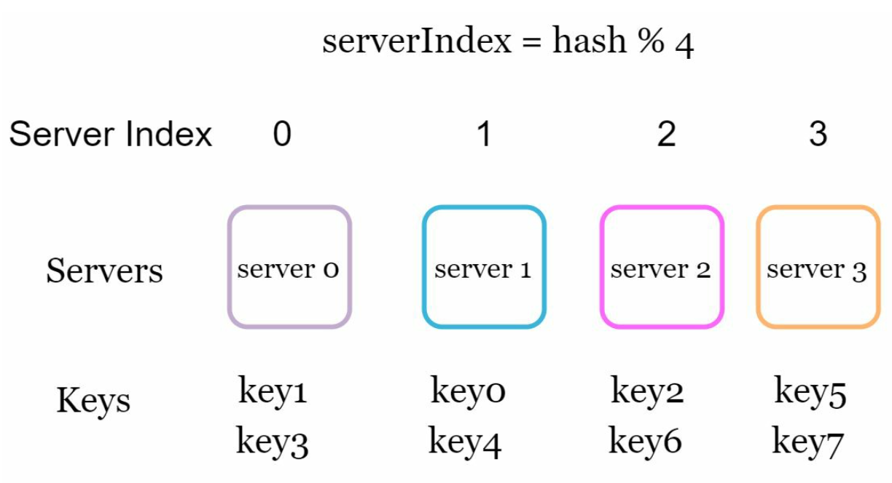

This approach works well when the size of the server pool is fixed, and the data distribution is even. However, problems arise when new servers are added, or existing servers are removed.

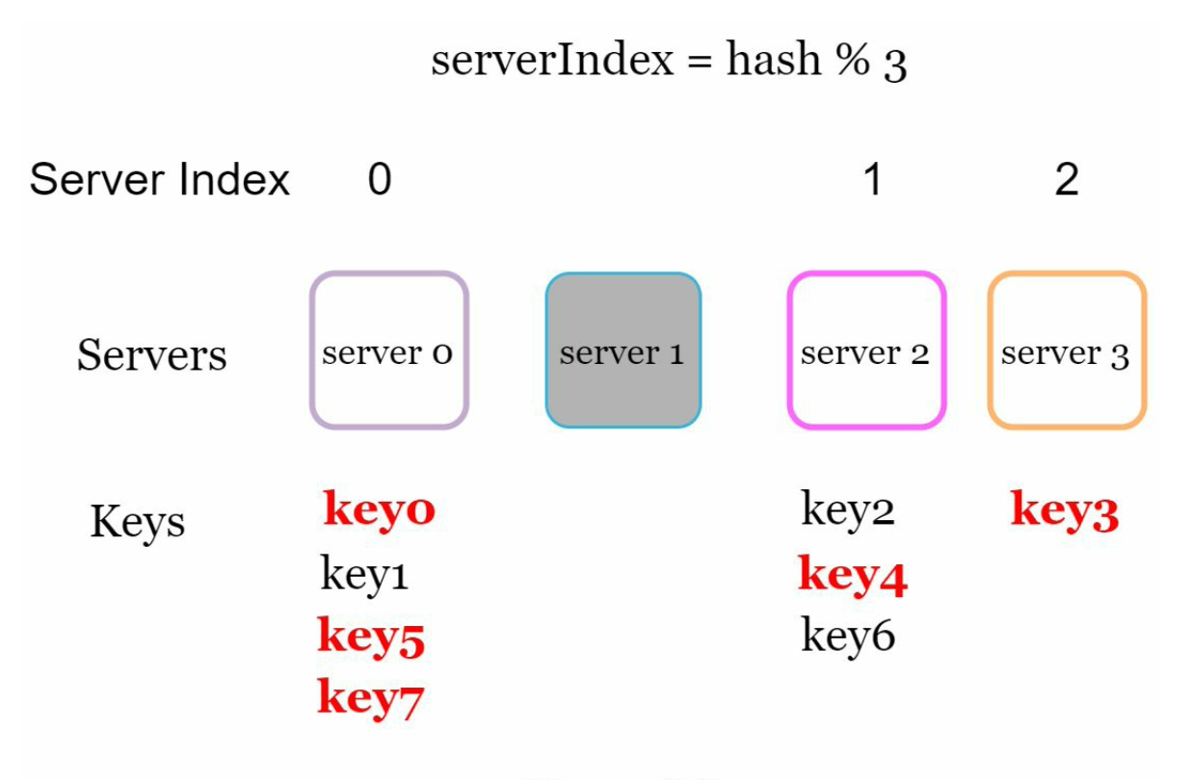

As shown in Figure 5-2, most keys are redistributed, not just the ones originally stored in the offline server (server 1). This means that when server 1 goes offline, most cache clients will connect to the wrong servers to fetch data. This causes a storm of cache misses. Consistent hashing is an effective technique to mitigate this problem.

**Consistent hashing**

**Hash space**

Assume SHA-1 is used as the hash function f, and the output range of the hash function is: *x0, x1, x2, x3, ..., xn*.

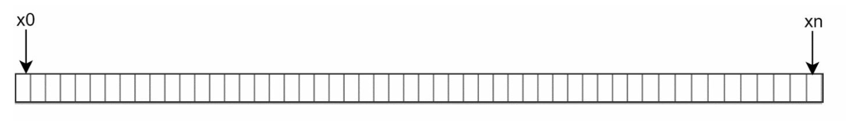

**hash ring**

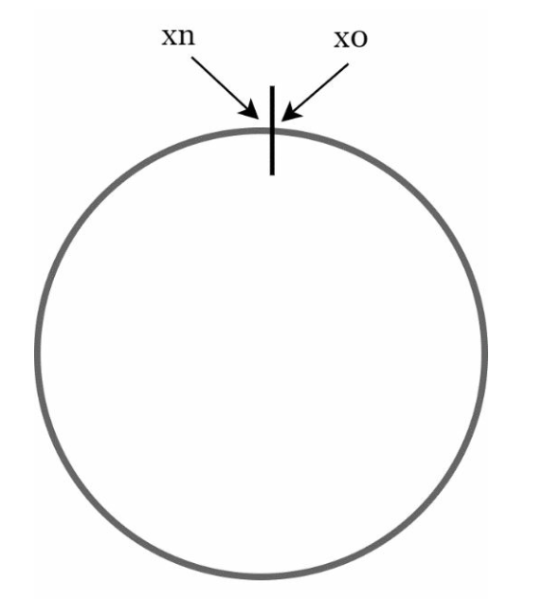

**Hash servers**

Using the same hash function f, we map servers based on server IP or name onto the ring. 4 servers are mapped on the hash ring:

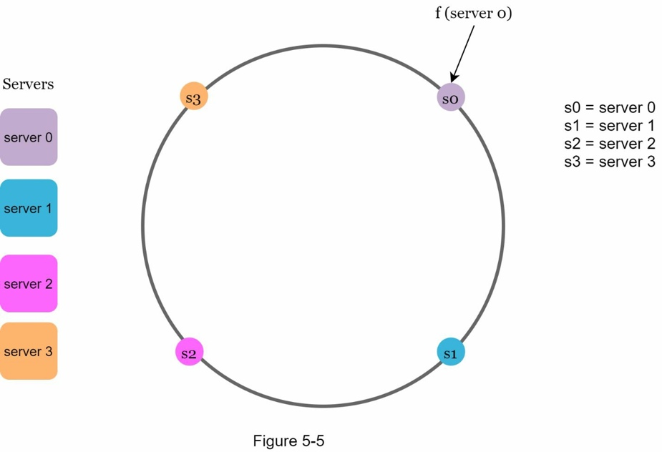

**Hash keys**

One thing worth mentioning is that hash function used here is different from the one in “the rehashing problem,” and there is no modular operation.

4 cache keys (key0, key1, key2, and key3) are hashed onto the hash ring

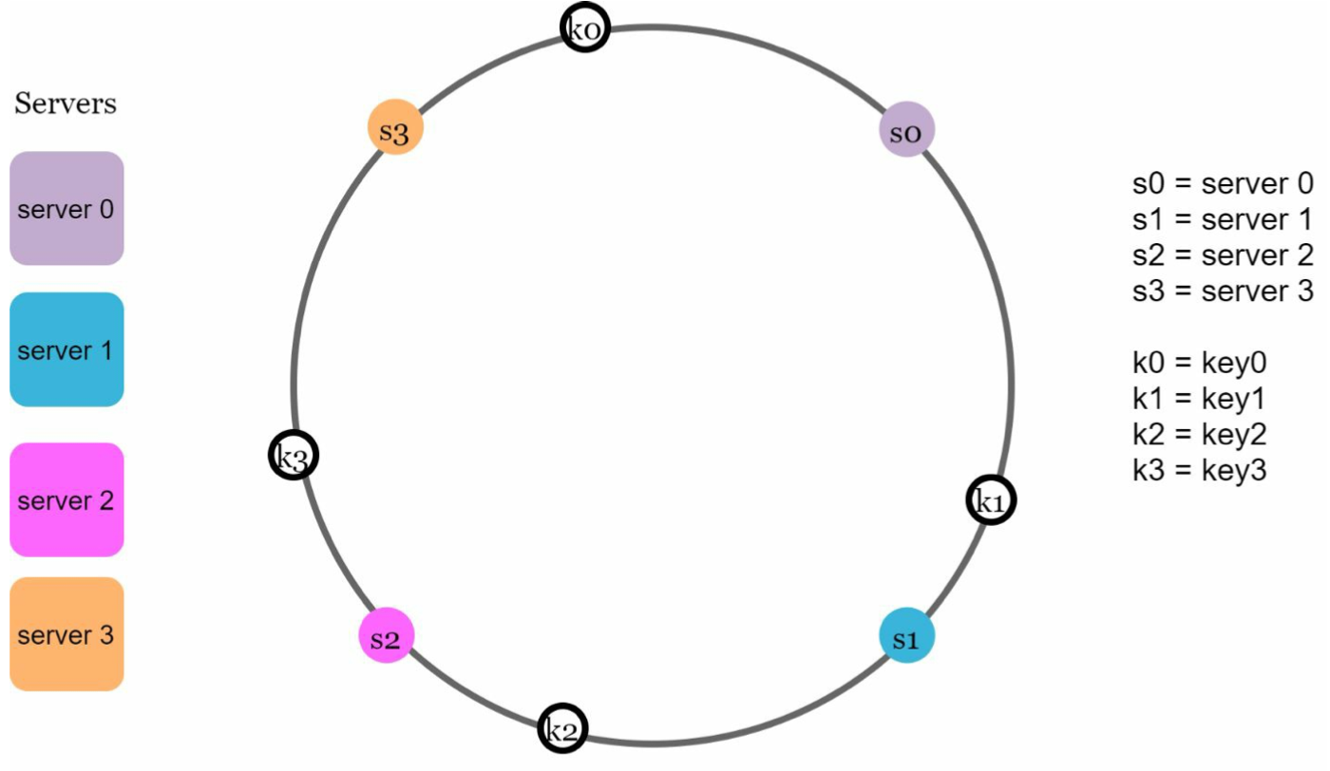

**Server lookup**

To determine which server a key is stored on, we go clockwise from the key position on the ring until a server is found. Going clockwise, *key0* is stored on *server 0*; *key1* is stored on *server 1*; *key2* is stored on *server 2* and *key3* is stored on *server 3*.

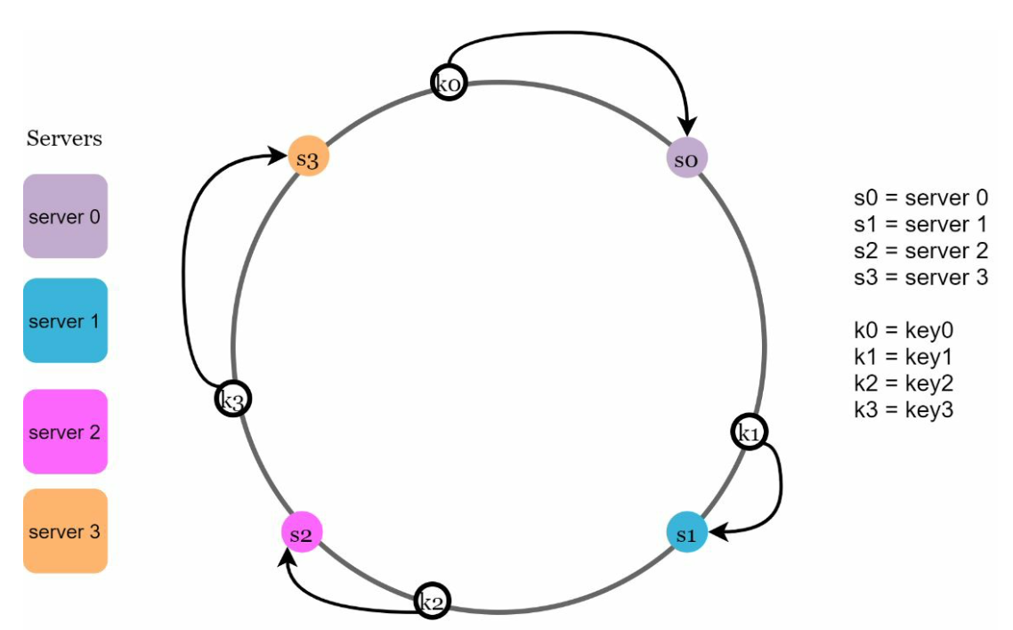

**Add a server**

Using the logic described above, adding a new server will only require redistribution of a fraction of keys. after a new *server 4* is added, only *key0* needs to be redistributed. *k1, k2,* and *k3* remain on the same servers. Now, *key0* will be stored on *server 4* because *server 4* is the first server it encounters by going clockwise from *key0*’s position on the ring.

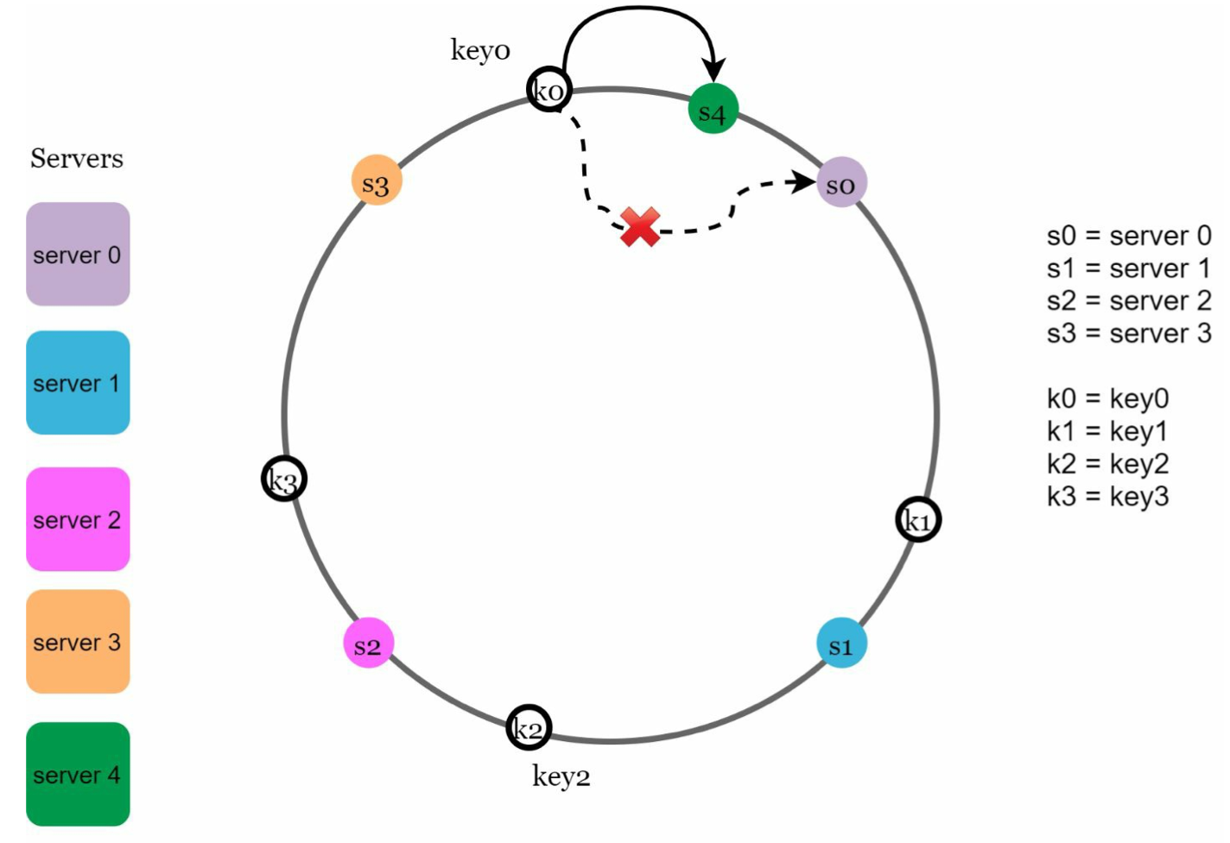

**Remove a server**

When a server is removed, only a small fraction of keys require redistribution with consistent hashing.

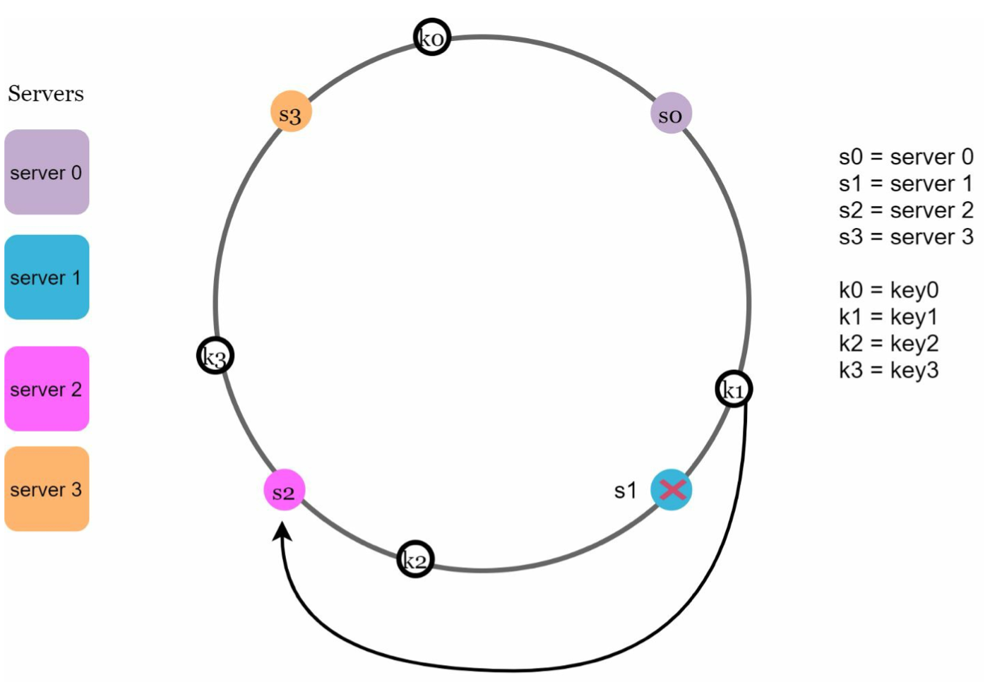

**Two issues in the basic approach**

First, it is impossible to keep the same size of partitions on the ring for all servers considering a server can be added or removed. A partition is the hash space between adjacent servers. It is possible that the size of the partitions on the ring assigned to each server is very small or fairly large.

Second, it is possible to have a non-uniform key distribution on the ring.

A technique called virtual nodes or replicas is used to solve these problems.

**Virtual nodes**

A virtual node refers to the real node, and each server is represented by multiple virtual nodes on the ring.

e.g. both *server 0* and *server 1* have 3 virtual nodes. The 3 is arbitrarily chosen; and in real-world systems, the number of virtual nodes is much larger. Instead of using *s0*, we have *s0_0, s0_1*, and s0_2 to represent *server 0* on the ring. Similarly, *s1_0, s1_1*, and *s1_2* represent server 1 on the ring.

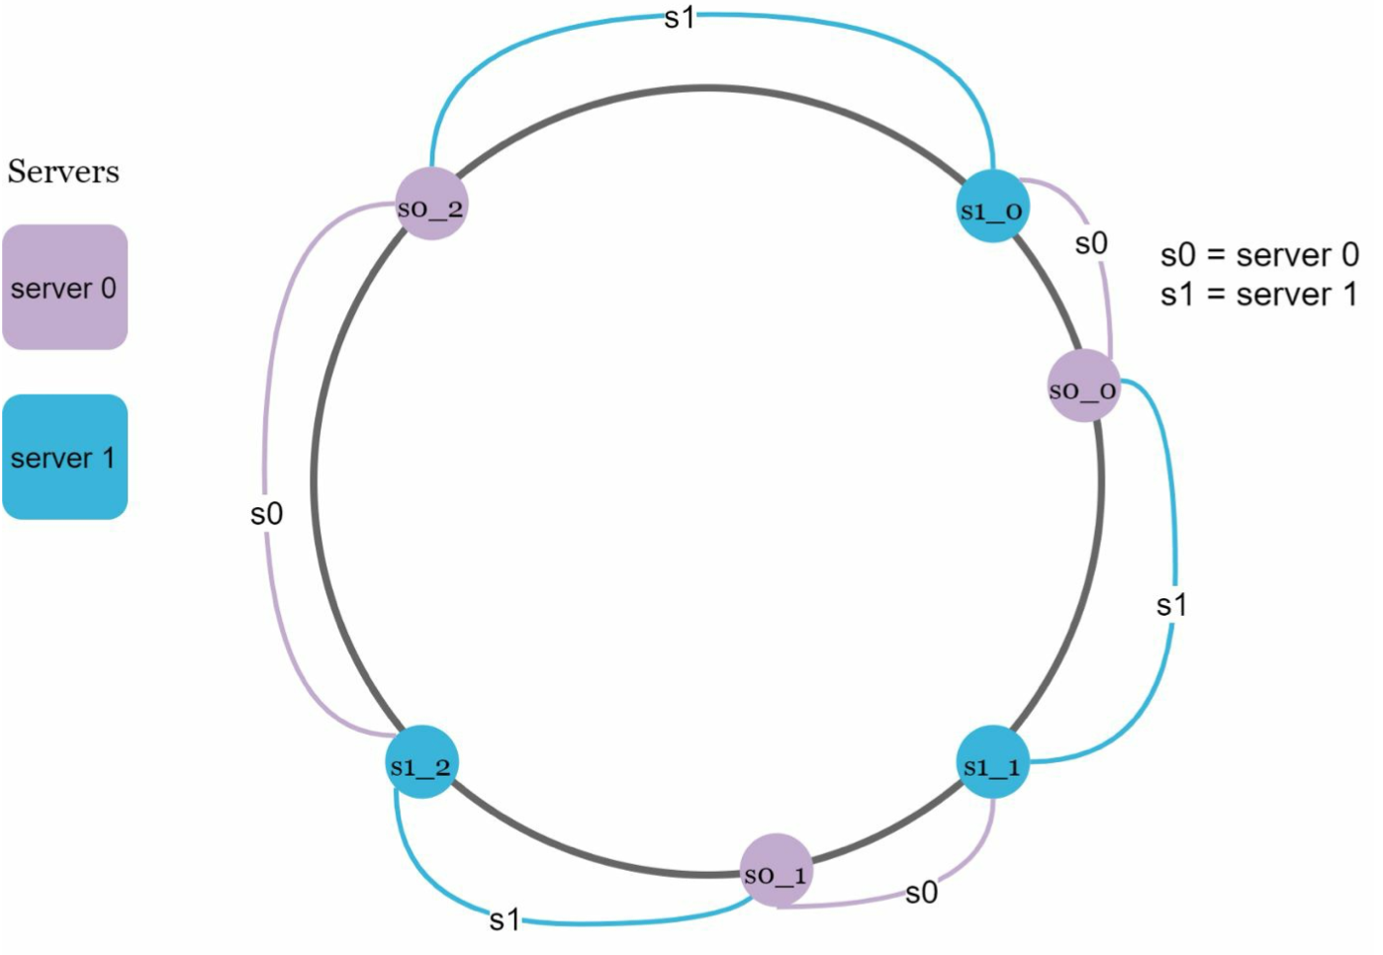

To find which server a key is stored on, we go clockwise from the key’s location and find the first virtual node encountered on the ring. to find out which server *k0* is stored on, we go clockwise from *k0*’s location and find virtual node *s1_1*, which refers to *server 1*.

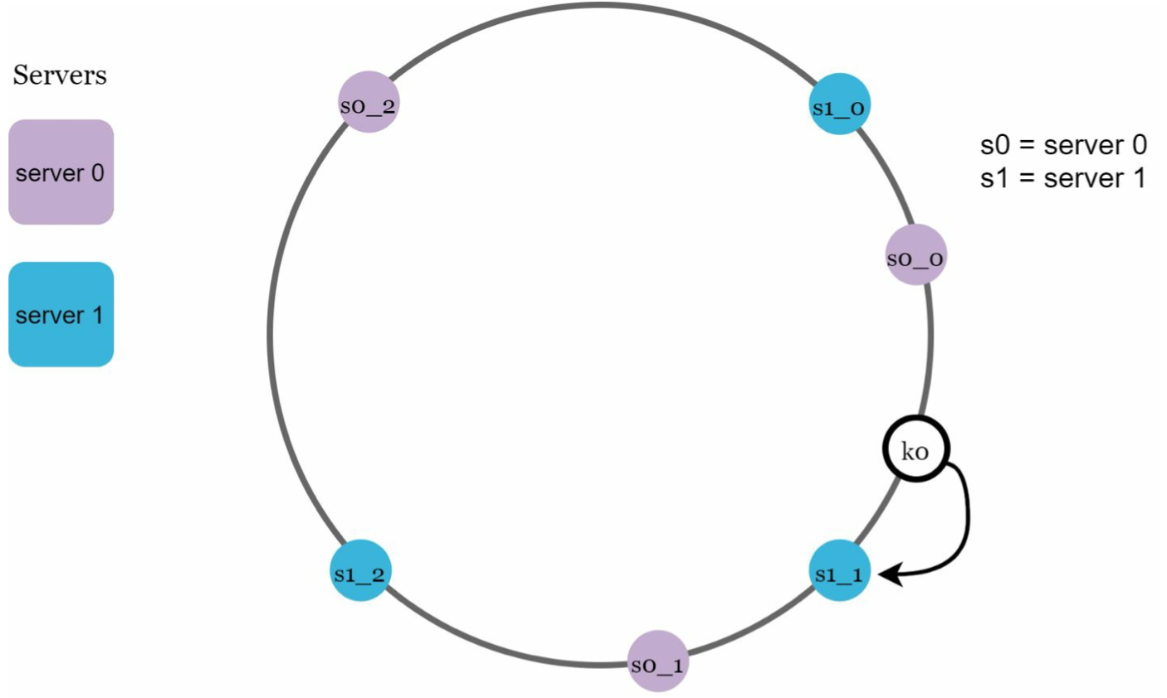

As the number of virtual nodes increases, the distribution of keys becomes more balanced. This is because the standard deviation gets smaller with more virtual nodes, leading to balanced data distribution. Standard deviation measures how data are spread out. The outcome of an experiment carried out by online research [2] shows that with one or two hundred virtual nodes, the standard deviation is between 5% (200 virtual nodes) and 10% (100 virtual nodes) of the mean. The standard deviation will be smaller when we increase the number of virtual nodes. However, more spaces are needed to store data about virtual nodes. This is a tradeoff, and we can tune the number of virtual nodes to fit our system requirements.

**Find affected keys**

a fraction of data needs to be redistributed.

E,g, *server 4* is added onto the ring. keys located between *s3* and *s4* need to be redistributed to *s4*.

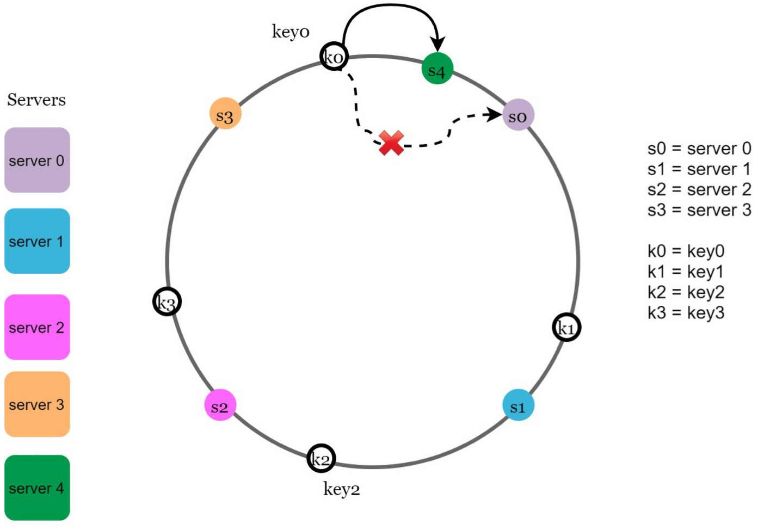

When a server (*s1*) is removed, keys located between *s0* and *s1* must be redistributed to *s2*.

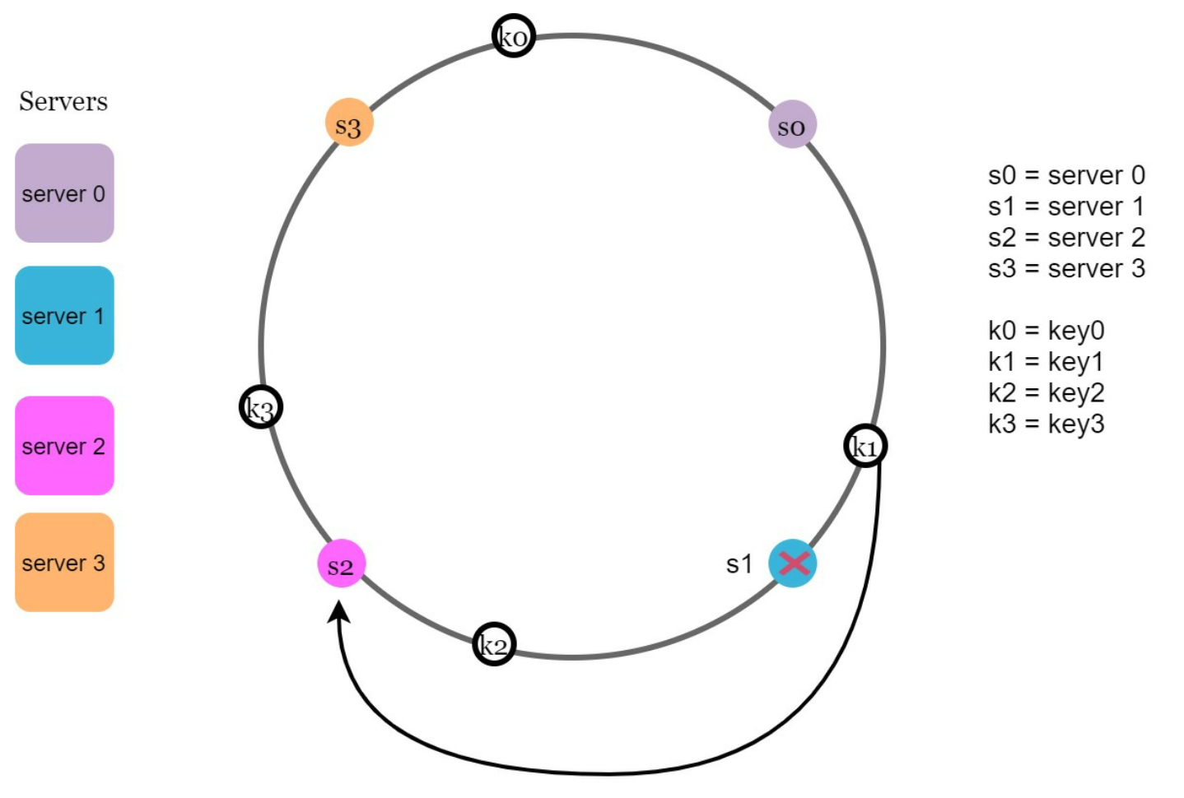

The benefits of consistent hashing include:

• Minimized keys are redistributed when servers are added or removed.

• It is easy to scale horizontally because data are more evenly distributed.

• Mitigate hotspot key problem. Excessive access to a specific shard could cause server overload. Imagine data for Katy Perry, Justin Bieber, and Lady Gaga all end up on the same shard. Consistent hashing helps to mitigate the problem by distributing the data more evenly.

**DESIGN A KEY-VALUE STORE**

A key-value store, also referred to as a key-value database, is a non-relational database. This data pairing is known as a “key-value” pair. three popular key-value store systems: Dynamo [4], Cassandra [5], and BigTable [6].

**Single server key-value store**

An intuitive approach is to store key-value pairs in a hash table, which keeps everything in memory. Even though memory access is fast, fitting everything in memory may be impossible due to the space constraint. Two optimizations can be done to fit more data in a single server:

• Data compression

• Store only frequently used data in memory and the rest on disk

Even with these optimizations, a single server can reach its capacity very quickly. A distributed key-value store is required to support big data.

**Distributed key-value store**

A distributed key-value store is also called a distributed hash table, which distributes key- value pairs across many servers.

CAP (**C**onsistency, **A**vailability, **P**artition Tolerance) theorem.

it is impossible for a distributed system to simultaneously provide more than two of these three guarantees: consistency, availability, and partition tolerance.

**Consistency**: consistency means all clients see the same data at the same time no matter which node they connect to.

**Availability:** availability means any client which requests data gets a response even if some of the nodes are down.

**Partition Tolerance:** a partition indicates a communication break between two nodes. Partition tolerance means the system continues to operate despite network partitions.

**CP (consistency and partition tolerance) systems**: a CP key-value store supports consistency and partition tolerance while sacrificing availability.

**AP (availability and partition tolerance) systems**: an AP key-value store supports availability and partition tolerance while sacrificing consistency.

**CA (consistency and availability) systems**: a CA key-value store supports consistency and

availability while sacrificing partition tolerance. Since network failure is unavoidable, a distributed system must tolerate network partition. Thus, **a CA system cannot exist in real- world applications.**

**Ideal situation**

In the ideal world, network partition never occurs. Data written to *n1* is automatically replicated to *n2* and *n3*. Both consistency and availability are achieved.

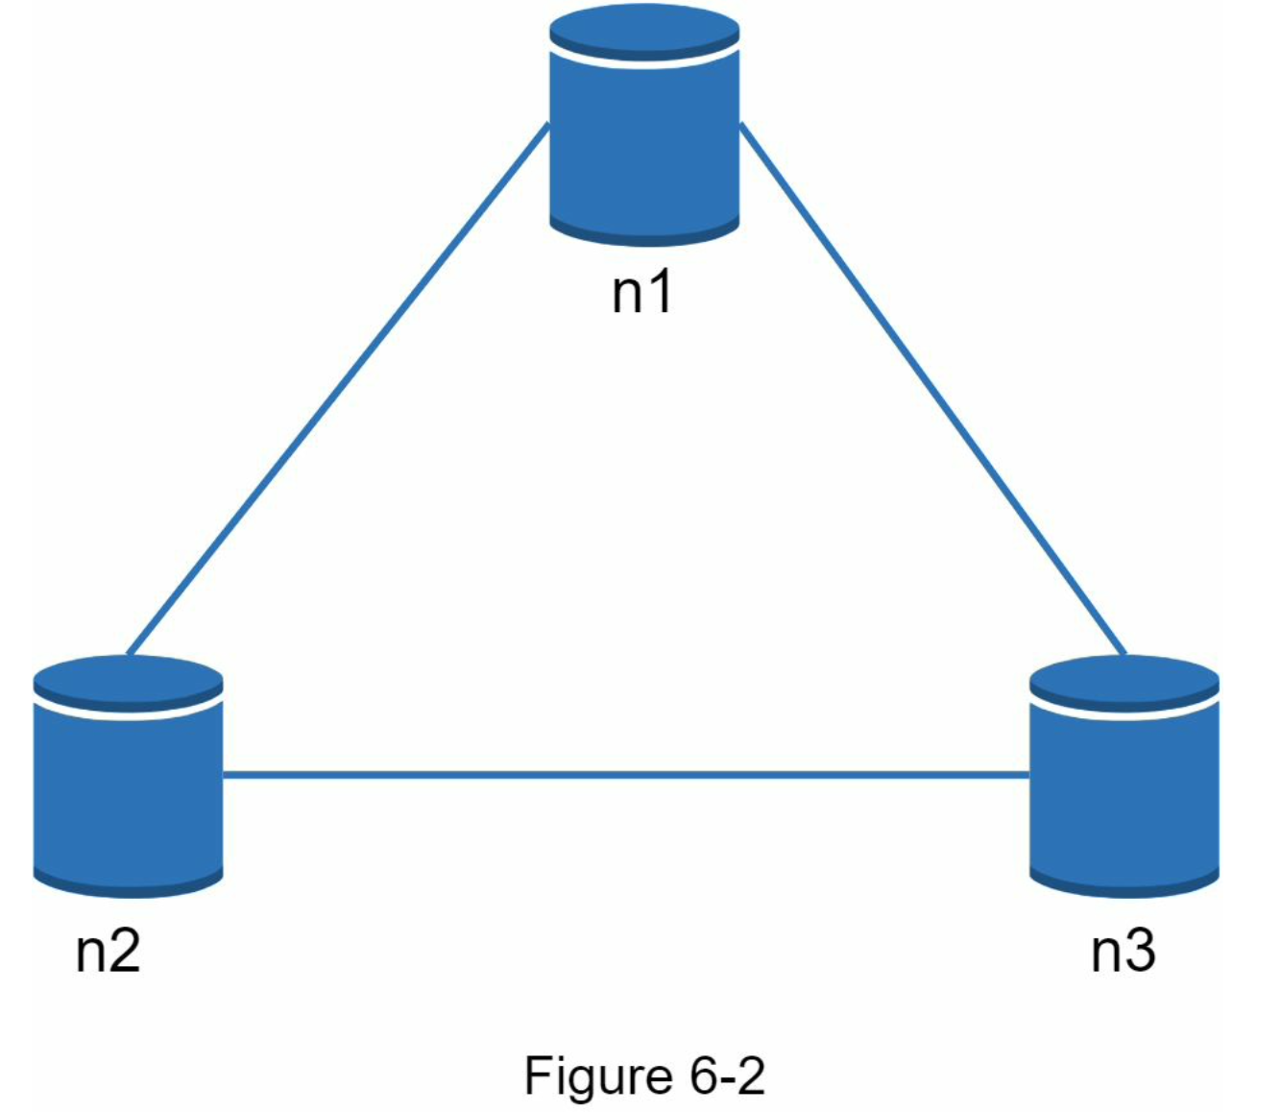

**Real-world distributed systems**

In a distributed system, partitions cannot be avoided, and when a partition occurs, we must choose between consistency and availability.

*n3* goes down and cannot communicate with *n1* and *n2*. If clients write data to *n1* or *n2*, data cannot be propagated to n3. If data is written to *n3* but not propagated to *n1* and *n2* yet, *n1* and *n2* would have stale data.

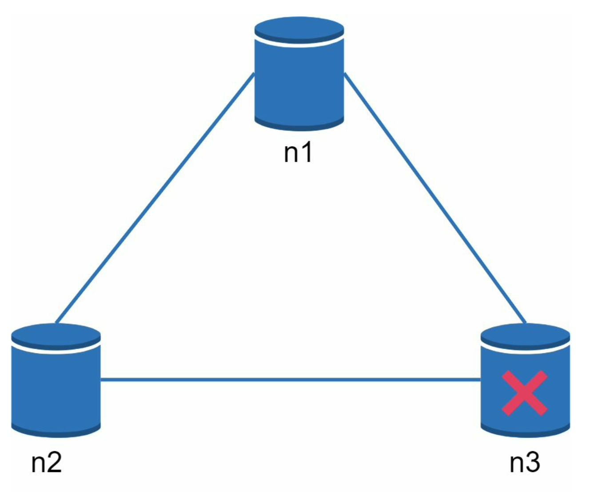

If we choose consistency over availability (CP system), we must block all write operations to *n1* and *n2* to avoid data inconsistency among these three servers, which makes the system unavailable. Bank systems usually have extremely high consistent requirements. For example, it is crucial for a bank system to display the most up-to-date balance info. If inconsistency occurs due to a network partition, the bank system returns an error before the inconsistency is resolved.

However, if we choose availability over consistency (AP system), the system keeps accepting reads, even though it might return stale data. For writes, *n1* and *n2* will keep accepting writes, and data will be synced to *n3* when the network partition is resolved.

**Data partition**

For large applications, it is infeasible to fit the complete data set in a single server. The simplest way to accomplish this is to split the data into smaller partitions and store them in multiple servers. There are two challenges while partitioning the data:

• Distribute data across multiple servers evenly.

• Minimize data movement when nodes are added or removed.

consistent hashing:

Using consistent hashing to partition data has the following advantages:

**Automatic scaling:** servers could be added and removed automatically depending on the

load.

**Heterogeneity:** the number of virtual nodes for a server is proportional to the server capacity. For example, servers with higher capacity are assigned with more virtual nodes.

**Data replication**

To achieve high availability and reliability, data must be replicated asynchronously over *N* servers, where *N* is a configurable parameter.

These *N* servers are chosen using the following logic: after a key is mapped to a position on the hash ring, walk clockwise from that position and choose the first *N* servers on the ring to store data copies. In Figure 6-5 (*N = 3*), *key0* is replicated at *s1, s2,* and *s3*.

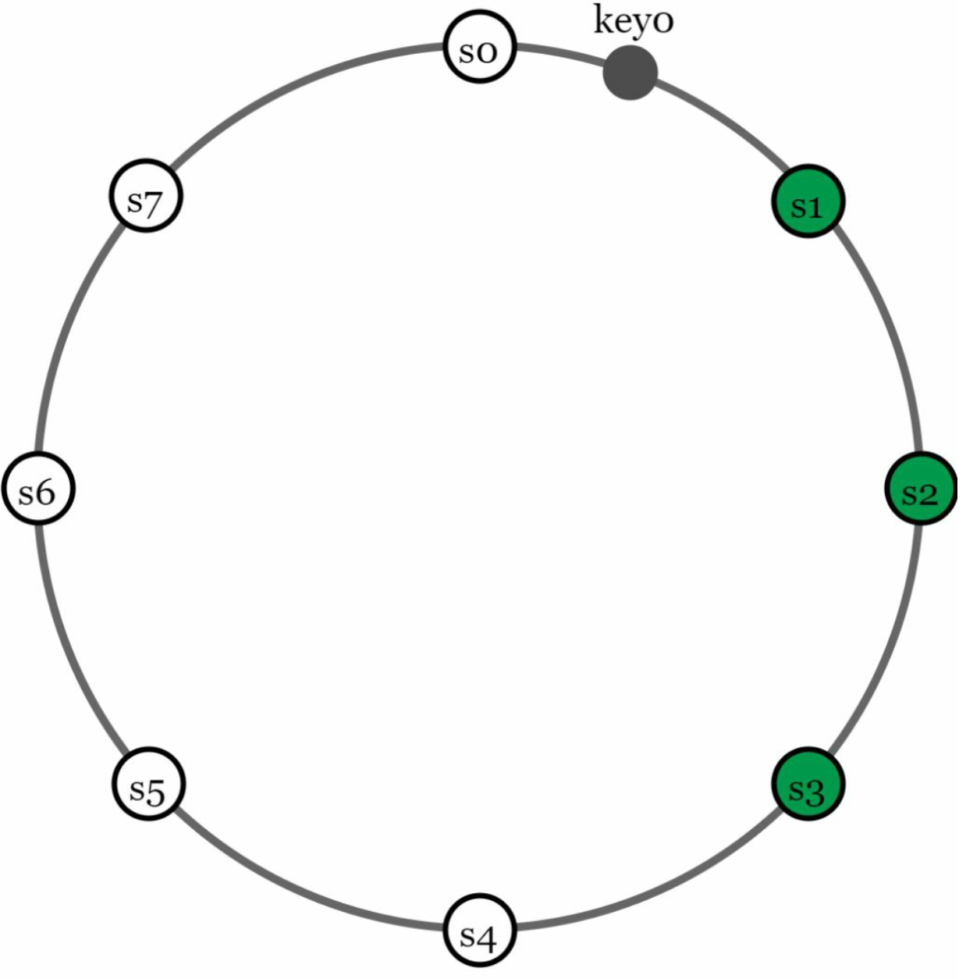

With virtual nodes, the first *N* nodes on the ring may be owned by fewer than *N* physical servers. To avoid this issue, we only choose unique servers while performing the clockwise walk logic.

Nodes in the same data center often fail at the same time due to power outages, network issues, natural disasters, etc. For better reliability, replicas are placed in distinct data centers, and data centers are connected through high-speed networks.

**Consistency**

Since data is replicated at multiple nodes, it must be synchronized across replicas. Quorum consensus can guarantee consistency for both read and write operations.

***N*** = The number of replicas

***W*** = A write quorum of size *W*. For a write operation to be considered as successful, write

operation must be acknowledged from *W* replicas.

***R*** = A read quorum of size *R*. For a read operation to be considered as successful, read

operation must wait for responses from at least *R* replicas.

*N = 3*:

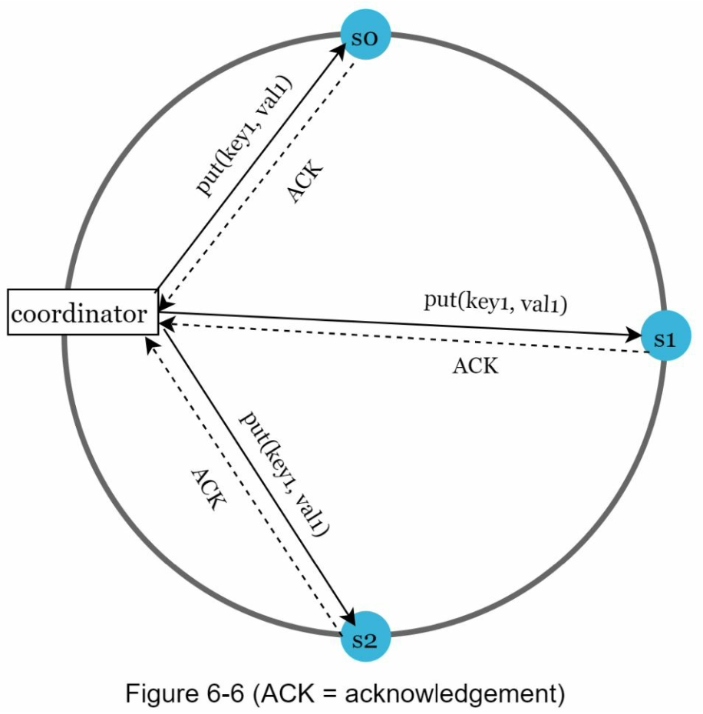

*W = 1* means that the coordinator must receive at least one acknowledgment before the write operation is considered as successful. For instance, if we get an acknowledgment from *s1*, we no longer need to wait for acknowledgements from *s0* and *s2*.

A coordinator acts as a proxy between the client and the nodes.

The configuration of *W, R* and *N* is a **typical tradeoff between latency and consistency.** If *W = 1* or *R = 1*, an operation is returned quickly because a coordinator only needs to wait for a response from any of the replicas. If *W* or *R > 1*, the system offers better consistency; however, the query will be slower because the coordinator must wait for the response from the slowest replica.

If *W + R > N*, strong consistency is guaranteed because there must be at least one overlapping node that has the latest data to ensure consistency.

If *R = 1* and *W = N*, the system is optimized for a fast read.

If *W = 1 and R = N*, the system is optimized for fast write.

If *W + R > N*, strong consistency is guaranteed (Usually *N = 3, W = R = 2*).

If *W + R <= N*, strong consistency is not guaranteed.

**Consistency models**

Consistency model is other important factor to consider when designing a key-value store. A consistency model defines the degree of data consistency, and a wide spectrum of possible consistency models exist:

• Strong consistency: any read operation returns a value corresponding to the result of the most updated write data item. A client never sees out-of-date data.

Strong consistency is usually achieved by forcing a replica not to accept new reads/writes until every replica has agreed on current write. This approach is not ideal for highly available systems because it could block new operations.

• Weak consistency: subsequent read operations may not see the most updated value.

• Eventual consistency: this is a specific form of weak consistency. Given enough time, all updates are propagated, and all replicas are consistent.

Dynamo and Cassandra adopt eventual consistency, which is our recommended consistency model for our key-value store.

From concurrent writes, eventual consistency allows inconsistent values to enter the system and force the client to read the values to reconcile. The next section explains how reconciliation works with versioning.

**Inconsistency resolution: versioning**

Replication gives high availability but causes inconsistencies among replicas. Versioning and vector locks are used to solve inconsistency problems. Versioning means treating each data modification as a new immutable version of data.

how inconsistency happens**: two simultaneous write; or network partition between two servers**

both replica nodes *n1* and *n2* have the same value. Let us call this value the original *value. Server 1* and *server 2* get the same value for *get(“name”)* operation.

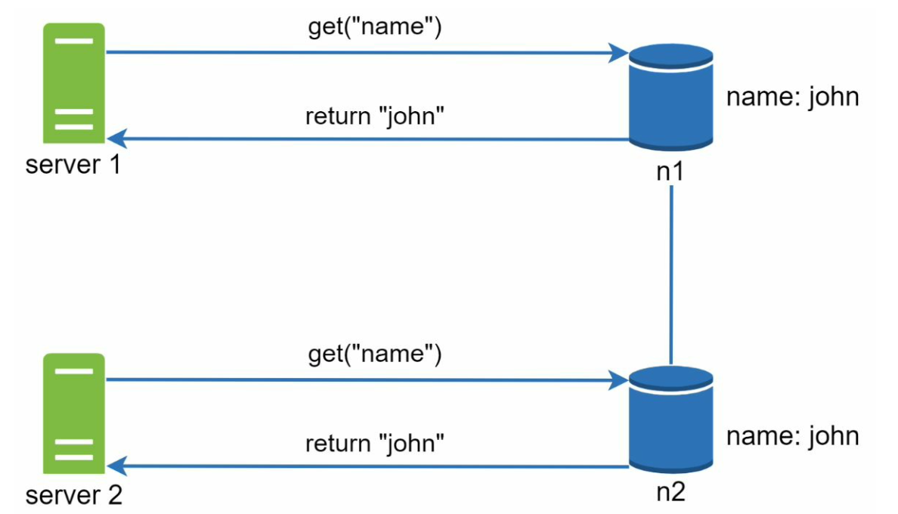

Next, *server 1* changes the name to “johnSanFrancisco”, and *server 2* changes the name to “johnNewYork” as shown in Figure 6-8. These two changes are performed simultaneously. Now, we have conflicting values, called versions *v1* and *v2*.

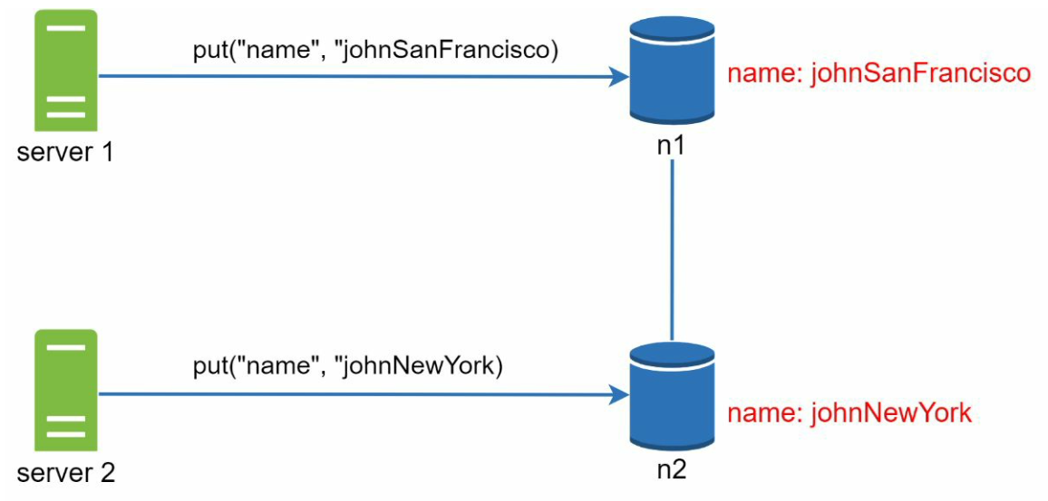

A vector clock is a common technique to solve this problem.

A vector clock is a *[server, version]* pair associated with a data item (**a key**).

If data item *D* is written to server *Si*, the system must perform one of the following tasks.

• Increment *vi* if *[Si, vi]* exists.

• Otherwise, create a new entry *[Si, 1]*.

If two writes simultaneously: D3 and D4. The conflict is resolved by the **client** and updated data is sent to the server (D5: **reconciliation**).

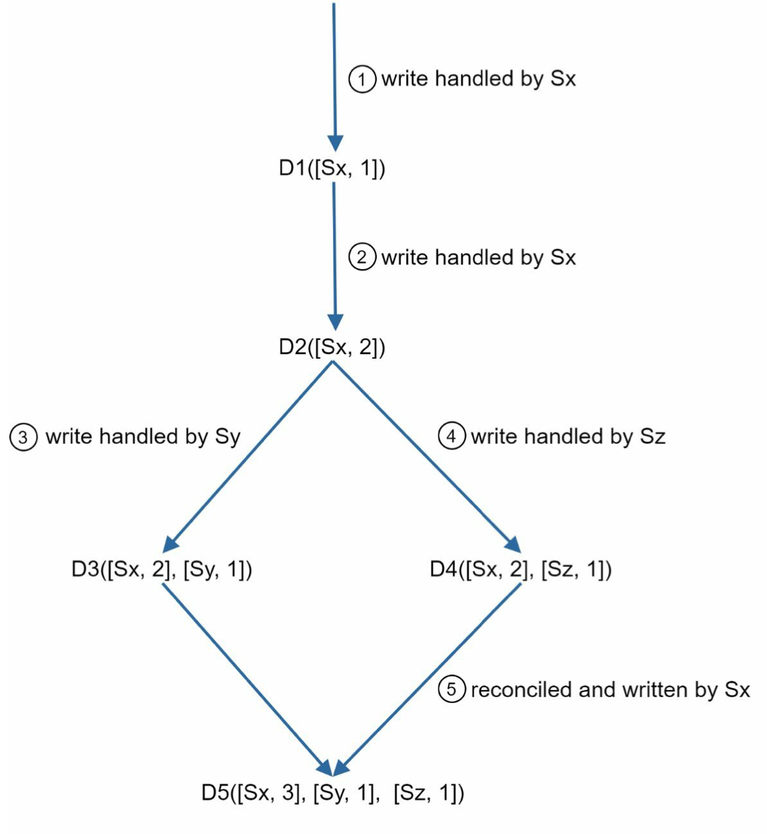

If network partition between two servers: <https://www.educative.io/answers/how-are-vector-clocks-used-in-dynamo>

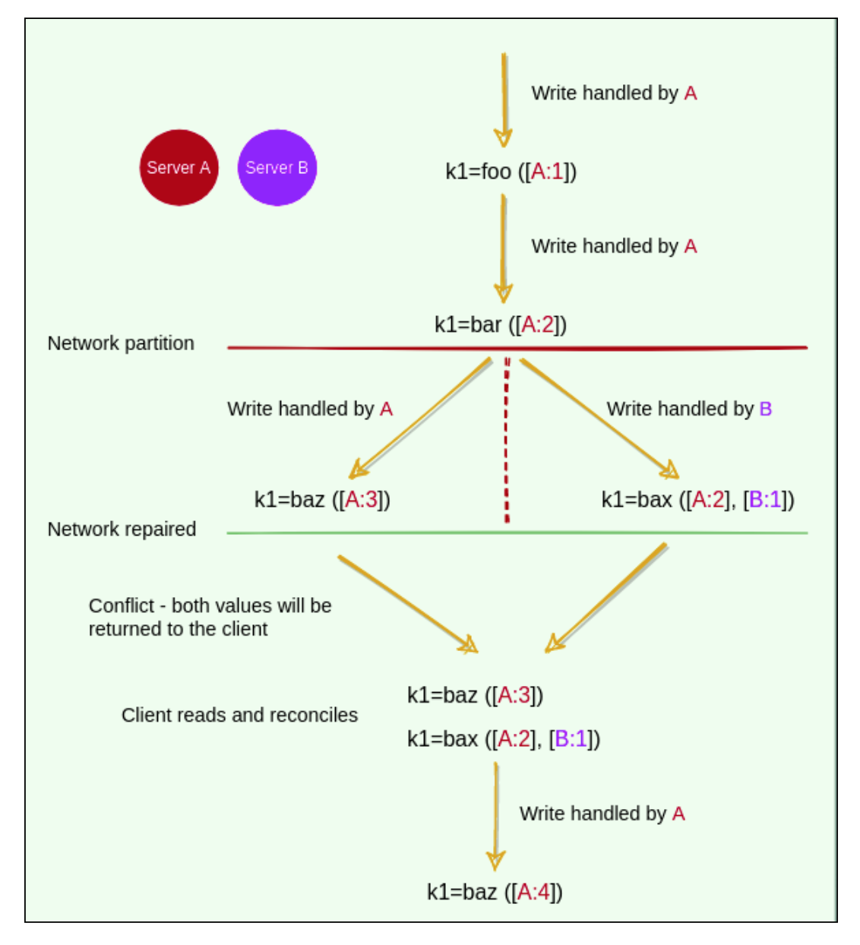

**Handling failures**

**Failure detection**

all-to-all multicasting is a straightforward solution. However, this is inefficient when many servers are in the system.

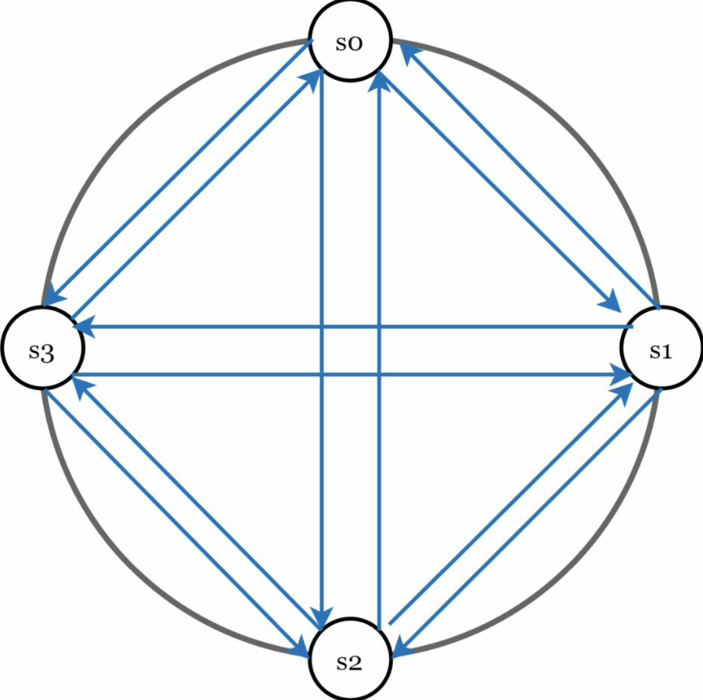

A better solution is to use decentralized failure detection methods like gossip protocol. Gossip protocol (**epidemic multicast**) works as follows:

• Each node maintains a node membership list, which contains member IDs and heartbeat counters.

• Each node periodically increments its heartbeat counter.

• Each node periodically sends heartbeats to a set of random nodes, which in turn propagate to another set of nodes.

• Once nodes receive heartbeats, membership list is updated to the latest info.

• If the heartbeat has not increased for more than predefined periods, the member is considered as offline.

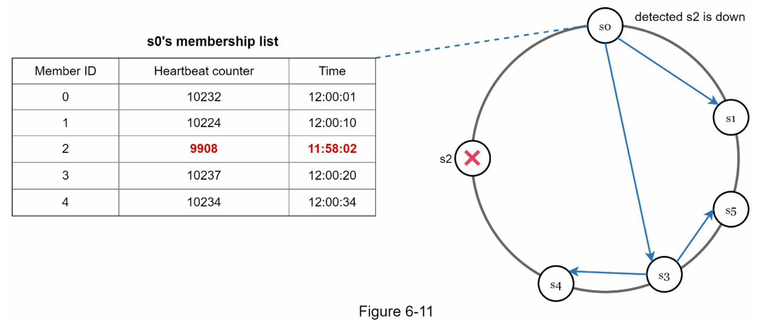

• Node *s0* maintains a node membership list shown on the left side.

• Node *s0* notices that node s2’s (member ID = 2) heartbeat counter has not increased for a

long time.

• Node *s0* sends heartbeats that include *s2*’s info to a set of random nodes. Once other nodes confirm that *s2*’s heartbeat counter has not been updated for a long time, node *s2* is marked down, and this information is propagated to other nodes.

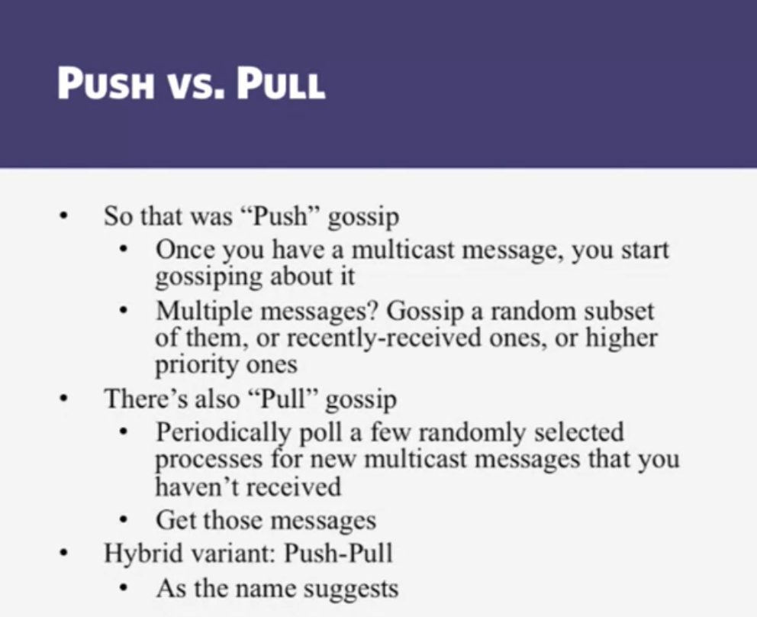

**Handling temporary failures**

After failures have been detected through the gossip protocol, the system needs to deploy certain mechanisms to ensure availability.

In the strict quorum approach, read and write operations could be blocked as illustrated in the quorum consensus section.

A technique called “sloppy quorum” is used to improve availability. Instead of enforcing the quorum requirement, the system chooses the first *W* healthy servers for writes and first *R* healthy servers for reads on the hash ring. Offline servers are ignored.

If a server is unavailable due to network or server failures, another server will process requests temporarily. When the down server is up, changes will be pushed back to achieve data consistency. This process is called hinted handoff. Since *s2* is unavailable in Figure 6- 12, reads and writes will be handled by *s3* temporarily. When *s2* comes back online, *s3* will hand the data back to *s2*.

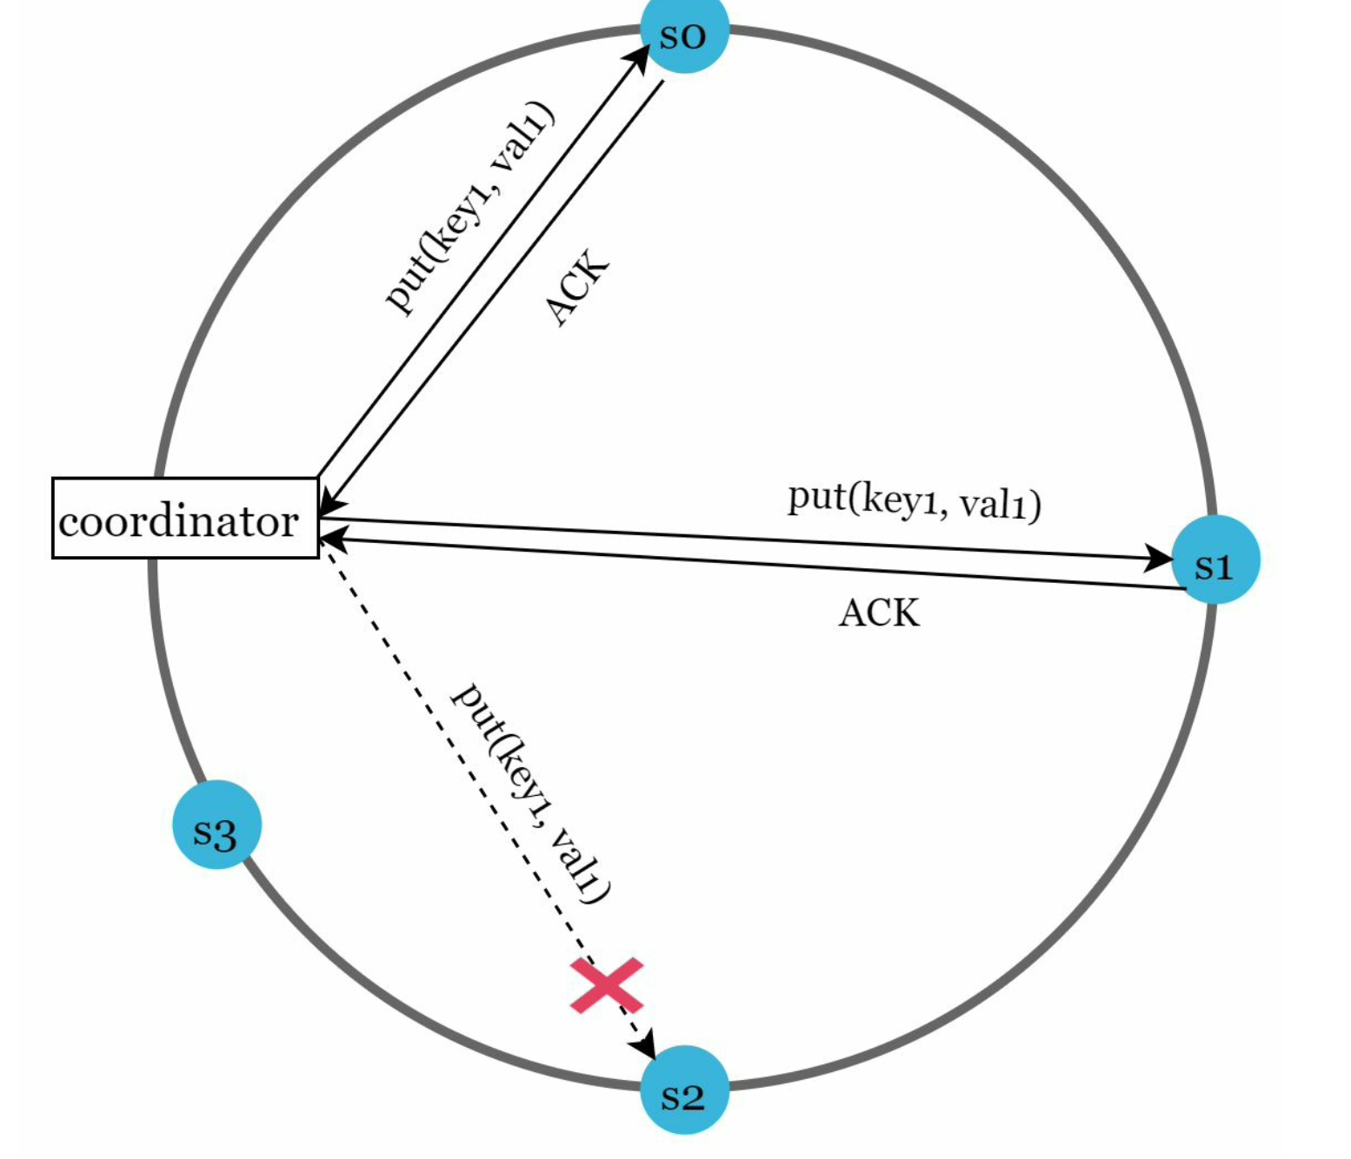

example: Amazon Dynamo

**Handling permanent failures**

Hinted handoff is used to handle temporary failures. What if a replica is permanently unavailable? To handle such a situation, we implement an anti-entropy protocol to keep replicas in sync.

Anti-entropy involves comparing each piece of data on replicas and updating each replica to the newest version.

A Merkle tree is used for inconsistency detection and minimizing the amount of data transferred.

A Merkle tree is a hash tree where leaves are hashes of the values of individual keys. Parent nodes higher in the tree are hashes of their respective children.

Assuming key space is from 1 to 12, the following steps show how to build a Merkle tree. Highlighted boxes indicate inconsistency.

Step 1: Divide key space into buckets (4 in our example) as shown in Figure 6-13. A bucket is used as the root level node to maintain a limited depth of the tree.

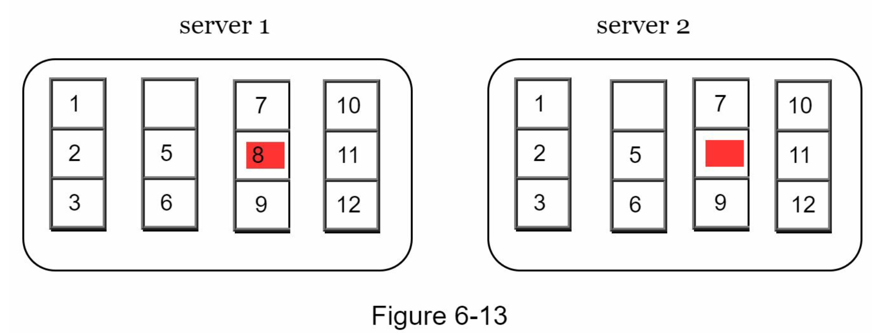

…

Step 4: Build the tree upwards till root by calculating hashes of children (Figure 6-16).

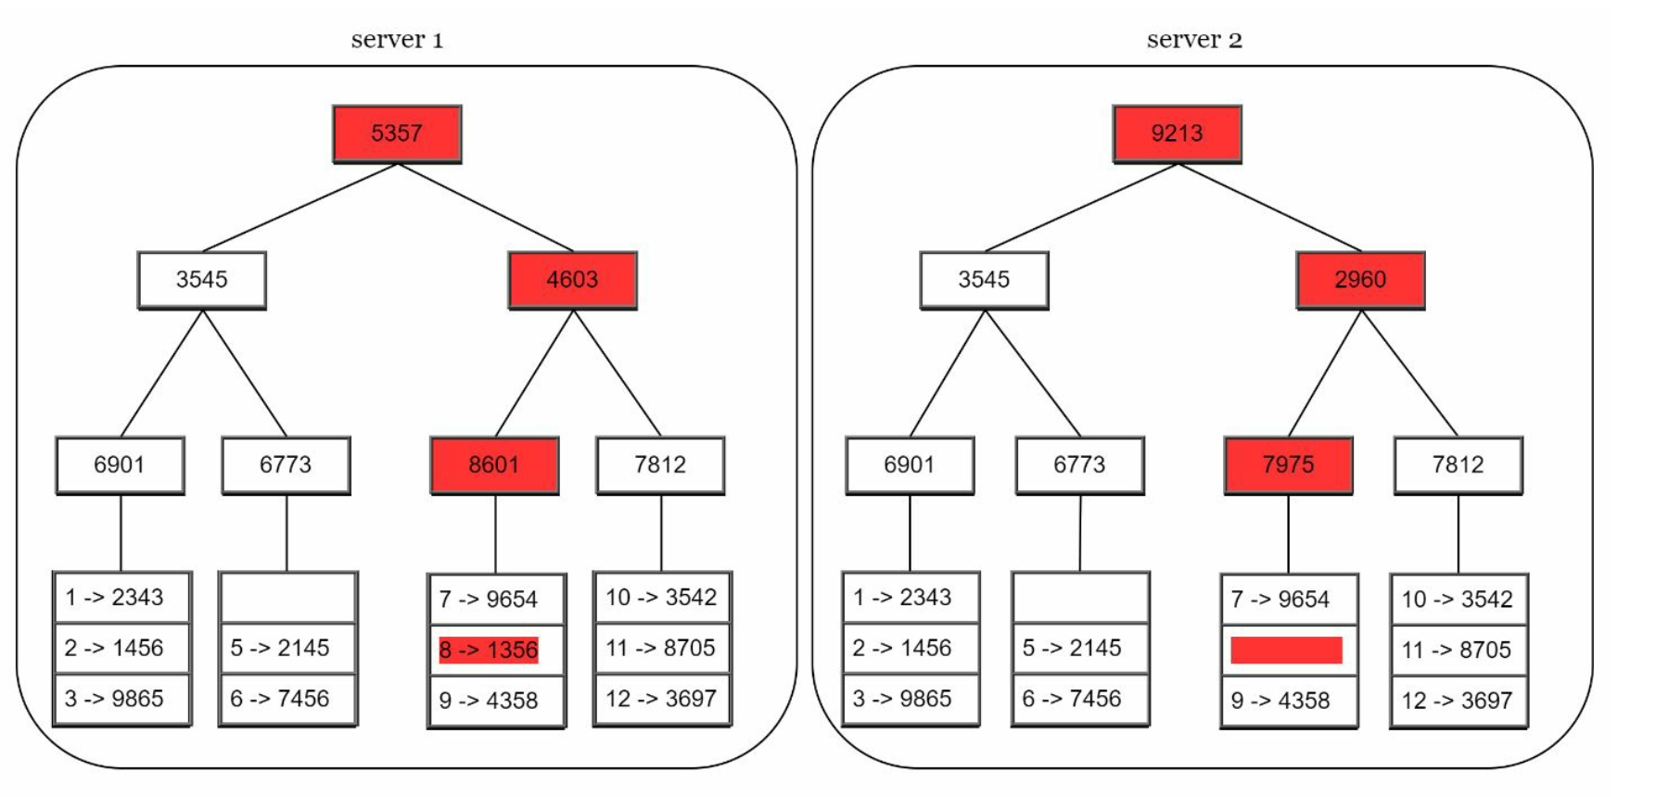

To compare two Merkle trees, start by comparing **the root hashes**. If root hashes match, both servers have the same data. If root hashes disagree, then the left child hashes are compared followed by right child hashes. You can traverse the tree to find which buckets are not synchronized and synchronize those buckets only.

Merkle trees minimize the amount of data that needs to be transferred for synchronization and reduce the number of disk reads performed during the anti-entropy process.

**Handling data center outage**

To build a system capable of handling data center outage, it is important to replicate data across multiple data centers.

**System architecture diagram for key-value store**

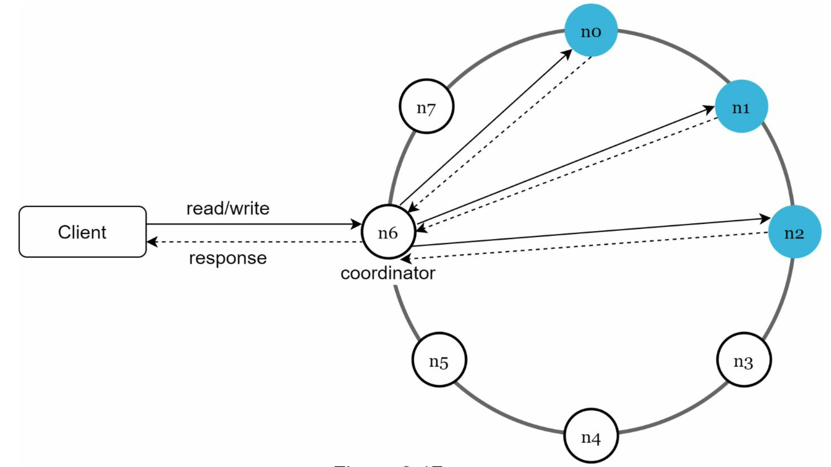

• Clients communicate with the key-value store through simple APIs: *get(key)* and *put(key,*

*value)*.

• A coordinator is a node that acts as a proxy between the client and the key-value store.

• Nodes are distributed on a ring using consistent hashing.

• The system is completely decentralized so adding and moving nodes can be automatic.

• Data is replicated at multiple nodes.

• There is no single point of failure as every node has the same set of responsibilities.

each node performs many tasks :

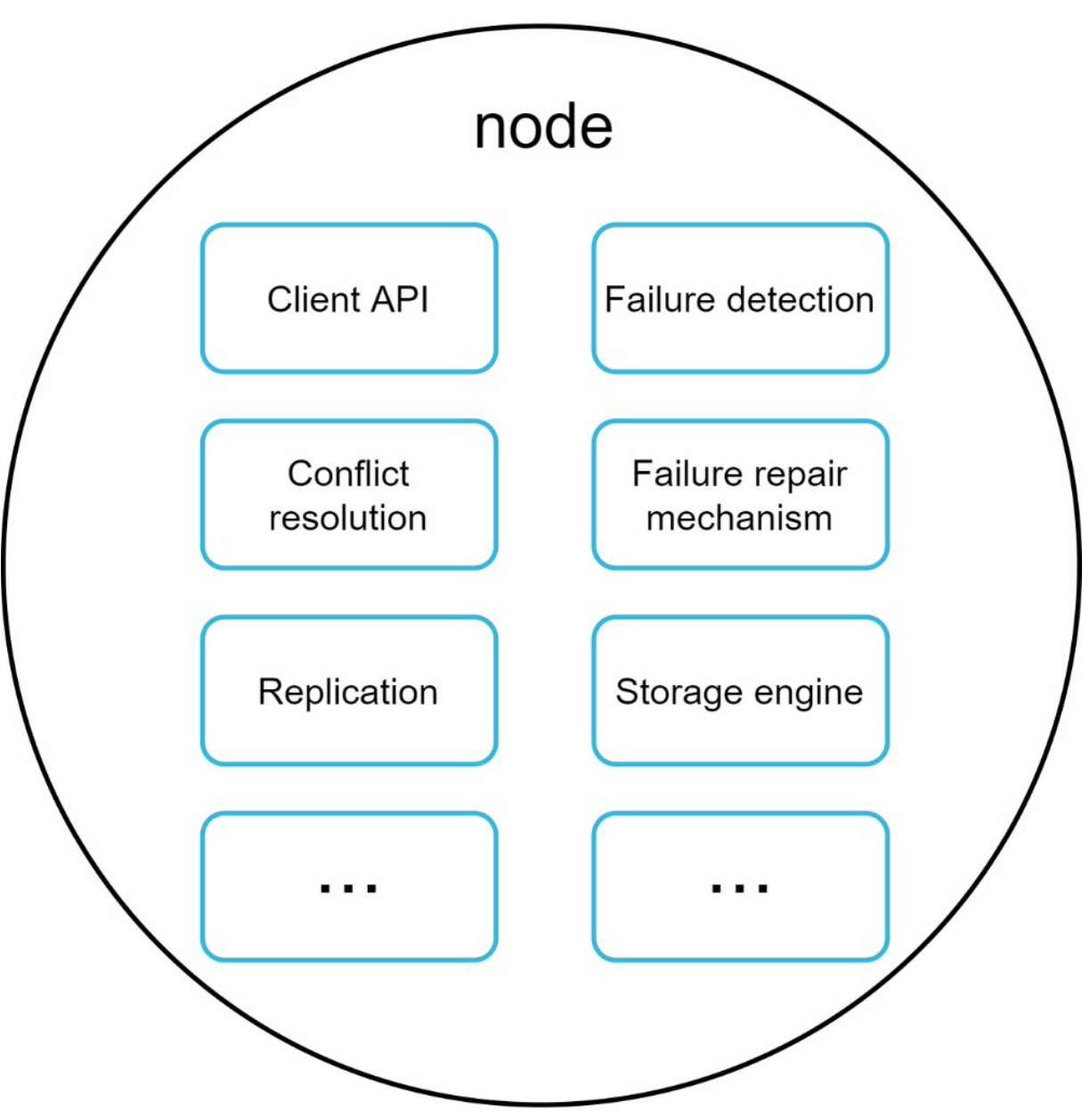

**Write path**

what happens after a write request is directed to a specific node :

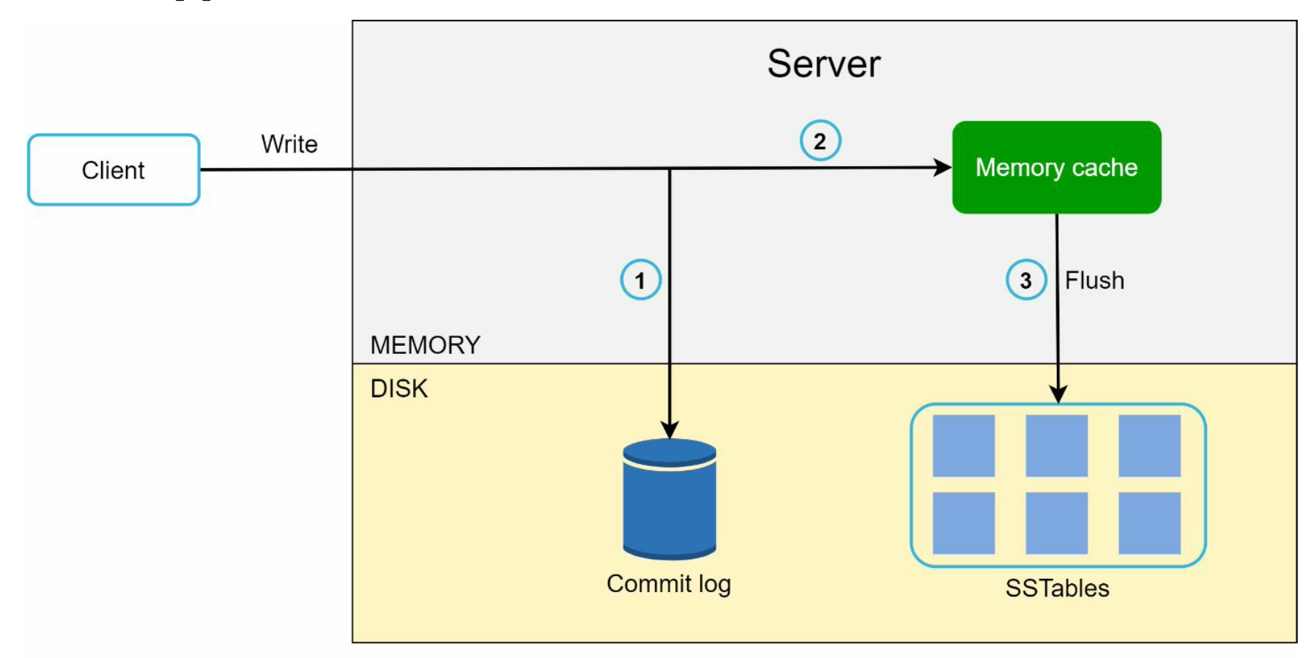

1. The write request is persisted on a commit log file.

2. Data is saved in the memory cache.

3. When the memory cache is full or reaches a predefined threshold, data is flushed to SSTable [9] on disk. Note: A sorted-string table (SSTable) is a sorted list of <key, value> pairs.

**SSTables: https://www.igvita.com/2012/02/06/sstable-and-log-structured-storage-leveldb/**

We want to preserve the fast read access which SSTables give us, but we also want to support fast random writes. Turns out, we already have all the necessary pieces: random writes are fast when the SSTable is in memory (let's call it MemTable), and if the table is immutable then an on-disk SSTable is also fast to read from. Now let's introduce the following conventions:

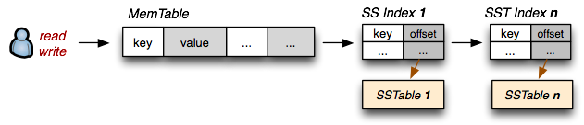

1. **On-disk SSTable indexes are always loaded into memory**
2. **All writes go directly to the MemTable index**
3. **Reads check the MemTable first and then the SSTable indexes**
4. Periodically, the MemTable is flushed to disk as an SSTable
5. Periodically, on-disk SSTables are "collapsed together"

**Read path**

After a read request is directed to a specific node, it first checks if data is in the memory cache. If so, the data is returned to the client

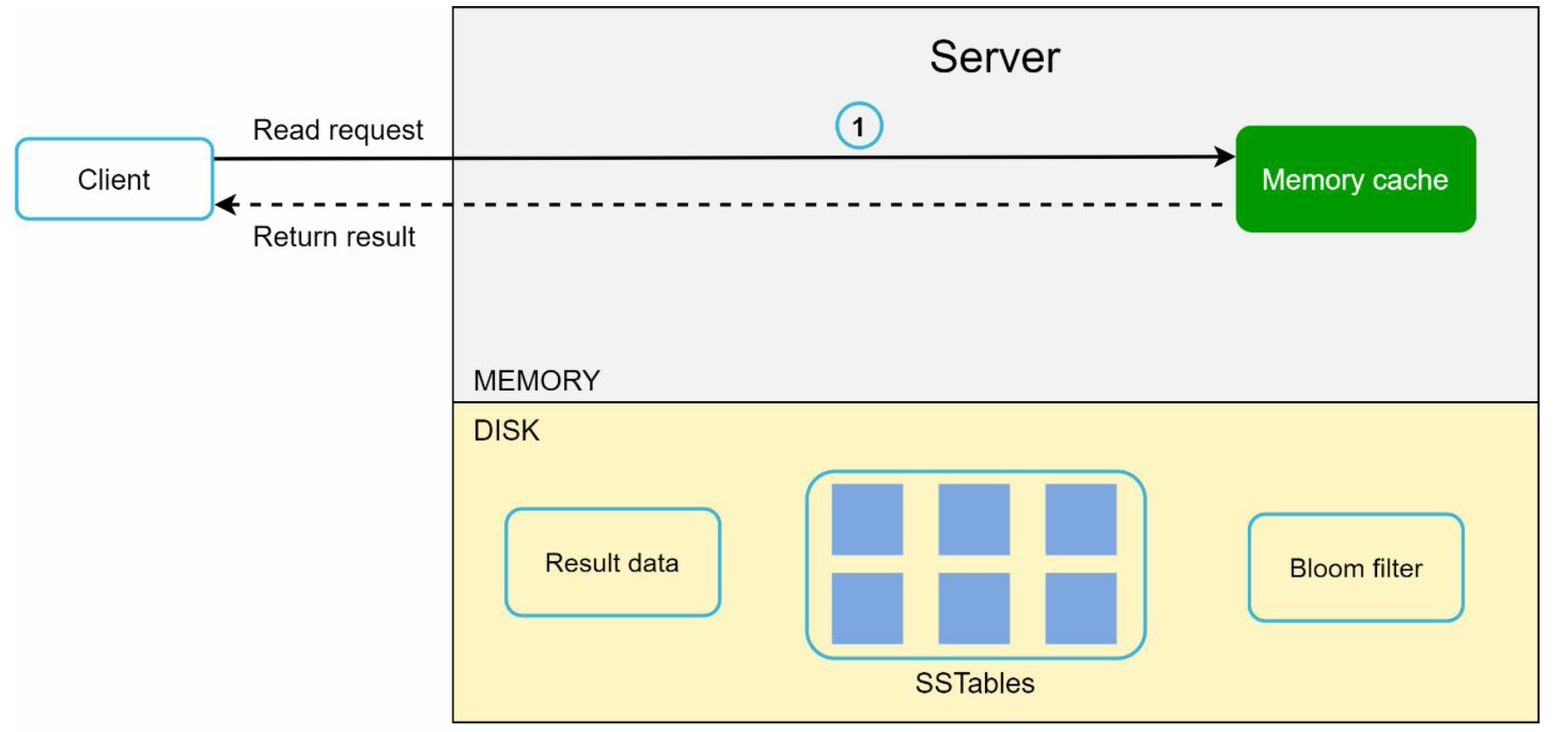

If the data is not in memory, it will be retrieved from the disk instead. We need an efficient way to find out which SSTable contains the key. Bloom filter is commonly used to solve this problem:

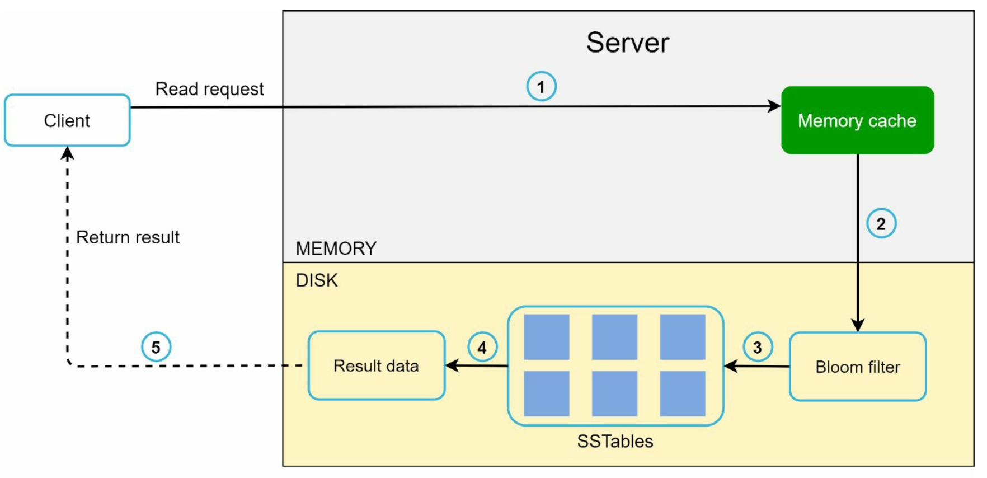

1. The system first checks if data is in memory. If not, go to step 2.

2. If data is not in memory, the system checks the bloom filter.

3. The bloom filter is used to figure out which SSTables might contain the key.

4. SSTables return the result of the data set.

5. The result of the data set is returned to the client.

**Summary**

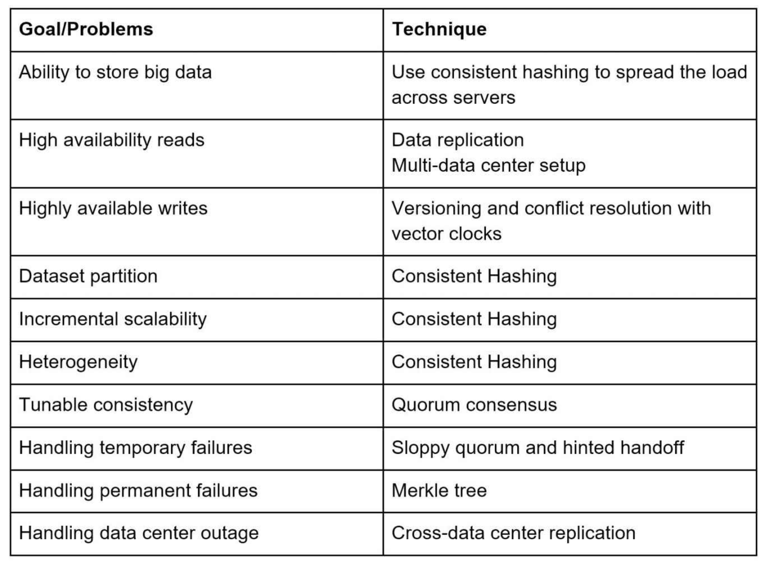

**DESIGN A UNIQUE ID GENERATOR IN DISTRIBUTED SYSTEMS**

Your first thought might be to use a primary key with the *auto_increment* attribute in a traditional database. However, *auto_increment* does not work in a distributed environment because a single database server is not large enough and generating unique IDs across multiple databases with minimal delay is challenging.

For this interview question, the requirements are listed as follows:

• IDs must be unique.

• IDs are numerical values only.

• IDs fit into 64-bit.

• IDs are ordered by date.

• Ability to generate over 10,000 unique IDs per second.

**Multi-master replication**

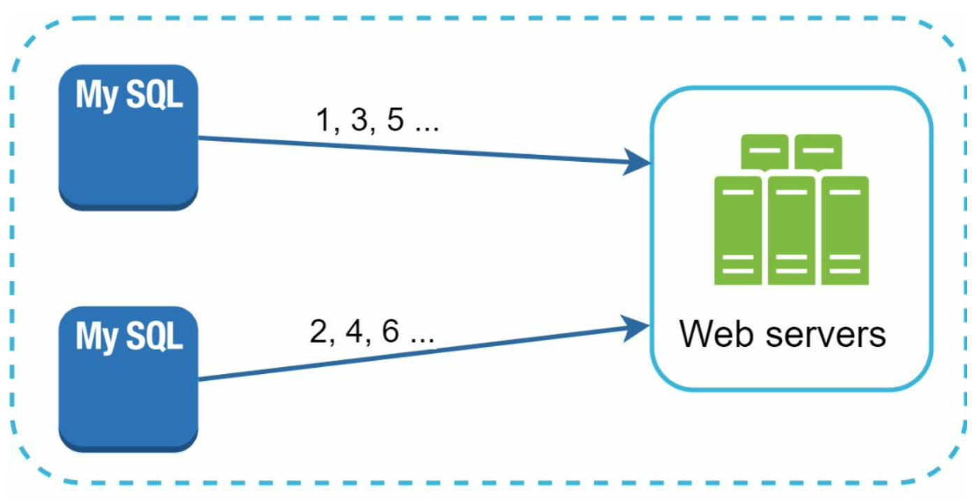

This approach uses the databases’ *auto_increment* feature. Instead of increasing the next ID by 1, we increase it by *k,* where *k* is the number of database servers in use.

This solves some scalability issues because IDs can scale with the number of database servers. However, this strategy has some major drawbacks:

• Hard to scale with multiple data centers

• IDs do not go up with time across multiple servers.

• It does not scale well when a server is added or removed.

**UUID**

UUID is a 128-bit number used to identify information in computer systems. UUID has a very low probability of getting collusion.

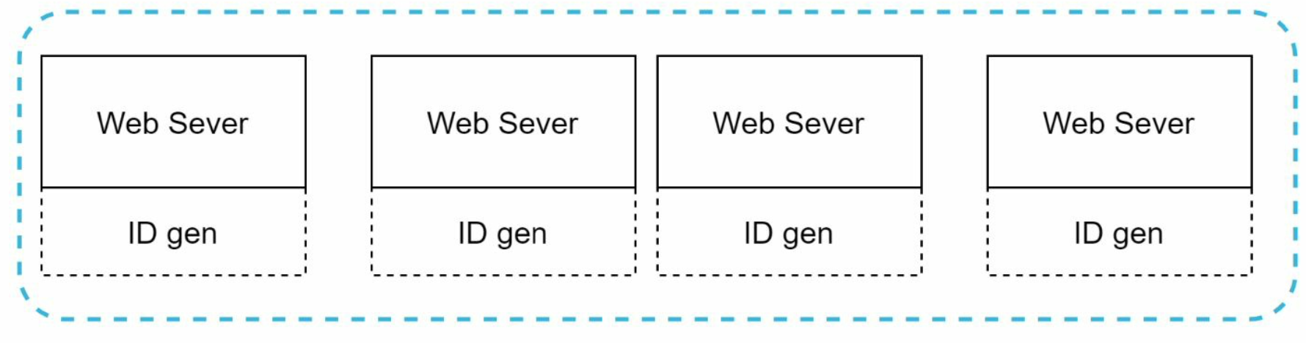

In this design, each web server contains an ID generator, and a web server is responsible for generating IDs independently.

Pros:

• Generating UUID is simple. No coordination between servers is needed so there will not be any synchronization issues.

• The system is easy to scale because each web server is responsible for generating IDs they consume. ID generator can easily scale with web servers.

Cons:

• IDs are 128 bits long, but our requirement is 64 bits.

• IDs do not go up with time.

• IDs could be non-numeric.

GUID: The term "GUID" was introduced by Microsoft for its implementation of [**universally unique identifiers**](https://en.wikipedia.org/wiki/Universally_unique_identifier) (UUID)

**Ticket Server**

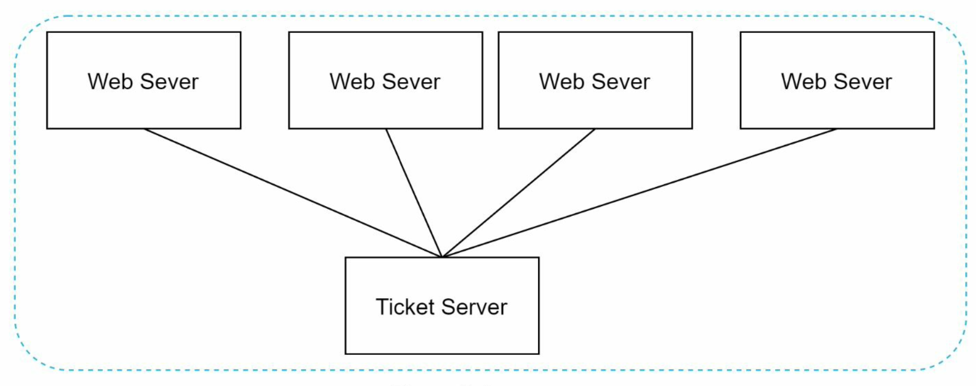

Flicker uses this

The idea is to use a centralized *auto_increment* feature in a single database server (Ticket Server)

Pros:

• Numeric IDs.

• It is easy to implement, and it works for small to medium-scale applications.

Cons:

• Single point of failure. Single ticket server means if the ticket server goes down, all systems that depend on it will face issues. To avoid a single point of failure, we can set up multiple ticket servers. However, this will introduce new challenges such as data synchronization.

**Twitter snowflake approach**

This can satisfy our requirements. ID:

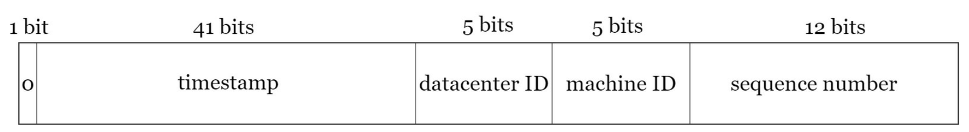

• Sign bit: 1 bit. It will always be 0. This is reserved for future uses. It can potentially be used to distinguish between signed and unsigned numbers.

• Timestamp: 41 bits. Milliseconds since the epoch or custom epoch. We use Twitter snowflake default epoch 1288834974657, equivalent to Nov 04, 2010, 01:42:54 UTC.

• Datacenter ID: 5 bits, which gives us *2 ^ 5 = 32* datacenters.

• Machine ID: 5 bits, which gives us *2 ^ 5 = 32* machines per datacenter.

Datacenter IDs and machine IDs are chosen at the startup time, generally fixed once the system is up running.

• Sequence number: 12 bits. For every ID generated on that machine/process, the sequence number is incremented by 1. The number is reset to 0 every millisecond.

Timestamp and sequence numbers are generated when the ID generator is running.

The maximum timestamp that can be represented in 41 bits is ~ 69 years After 69 years, we will need a new epoch time or adopt other techniques to migrate IDs.

Sequence number is 12 bits, which give us 2 ^ 12 = 4096 combinations. This field is 0 unless more than one ID is generated in a millisecond on the same server. In theory, a machine can support a maximum of 4096 new IDs per millisecond.

If there is extra time at the end of the interview, here are a few additional talking points:

• Clock synchronization. In our design, we assume ID generation servers have the same clock. This assumption might not be true when a server is running on multiple cores. The same challenge exists in multi-machine scenarios. Network Time Protocol is the most popular solution to this problem.

• Section length tuning. For example, fewer sequence numbers but more timestamp bits are effective for low concurrency and long-term applications.

• High availability. Since an ID generator is a mission-critical system, it must be highly available.